Project Deliverable E: Project Planning & Cost Estimate
GNG1103 [D03] – Professor David Knox

Submitted by:
Team 13, Oscar Black
Rafael Aragon, 300208499
Lucas Calvin, 300168913
Alessandro Furlano, 300116738
Sukhshant Litt, 300186325
Nathaniel Veluppillai, 300193467

Due Date: 2021/02/28
University of Ottawa
Table of Contents
Introduction 2
Final Design Concept 2
Prototyping Plan 3
Prototype 1 3
Tasks 3
Risk 3
Cost 4
Prototype 2 4
Tasks 4
Risk 4
Cost 5
Prototype 3 5
Tasks 5
Risk 5
Cost 6
Final Prototype 6
Tasks 6
Risk 6
Cost 6
BOM 7
Conclusion 7
Wrike 9

Introduction
Team 13 began this deliverable with the intent of making a schedule as well as a cost list for the 3 prototypes we will be making. Team 13 began with organising the first prototype which is focused on the development of the humidity sensor which requires team 13 to schedule and assign the tasks of circuit building and design, testing, code, and cad modelling. The next task was the development of our emergency alarm system which has the tasks of developing its code, case and accelerometer case design, as well as their fabrication. Finally, The team developed another plan for prototype 3 which is focused on the accelerometer’s design and code. Leaving the last part to create the plans for a final prototype as well a BOM list ensuring we stay within budget.

Final Design Concept
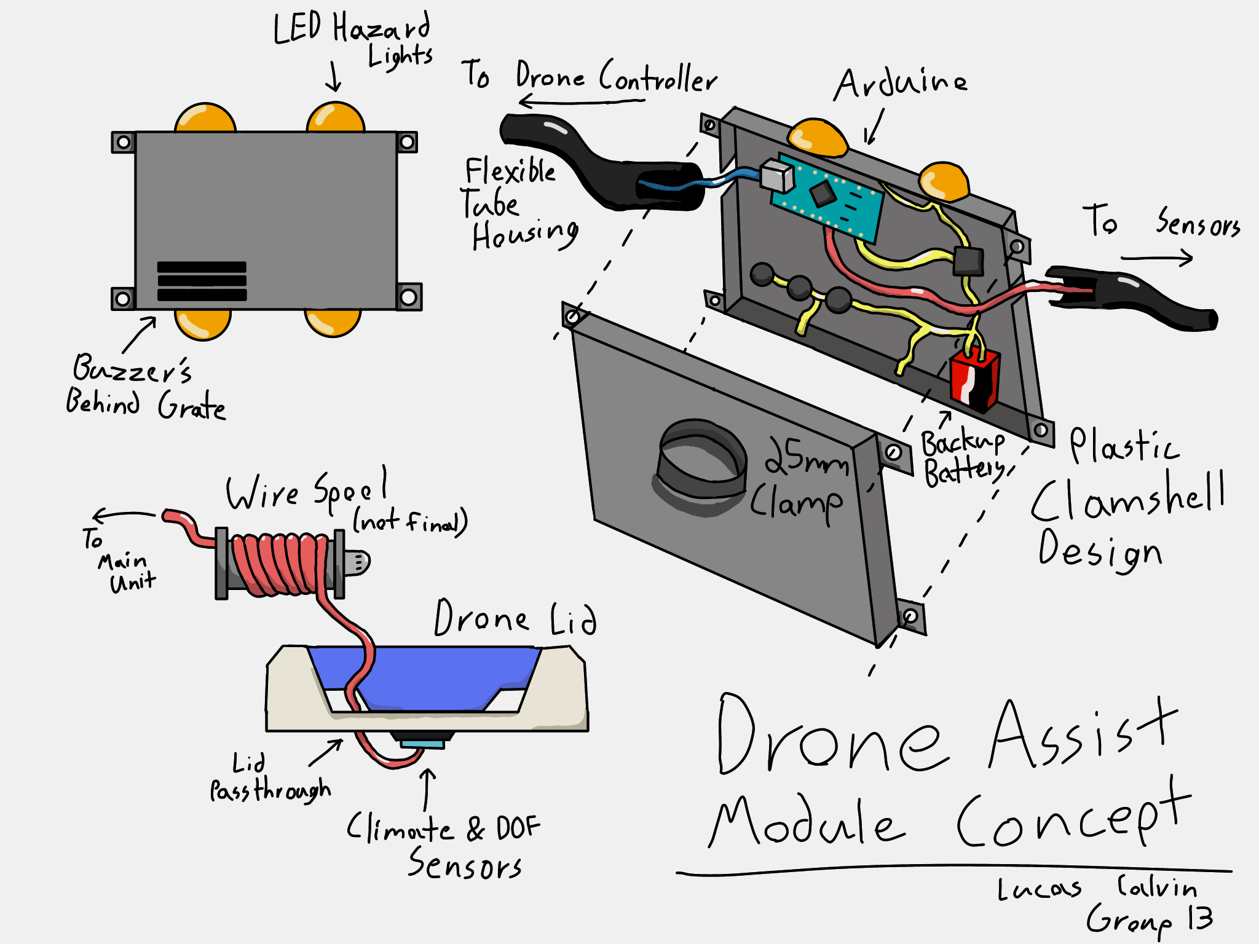
Below is a drawing developed byTeam 13 inorder to demonstrate the intended layout and construction of the product. This will serve as a guide in the direction of the prototypes and help illustrate hurdles in the creation of the final design that should be addressed in the prototypes.

Prototyping Plan

Prototype 1
Prototype 1 will have both physical and analytical parts. The physical part of the prototype will be focused on the Humidity Sensor system. It will focus on the implementation of it to ensure that it functions properly and gives an accurate reading of relative humidity and temperature. The analytical parts will be the design of the Case for the main circuit and the design of how we will attach the Humidity Sensor to the side of the box. Testing will only be done on the Humidity Sensor and the goal will be to ensure that it gives consistent readings within a range of 5% for humidity and 2% for temperature.

Tasks
Humidity Sensor Circuit Design and Building
Humidity Sensor Testing
Humidity Sensor Code
Case Modelling in CAD
Humidity Sensor Case Design in CAD

Risk
The risk factor with prototype 1 is very low as all of the parts are already available to the team and 1 of the team members has experience using the DHT 11 climate sensor that the team has decided to use.

Cost
The team will need to use a DHT 11 humidity sensor which they have found to cost $7.19. They will also use OnShape in order to design the Case which is free.

Prototype 2

Prototype 2 will be a physical focused prototype on the emergency alarm subsystem. This will involve the designing, implementation and the testing of the system to ensure that it functions properly. We will also test the sizing of the case ensuring that all components fit as designed.

Tasks
Alarm System Circuit Design and Building
Alarm System Code
Alarm System Case Design in CAD
Accelerometer Case Design in CAD

Risk
The possible risks related to this prototype are the possibilities of not receiving all of the components in time which would mean we wouldn't be able to build a physical prototype. If this occurs the team will design the circuit using tinkerCAD which will allow us to have a proof of concept and ensure that our code functions properly. If this occurs the team will still design the alarm system case.

Cost
The cost associated with this prototype will be the cost of the alarm system and the cost of the 3D printing which the team expects to be $7.90.

Prototype 3
Prototype 3 will be both physical and analytical. The physical part of this prototype will be the implementation of the accelerometer. The analytical part of this prototype will be the code to go along with the accelerometer and the code to ensure that there is communication between the flight controller and the arduino

Tasks
Accelerometer Circuit Design and Building
Accelerometer Code
Flight Controller Communication Code

Risk
The possible risks related to this prototype are the possibilities of not receiving all of the components in time which would mean we wouldn't be able to build a physical prototype. If this occurs the team will design the circuit using tinkerCAD which will allow us to have a proof of concept and ensure that our code functions properly. The team already has access to multiple arduinos which means there should be no issue testing the communication between the Flight controller and the arduino.

Cost
The cost associated with this prototype will be the cost of the accelerometer and the cost of the 3D printing which the team expects to be $8.23.

Final Prototype
In this prototype the team will implement all three subsystems together ensuring that they all function properly in the process.

Tasks
Combining Code
Combining Subsystems

Risk
There should be relatively low risk for this prototype as the team plans to have already done the majority of the work this prototype is just putting together all of the prototypes into a single system.

Cost
The cost associated with this prototype specifically will be the cost of the Arduino Nano which we have found to be $9.54.

BOM
Listed below is team 13’s bill of materials. This is what the team has planned and budgeted to use in the designing and building of their project. These devices were chosen due to their mostly based on their cost. The team hopes to collaborate with other teams in order to save on shipping.
Digi-Key | Description | Manufacturer | Digi-Key Part Number | Manufacturer Part Number | Quantity Available | Quantity | Unit Price | Extended Price
 | SEEEDUINO NANO | ‎Seeed Technology Co., Ltd‎ | 1597-102010268-ND | 102010268 | 63 | 1 | 9.54 | $9.54
 | DHT11: TEMPERATURE AND HUMIDTY | DFRobot | 1738-1089-ND | DFR0067 | 107 | 1 | 7.19 | $7.19
 | ADXL343 - TRIPLE-AXIS ACCELEROME | Adafruit Industries LLC | 1528-2874-ND | 4097 | 54 | 1 | 8.23 | $8.23
 | BUZZERS TRANSDUCER | DB Unlimited | 2104-TE122405-6-ND | TE122405-6 | 2270 | 5 | 1.58 | $7.90
 | CBL 5CON 26AWG 1M BLK | Tensility International Corp | T1426-1-ND | 30-01283 | 53 | 1 | 3.13 | $3.13
Software Libraries | Adafruit_ADXL343 | Adafruit | NA | NA | NA | NA | 0 | $0.00
 | DHT sensor library | Adafruit | NA | NA | NA | NA | 0 | $0.00
 | EasyBuzzer | Evert Arias | NA | NA | NA | NA | 0 | $0.00
 |  |  |  |  |  |  | Subtotal | $35.99
 |  |  |  |  |  |  | shipping cost | $8
 |  |  |  |  |  |  | tax price | $5.04
 |  |  |  |  |  |  | Total | $49.03

Conclusion
To conclude the work for this deliverable we completed the schedule that we created for ourselves as a group. To ensure that we stay on task we must remain organized; therefore we created a schedule with the tasks that were assigned to each member of the group. WE successfully created an updated BOM list for the 3 prototypes. To ensure quality we went over the risk and cost for the humidity sensor, alarm system and the accelerator case design. Running through the issues we were able to create a good outline of the 3 subsystems that will function together. Thereafter we discussed our next plan towards the drone designs.

Wrike
