University of Ottawa
GNG 1103: Engineering Design

Deliverable D- Conceptual Design

February 11^{th,} 2023
Group F-12
Avery Taylor (300366472)
Emily Facette (300109170)
Rashad Nesar (300372555)
Annabelle Osazuwa (300361617)

Abstract
This document presents the steps that were taken to develop conceptual designs for an erosion testing device. The team used benchmarking and analysis to address the identified problem from the client. Each design was evaluated against established criteria and client needs. The document includes detailed drawings, drawbacks, and benefits of different subsection options, a design criteria matrix, as well as a selection matrix for each option. Based on the analysis, Design 1 was selected as the best option, meeting all criteria including budget, safety, and motor protection. The document concludes with recommendations for future work.

Table of Contents
Abstract 3
1.0 Introduction 5
2.0 Drawings 5
2.1 Initial Individual Drawings 5
2.1.1 Subsections Breakdown 5
2.1.2 Subsections Drawings 6
2.2.1 Drawbacks and benefits of each subsection option 7
2.3 Condensed Drawings 8
3.0 Matrix 10
3.1 Design Criteria Matrix 11
3.2 Selection Matrix 12
3.3 Weighted Design Criteria Matrix 13
4.0 Conclusions and Recommendations 13
5.0 Future Works 14
6.0 References 14
Appendix 15

1.0 Introduction
This document presents our team's process of benchmarking and analysis to develop conceptual designs aimed at solving the accelerated rock erosion test system design requested from Nuclear Laboratories. Each design is evaluated against established criteria to assess its viability and effectiveness in addressing the issues at hand.

2.0 Drawings

2.1 Initial Individual Drawings

2.1.1 Subsections Breakdown
The different subsystems which will be considered are the motor configuration, rock adherence, the jug set up and features, and the jug material, as follows:
- Motor configuration
  - Side
  - Bottom
  - Top
  - Fan
  - Splash guard
- Rock adherence
  - Wired
  - Free
  - Gorilla tape
  - Clamp
- Jug setup and Features
  - Drain
  - Baffles
  - Depth of propellor/disk
  - Addition of temperature sensor and heater
- Jug Material
  - Plastic
  - Steel
  - Composite Materials

2.1.2 Subsections Drawings
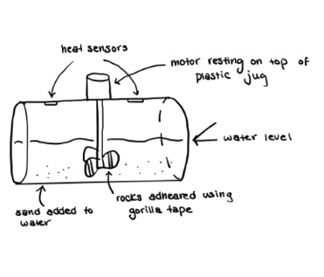
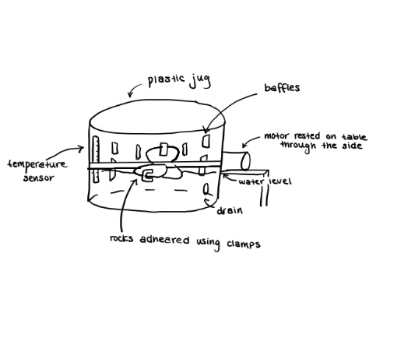
The following figures show the different options for each subsection.
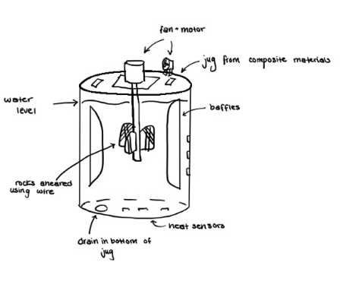
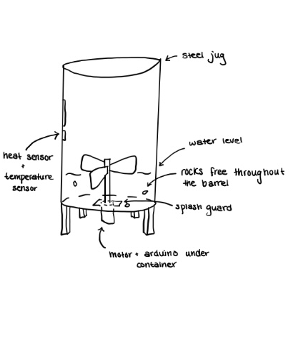

2.2.1 Drawbacks and benefits of each subsection option
The following tables breakdown the advantages and disadvantages of each subsection option.

2.2.1.1 Motor Configuration
Product | Advantages | Disadvantages
Side of container | - Water in container will not start spinning | - Water hitting the motor  - Inconvenient round surface to balance on a surface
Bottom of container | - Can spin dowel easily | - Needs a way to seal the space between the motor and container
Top of container | - Low chance of water/motor contact  - Stable flat bottom | - Rotation of the water could affect erosion rate
Colling fan | - Lowers temperature of motor over long period of time | - Can’t know to what extent the fan cools the motor
Splash guard | - Protect against water splashing

2.2.1.2 Rock Adherence
Product | Advantages | Disadvantages
Wired | - Metal wire is unlikely to erode | - Samples must be tied very well or will come loose  - Wire can cause wear on sample
Free | - No contact between sample and motor/dowel | - Collisions between samples are inevitable leading to inaccurate erosion data
Gorilla tape | - Easy to fasten samples tightly | - Samples probably will come loose in water
Clamp | - Tight connection to dowel  - Unlikely to erode | - Force of clamp on sample may damage it leading to higher rate of erosion than in reality

2.2.1.3 Jug Setup and Features
Product | Advantages | Disadvantages
Drain | - Easy to add or remove water | - Possible for water to escape
Baffles | - Minimize water rotation that would lower erosion | - Could detach from side of container and hit samples
Shallow propeller placement | - Shorter motor stem means less weight/ force required to spin it | - May not be fully submerged in water
Deep propeller placement | - Will be fully submerged in water
Temp sensor/heater | - Allows us to accurately monitor and change temp. | - Being in contact with water may limit its capabilities

2.2.1.4 Jug Material
Product | Advantages | Disadvantages
Plastic  (Dmadden, 2018) | - Lightweight  - Corrosion Resistant  - Inexpensive | - Not as strong as steel  - Can be affected by temperature
Steel  (Thakur, 2024) | - Strong and Durable  - Not affected by internal temperature | - Prone to corrosion  - Heavy  - Expensive
Composite Materials (Plasticon Composite France, 2018) | - Can be engineered to have specific strength properties  - Resistant to corrosion  - Long lifespan | - Expensive  - Difficult to manufacture

2.3 Condensed Drawings
The following figures show the subsystems condensed into three different fully functional solutions.
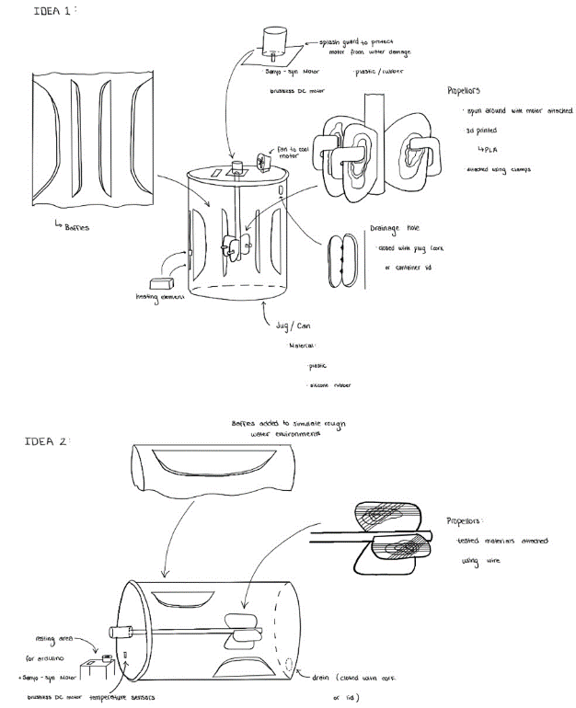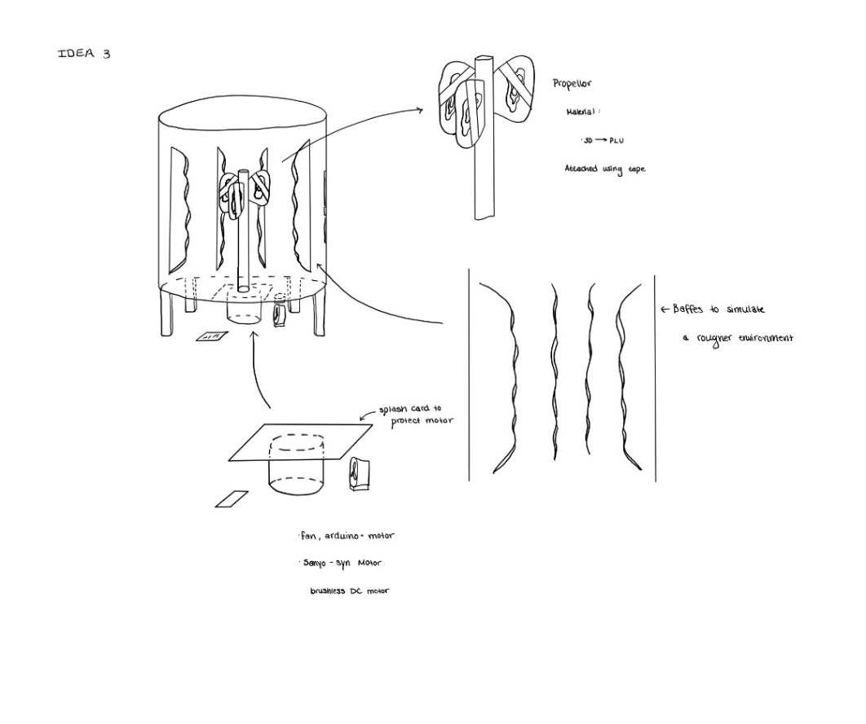

3.0 Matrix
The features of each fully functional system can be broken down based on the design needs/criteria. In addition, there is a selection matrix, in which the importance of each criterion was quantified based on their importance as emphasized by the client.

3.1 Design Criteria Matrix
Criteria | Design 1 | Design 2 | Design 3
Cost of container | $20 | $300 | $90
Motor protected from water | Yes | No | No
Stabilization measures | Drum Standing upright- Very secure | Drum on flat stand- Less secure | Drum on legs- Not very secure
Samples are fastened | Clamp | Wire | Waterproof Tape
Container Material | Plastic | Composite HDPE | Steel
Variety of conditions can be tested | Yes | Yes | Yes
Information can be documented | Yes | Yes | Yes
Turbulence is promoted | Yes | Yes | Yes
Can heat water | Yes | No | No

3.2 Selection Matrix
Criteria | Design 1 (motor on top) | Design 2 (motor on side) composite | Design 3 (motor on bottom) Steel
Cost of container | $20 | $300 | $90
Motor protected from water | Yes | No | No
Stabilization measures | Drum Standing upright- Very secure | Drum on flat stand- Less secure | Drum on legs- Not very secure
Samples are fastened | Clamp | Waterproof Tape | Wire
Container Material | Plastic | Composite HDPE | Steel
Variety of conditions can be tested | Yes | Yes | Yes
Information can be documented | Yes | Yes | Yes
Turbulence is promoted | Yes | Yes | Yes
Can heat water | Yes | No | No

3.3 Weighted Design Criteria Matrix
Criteria | Weight of Criteria | Design 1 | Design 2 | Design 3
Cost of container | 5 | 3 | 1 | 2
Motor protected from water | 3 | 3 | 1 | 1
Stabilization measures | 2 | 2 | 2 | 1
Samples are fastened | 4 | 3 | 2 | 2
Container Material | 1 | 2 | 3 | 3
Variety of conditions can be tested | 5 | 3 | 3 | 3
Information can be documented | 5 | 3 | 3 | 3
Turbulence is promoted | 2 | 3 | 3 | 1
Can heat water | 3 | 3 | 1 | 1
Total |  | 87 | 62 | 61

4.0 Conclusions and Recommendations
This analysis has furthered our comprehension regarding the approach to benchmarking and conceptual thinking. This document shows the comprehensive benchmarking and analysis process that our team used to craft some conceptual designs to tackle the identified problem. As we move forward, these conceptual designs serve as a solid foundation for further refinement and mark a significant step towards resolving the challenge at hand. By applying our design criteria, we have chosen the best design, being Design 1. Design 1 satisfies all our criteria. This criterion includes the budget, safety of the apparatus, the motor being protected, and other erosion-inducing elements. The water can be heated in this setup, the conditions are repeatable, and the results are measurable. Overall, the design and configuration of Design 1 will meet our client’s needs and achieve the project's needs.

5.0 Future Works
In the upcoming client meeting, we plan to gather feedback from the client to identify any additional requirements or improvements needed for the design. Following this, we intend to create a prototype based on Design 1 to verify its functionality and performance.

6.0 References
Dmadden. (2018, September 26). What can you store in plastic barrels? Container Exchanger. https://blog.containerexchanger.com/what-can-you-store-in-plastic-barrels/
Plasticon Composite France. (2018, August 13). COMPOSITE MATERIALS: BENEFITS AND DRAWBACKS - PFA COMPOSITES GRE. PFA COMPOSITES GRE. https://www.epoxyresolutions.com/technology/the-composite-benefits-and-drawbacks/?lang=en#:~:text=Sustainability%20%2F%20anti%2Dcorrosion%20%2F%20fatigue,of%20shocks%20and%20compression%20stress.
Thakur, M. (2024, January 5). Advantages and disadvantages of steel. EDUCBA. https://www.educba.com/advantages-and-disadvantages-of-steel/

Appendix
Cost of Barrels
Plastic: $20 (https://rainbarrel.ca/BarrelMan/product-category/plastic-barrels/)
Steel: $90 (https://www.thecarycompany.com/55-gallon-tight-head-steel-drum-26w55t?queryID=78a57dcd08e8e5508ded0bca79bd9d76&objectID=13&indexName=m2prod_default_products)
Composite: $300 (https://www.thecarycompany.com/55-gallon-composite-steel-plastic-drum?queryID=2186be2abc8314f661e527da7bb61964&objectID=50742&indexName=m2prod_default_products)

