PROJECT DELIVERABLE F:
PROTOTYPE I AND CUSTOMER FEEDBACK

Submitted by

Team D14

Cristie Kwan (300186315)

Fatmah Bayrli (300159193)

Bill Wu (300170086)

Michael Hetu (300209299)

Mashal Joyaa (300082650)

On

March 9th, 2021

Professor: David Knox
TA: Justine Boudreau
PM: Kaleb Mannion, Evelyn Wattenbarger

Introduction:
This deliverable will give us a more accurate understanding of our prototype. Working on interpreting the reason behind the prototype and what we adjusted in our design to connect the customer’s needs using inexpensive material to produce an introductory model. This deliverable focuses on the prototyping test plan based on the outline provided in our class, which was “Lecture 11 –Prototyping Test Plan.”And It demonstrates simple prototypes made with inexpensive materials. The document will present feedback from the client on the model to improve the result of the final project. There are some standard goals to ensure that the test plan is achieved. Likewise, the goal will be to establish feasibility, analyze key subsystems or reduce risks and uncertainties and define stopping criteria.

Prototype Test Plan:
The following table is the prototype testing format that we will be developing. There are going to be three main prototype tests which are testing different components of our prototype. The three tests will be as follows; testing of audio levels of the speaker system, a testing of the light system, and testing of the waterproof capabilities of the box cover.

Test ID | Test Objective  (Why) | Description of Prototype used and of Basic Test Method  (What) | Description of Results to be Recorded and how these results will be used (How) | Estimated Test duration and planned start date  (When)
1 | Confirming that the sound subsystem performs as desired | The prototype that we will use to test the sound subsystem for its performance abilities, will be the second prototype, and we will test the sound system’s alerts that are created. The audio will be attempted to be heard from different distances from the device, in order to get an understanding of how loud truly is relative to the environment. | How loud, and from what different distances is this audio alert from the prototype efficient in fulfilling its duty as an anti-theft alarm + emergency beacon. These results will be used to determine if the hardware used is capable of making a sufficient auditory signal. | We plan on testing this before March 11th, and it is estimated to take about 20 minutes. Therefore, March 10th will be the hard date on which will most likely be performed.
2 | Confirming that the light subsystem performs as desired | The prototype that we will use to test the sound subsystem for its performance abilities, will be the second prototype, and we will test the light system’s luminosity levels. We will observe the true luminosity to the naked eye in a darkened environment (mimicking night-time deliveries), and during the day for safety purposes. | How bright, and from what ranges of distance is the light system effective in serving as an “emergency beacon”, and a visual aspect of the “anti-theft” solution. This will be used to help us determine if our chosen components fit within the practical requirements of our solution. | We plan on testing this before March 11th, and it is estimated to take about 20 minutes. Therefore, March 10th will be the hard date on which will most likely be performed.
3 | Confirming that the “waterproof” aspect of our solution is true | The prototype that we will use to test the “waterproof” aspect of our solution, will be the second prototype, and we will test whether or not the cover subsystem of the solution is capable of proving it’s “waterproof” status. 1 litre of water will be prepared, and will be poured on the prototype from an aerial point of view, in order to determine if the covering/case of the solution is waterproof | For this type of prototyping test, it is actually just a confirmation of whether or not the covering/case for the prototype protects the interior components from any potential water damage. If it does, the approves of our design and will allow us to confirm the functionality of our “waterproof” feature | We plan on testing this before March 11th, and it is estimated to take about 15 minutes. Therefore, March 10th will be the hard date on which will most likely be performed.

Stopping Criteria:
The stopping criteria helped us to acknowledge when to stop when our goal is achieved. To sufficiently meet the test objectives, we will check whether the LEDs and speakers to make sure they are working properly. Once we intuitively see that the LEDs light up smoothly and investigate the noise of the speaker, we can conclude that the test target has been reached.

Client Feedback :
On February 24, 2021, we had our second customer meeting to discuss the model. We can show the client some of the slides we made and ask for their opinions and feedback. One change emphasized is that the shape of the prototype is not aerodynamic hence they recommended creating a more aerodynamic design. Another problem is the number of speakers. They recommend installing only one speaker so the wires can be more organized.

Speakers:
Similar System:
Similar devices include simple alarm clock systems that are small and pocket-sized, yet when properly activated will emit noise. For example, NOKLEAD Digital Travel Alarm Clock – Mini Portable LCD Display Clock with Backlight Calendar Temperature Snooze 12/24H Makeup Mirror, Small Folding Battery Operated Desk Clock for Kid Bedroom
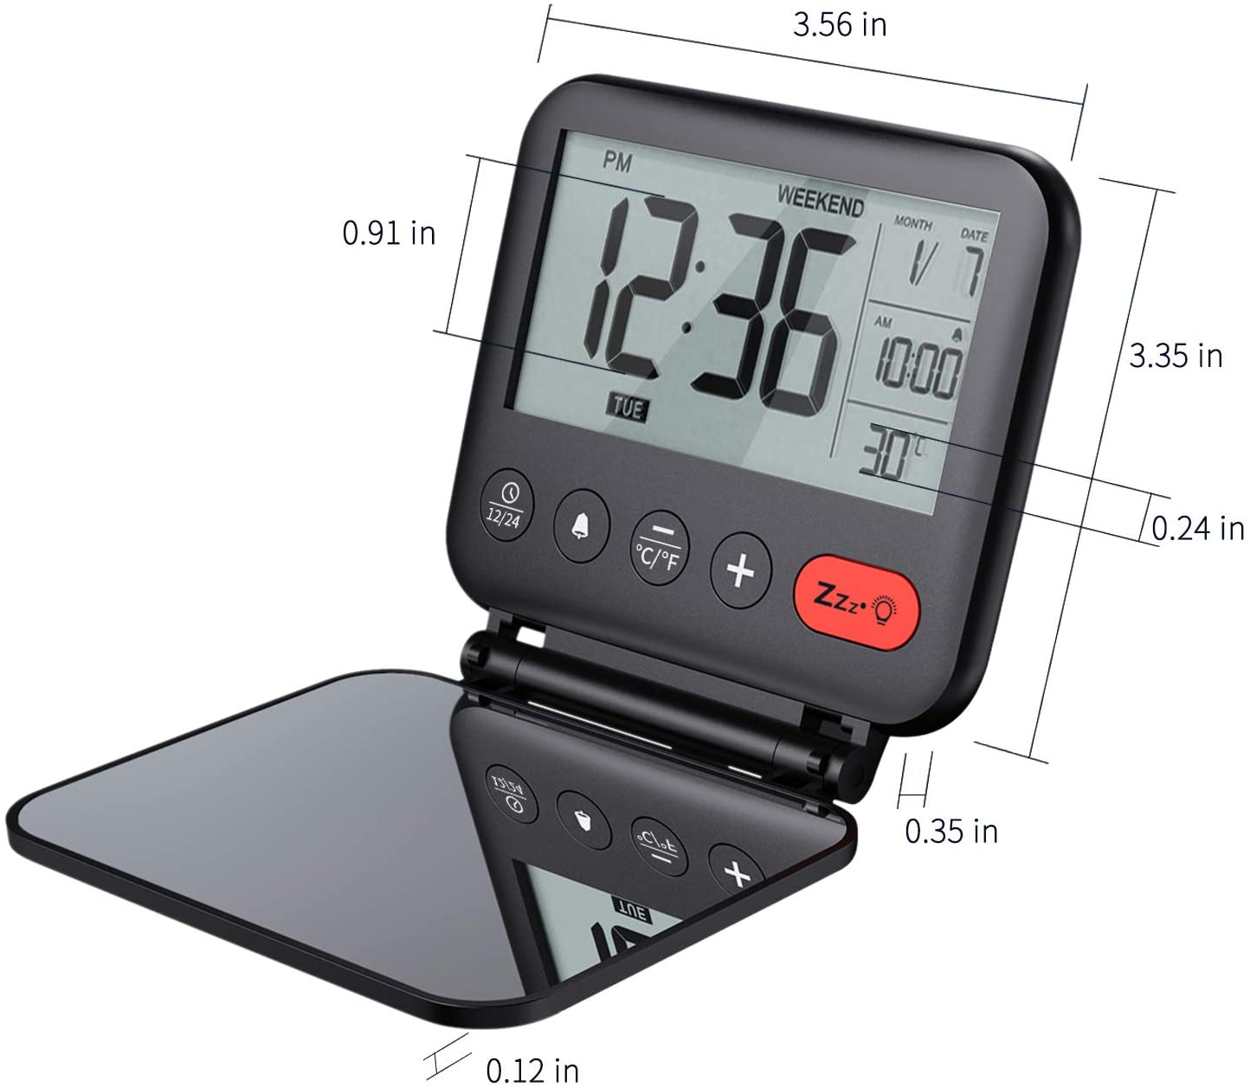
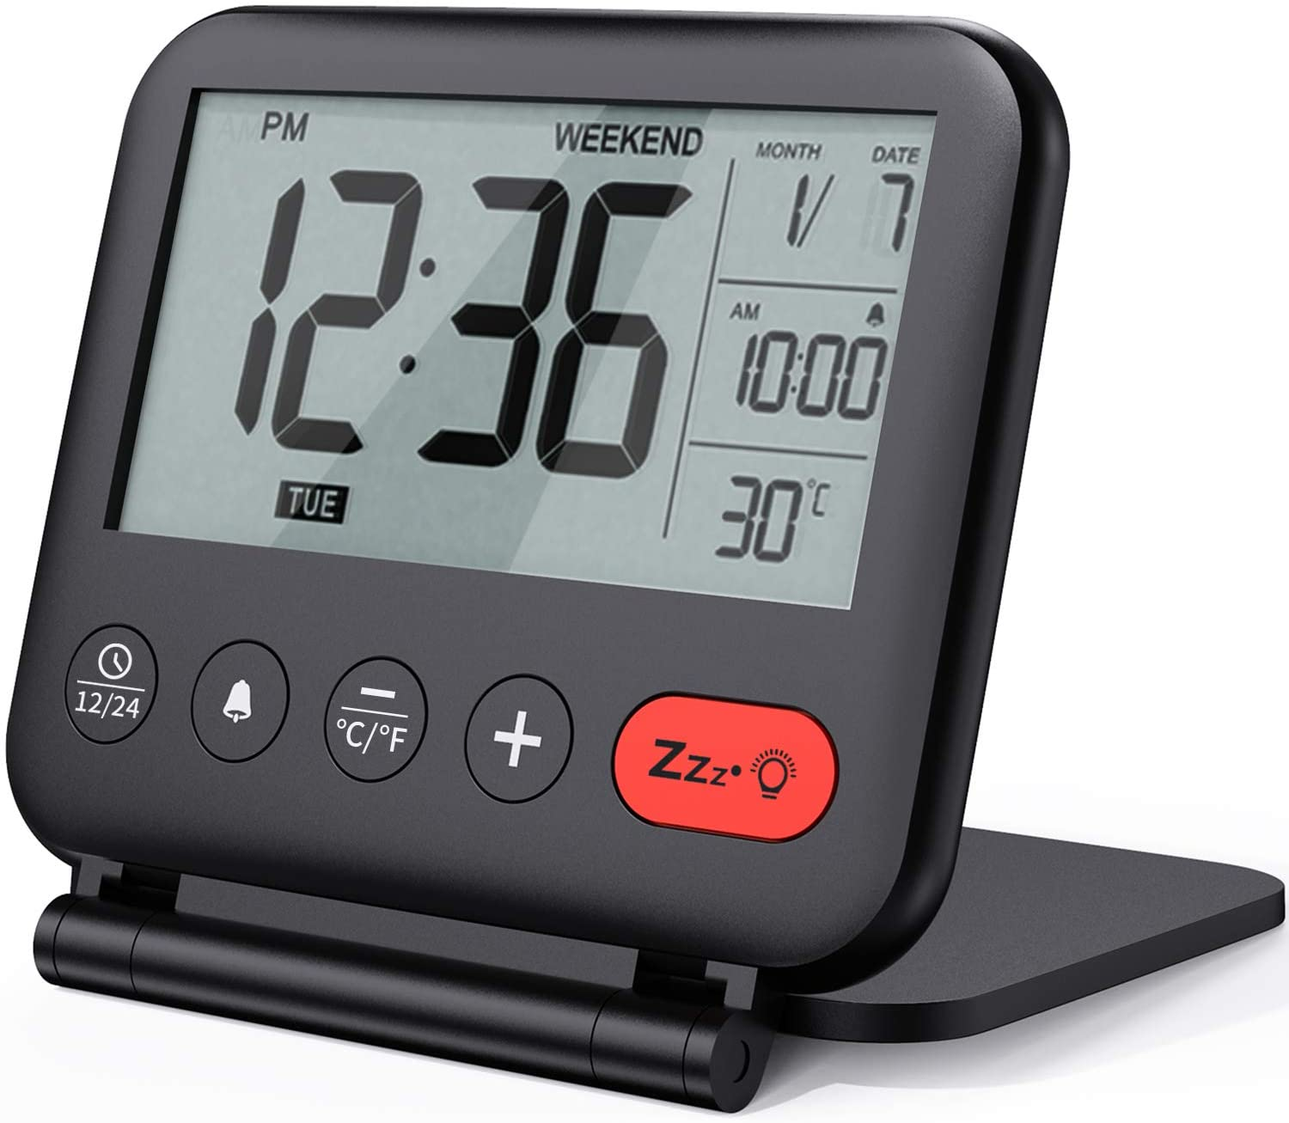
Figure 1: NOKLED Digital Travel Alarm Clock

With an alarm that activates when the correct conditions were selected and being small enough to not take up any access room, with dimensions of just 9 x 8.5 x 1.2 centimetres weighing only 95.8 grams. With 60-75 dB of sound being produced Indicating that the speaker we would implement should theoretically be possible when comparing the two different devices.

Similar System:
A similar device to the speaker that we have chosen to use is the Ultrasonic Directive Speaker 40 KHz 10mm
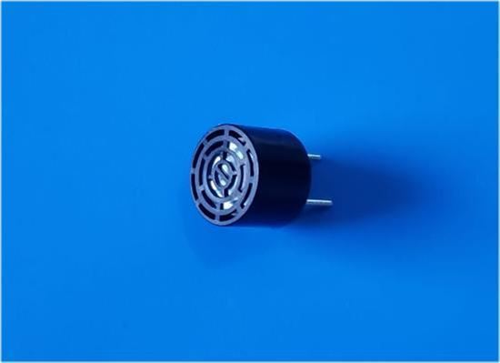
Figure 2: Ultrasonic Directive Speaker
It is a small speaker that emits 40Khz of sound, at only 10mm wide, it is even smaller than the speaker that we are using for our device. Indicating that despite the relatively small dimensions for the speaker if hooked up properly the noise should be able to be emitted to a large radius.

Lights:

Similar System:
Similar devices to the LED light setup that we have on our prototype is singular/groups of individual LEDs. Our LED light setup involves bright but basic and easy to implement LEDs that are capable of being found in many online electronic component stores. The LEDs we will compare to our prototypes will be LEDs of the same power level/energy requirements.

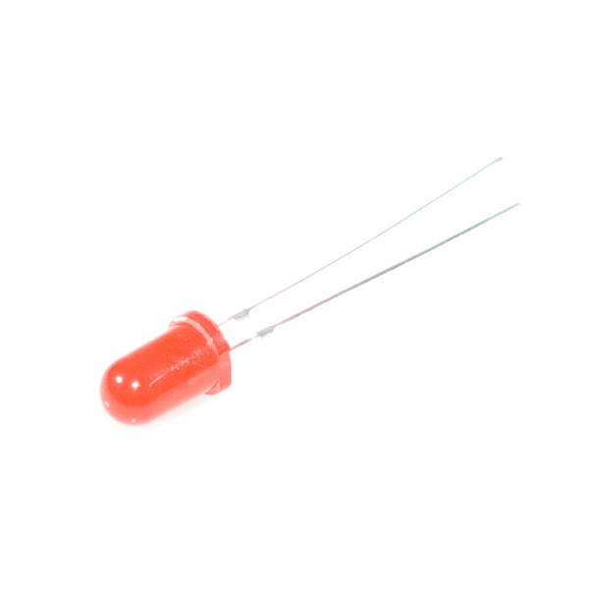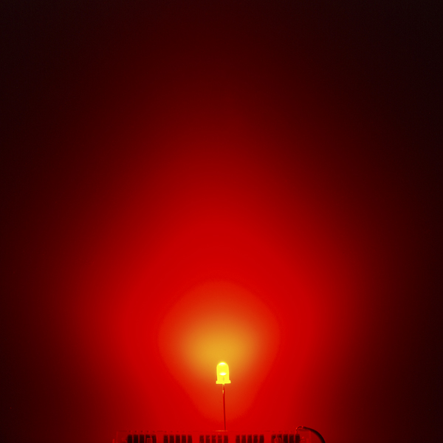
Figure 3: LED -Basic Red 5mm

- 1.8-2.2VDC forward drop
- Max current: 20mA
- Suggested using current: 16-18mA
- Luminous Intensity: 150-200mcd
This is a similar LED to the one we plan on using in our prototypes. It has the same size and colour, and it was tested to have a luminosity intensity that ranges from 150-200 mcd

Similar System:
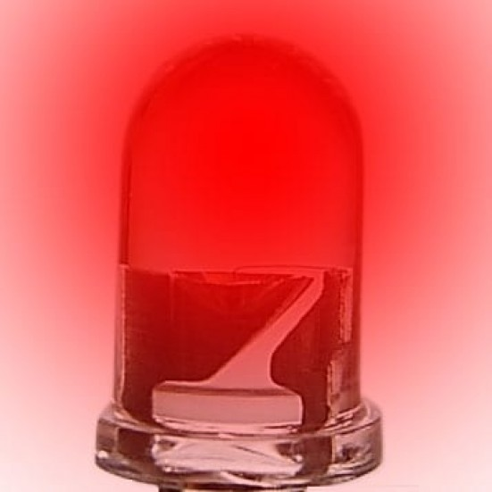
Figure 4: 5mm Super Bright Red LEDs
- Colour Frequency: 628nm (Red)
- Luminous Intensity: 8,000mcd
- Viewing Angle: 15°
- Forward Voltage: 1.9v - 2.6v
- Typical Voltage: 2.1v
- Typical Forward Current: 20mA
- Style: Round 5mm - T1 3/4
This is also another 5mm Red LED, which is similar to what we plan on implementing into our prototype. Boasting a powerful luminous intensity of 8000 mcd, it appears to be more powerful than other similar LEDs, but these cost $3 for each unit
Conclusion:
Before the design proceeded further, we made a prototype to understand the main points of the project. Based on the prototyping test plan we had, we were able to do a project test of the general objectives. Based on meeting with customers, the prototype helped us determine the customer needs and provide changes to the model specifications and what we need to look at in our design with the inexpensive component we used. Our main goal is to make clients satisfied with the design.

Reference:
Ceramics, S. (n.d.). Ultrasonic directive Speaker 40 Khz 10mm. Retrieved March 09, 2021, from https://www.steminc.com/PZT/en/ultrasonic-directive-speaker-40-khz-10mm?gclid=Cj0KCQiA1pyCBhCtARIsAHaY_5fnHexYNGZmbamOHeCdKIwzwNchavr8Sq0xGGT0C69TwN4ItwXrKV4aAhmYEALw_wcB
NOKLEAD digital Travel alarm Clock – mini Portable Lcd display clock with Backlight Calendar Temperature Snooze 12/24H Makeup Mirror, small Folding battery OPERATED desk clock for Kid Bedroom (black). (n.d.). Retrieved March 09, 2021, from https://www.amazon.ca/NOKLEAD-Digital-Travel-Alarm-Clock/dp/B08KVZ1YJN/ref=sr_1_7?dchild=1&gclid=Cj0KCQiA1pyCBhCtARIsAHaY_5fDmyfnsOum02_9QocfJkSR7BYBt2g1EuKMFVd2DKHDmQ7bWo0mai0aAmfkEALw_wcB&hvadid=336904504946&hvdev=c&hvlocphy=9000819&hvnetw=g&hvqmt=b&hvrand=447693178865929291&hvtargid=kwd-297971706464&hydadcr=1504_9454476&keywords=mini%2Balarm%2Bclock&qid=1615328680&sr=8-7
PCBoard.ca (n.d.). 5mm Super Bright Red LEDs. Retrieved March 09, 2021, from https://www.pcboard.ca/5mm-super-bright-red.html
Sparkfun. (n.d.). LED - Basic Red 5mm. Retrieved March 09, 2021, from https://www.sparkfun.com/products/9590
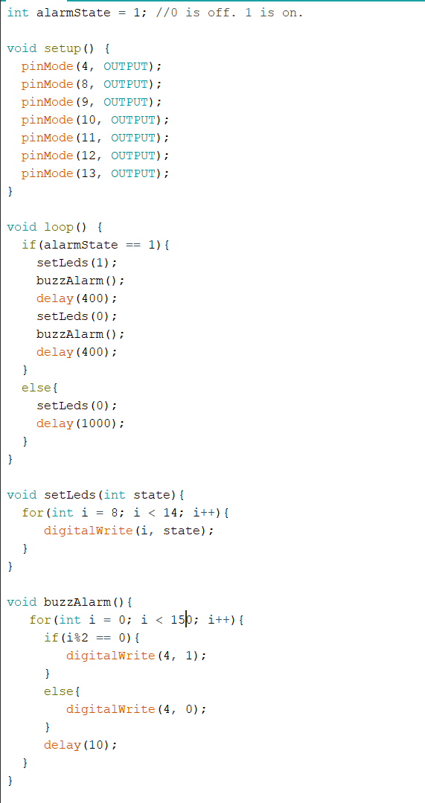
This is a screenshot of the code of our prototype using Arduino.
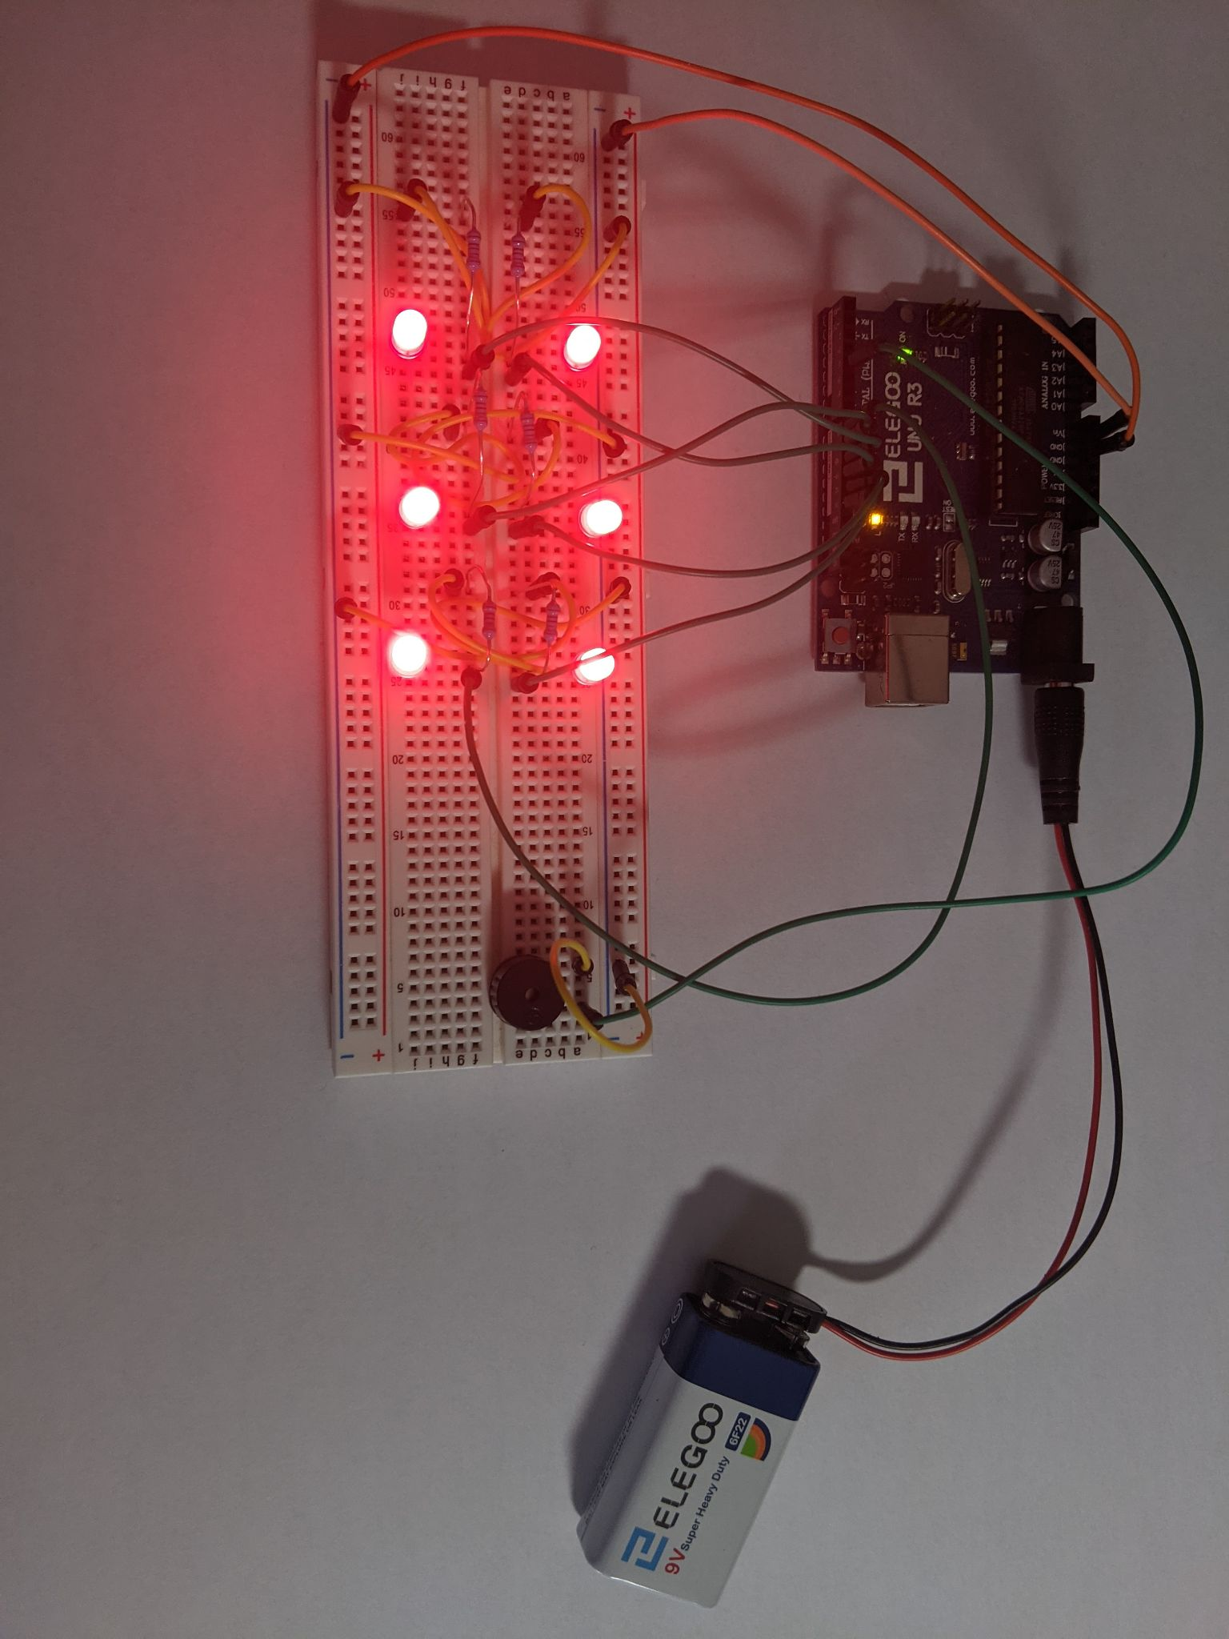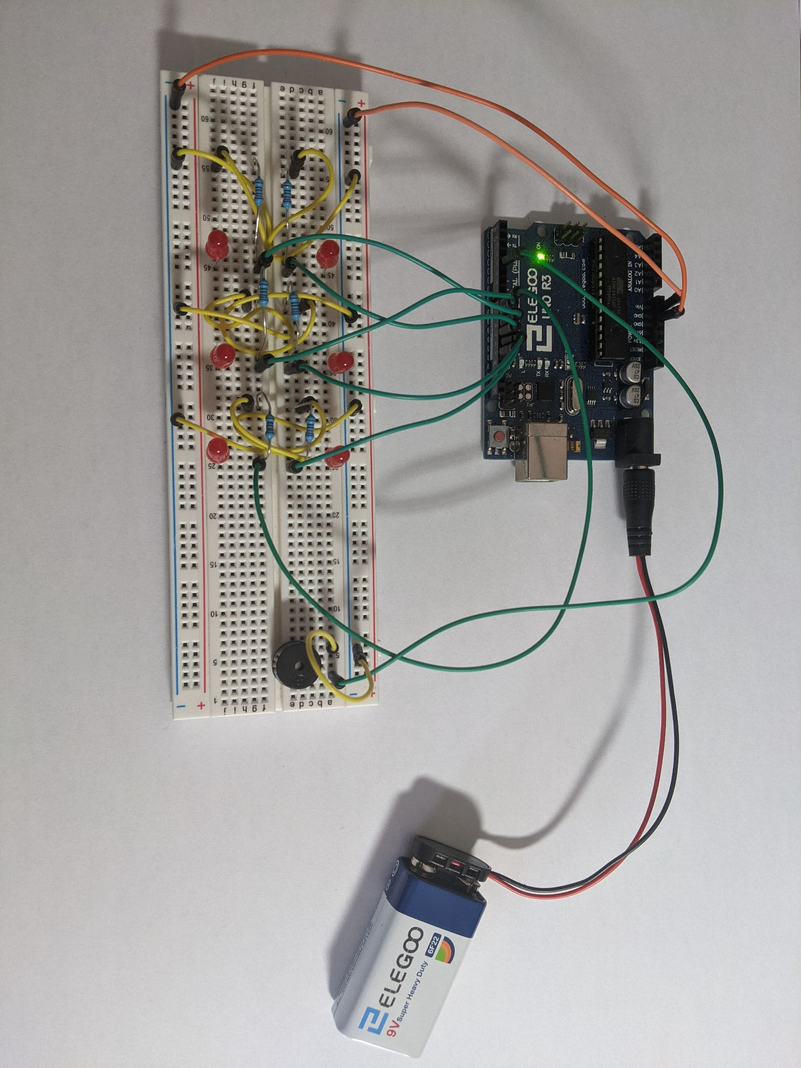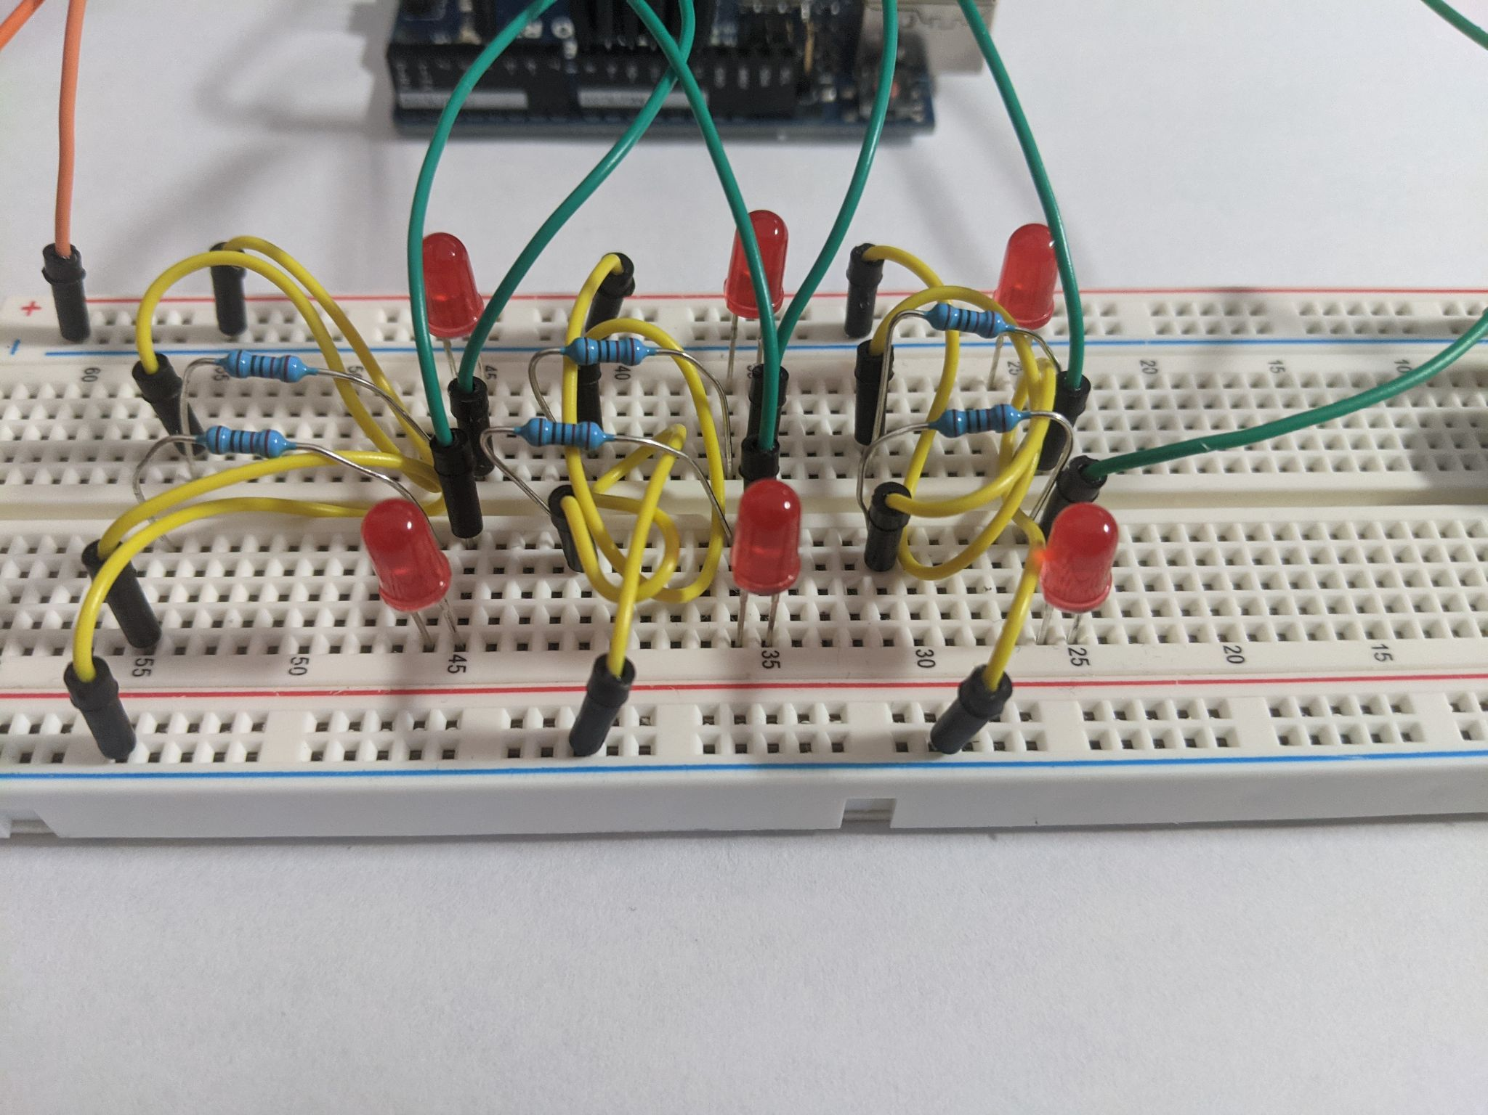
Figure 7: Pic of LEDs connected in the board

