3-minute project pitch
SO WHAT- PROBLEM
Our team is excited to show you our accelerated rock erosion testing apparatus.
Rotating equipment is used in all sorts of industries, such as the energy sector, geologists, and of course nuclear science. These parts are exposed to very high fluid viscosities, which can cause erosion over time. Erosion is also a prevalent issue for today's climate crisis, with increasing temperatures, and ultimately accelerated melting of glaciers and ice caps. This is increasing the water level of oceans and severity of storms; consequently, causing premature rock erosion and costal erosion. To predict the performance of material, a highly accelerated erosion testing apparatus will be constructed so users can predict the performance of a sample. We have been tasked with creating a prototype which mimics a high fluid viscosity, to test which parameters are most influential in causing erosion.
WHO CARES- Benchmarking
We aren’t the first people to design such a project, so we did a lot of benchmarking before starting our Design Process and we discovered a diverse range of potential users including, Research Organizations such as Canadian Nuclear Laboratories, the Government, Farmers and other professionals in Agriculture to name a few.
We learned that older tests such as the 1952 CSIRO accelerated erosion test provided introductory information on erosion testing processes seeing as this test was the first to appraise the quality and durability of earthen construction materials. However, this test failed to effectively portray the real-world conditions. More modern testing processes such as The Rotating Erosion Test Apparatus (RETA) offered more relevant insight for our project. The test utilizes a water-filled rotating outer cylinder to generate shear stress and measure erosion on a sample placed in an annular space. This method really influenced the design we went with as the cylindrical set up was functional and easy to implement.
Benchmarking helped us understand the real-world implications and functionality of the Erosion Testing Device.
WHY YOU & WHY NOW
Our focus throughout the development of this device has been repeatability. To make sure our solution would give repeatable results, we made sure we had precise control of the speed of the motor. We can adjust the speed using a potentiometer to increase or decrease the voltage going to the motor. A hall sensor can detect when the motor makes a full rotation; we are using this along with a program in Arduino IDE to calculate and output the motor's speed in real time. This along with the robust configuration of the bucket, allows any material to be tested. This device will be used to quickly compare different materials’ erosion resistance, so CNL will be able to make more informed decisions on their choice of materials in all their future projects.
Our project revolves around the creation of a prototype for an accelerated rock erosion testing apparatus, aimed at prioritizing, safety, functionality, and repeatability while incorporating engineering principles. Our final deliverable, Prototype III, is a result of rigorous testing, user feedback, and iterative design processes. Our main subsystems are the jug configuration, the motor and rod configuration, and the electronic components.
Throughout our first few prototypes, we implemented the relay switch, and the covers on the Marettes. Our design focuses on repeatability, which is why we have developed a code to measure the RPM. This will allow users to test a variety of different parameters while maintaining others.
SUBSYSTEMS
Jug Configuration
- Home Depot Bucket and Lid
- Plywood
- Baffles
  - 3D printed
    - Promote Aeration
    - Keep additives stirred
Motor and Rod Configuration
- Motor and Chuck
  - 1200 Watts
  - DC 12V
  - Unloaded Speed: 10000 RPM
  - Loaded Speed: 8800 RPM.
- Adherence to Lid
- Hole in Lid

Electrical Components
- Potentiometer
- Speed Controller
- Relay switch
  - Safety
- Battery
  - 3000mAh 12V Lithium Ion
- Arduino
- Hall Sensor
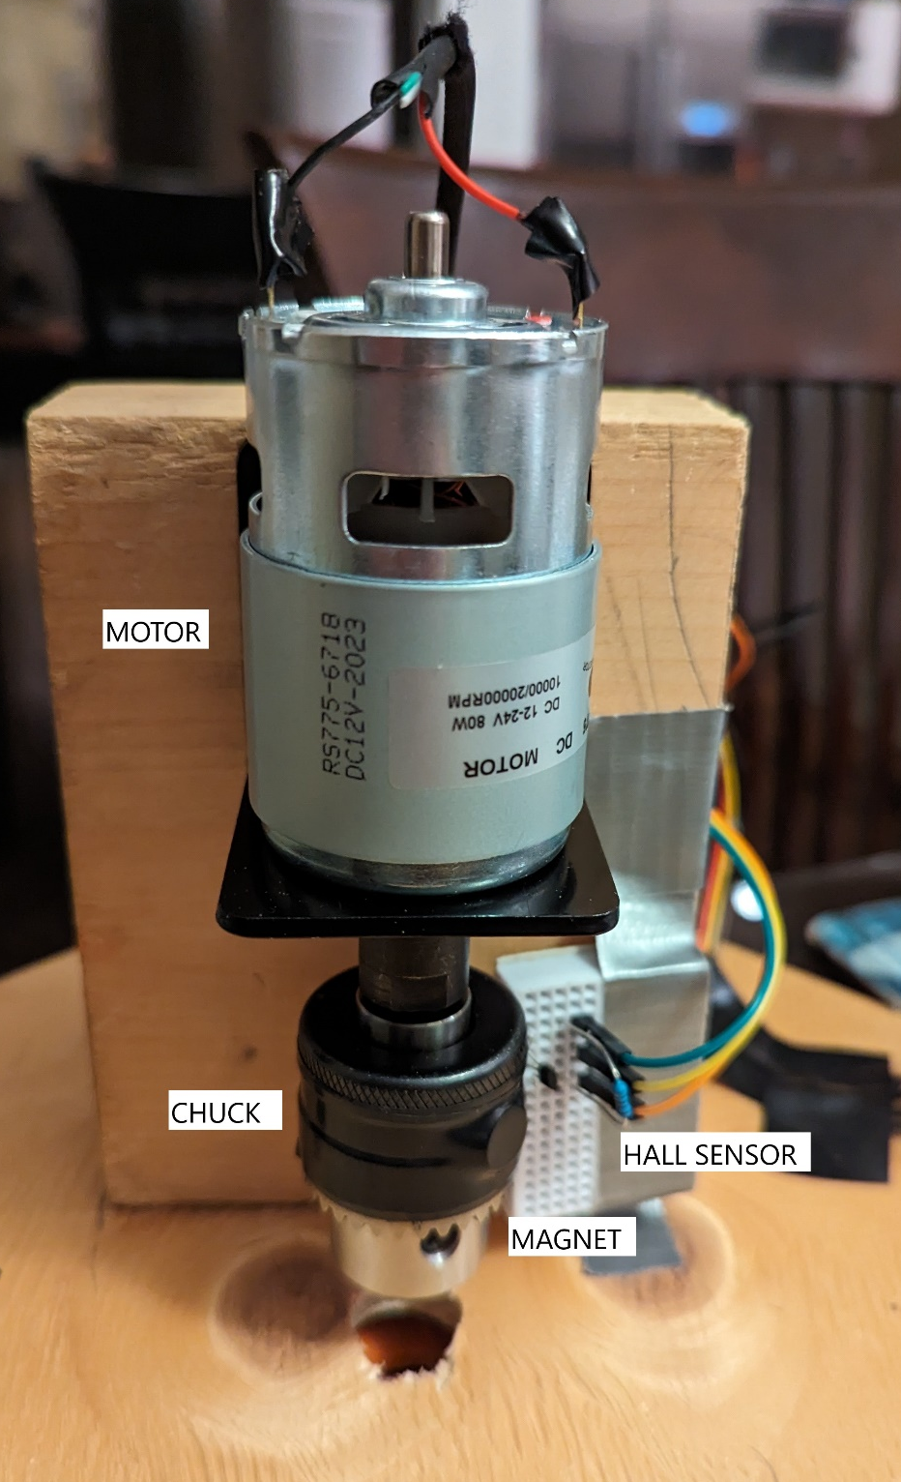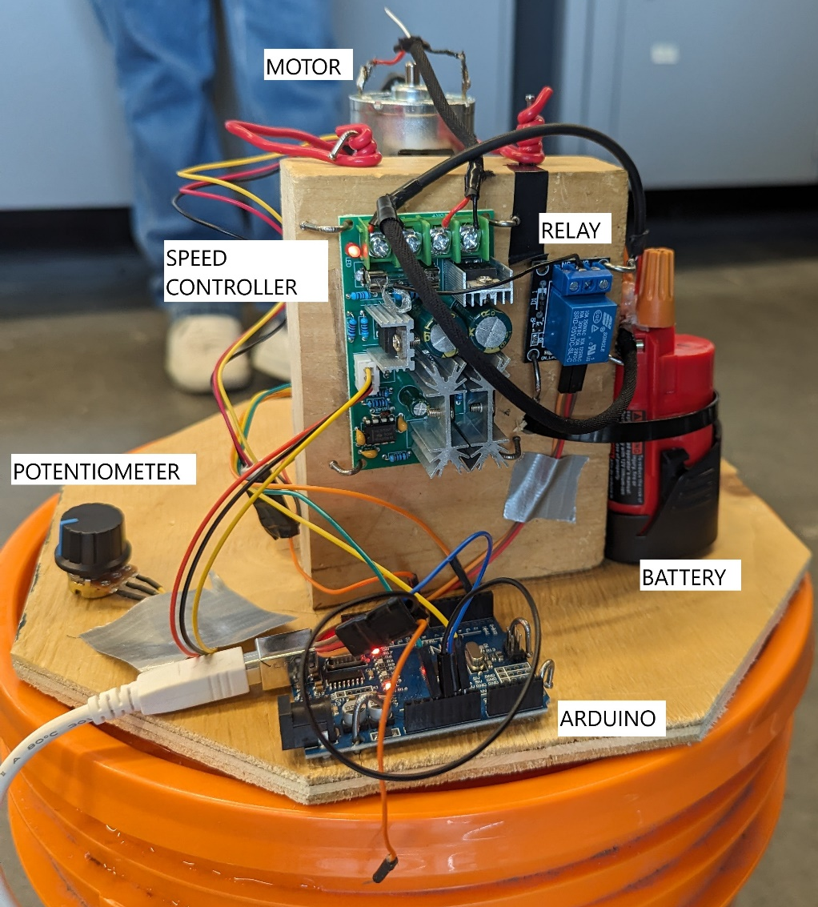
“Canadian Nuclear Laboratories has tasked us with designing and developing an erosion testing system which is safe, economical, durable, and stable. The system must be flexible and repeatable to accommodate different testing parameters to obtain a deeper understanding of how different factors affect the rate of erosion.”
AREA ENGINEERING

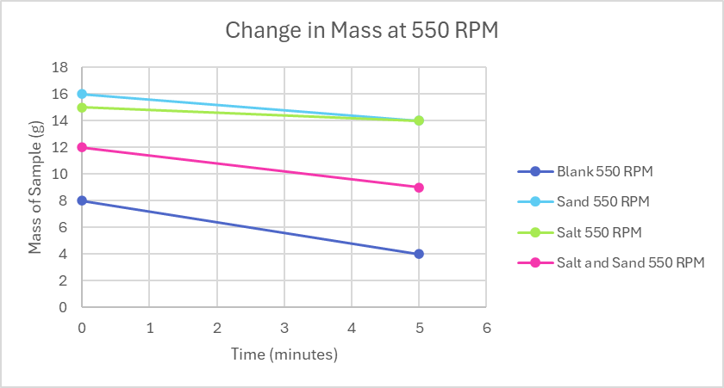
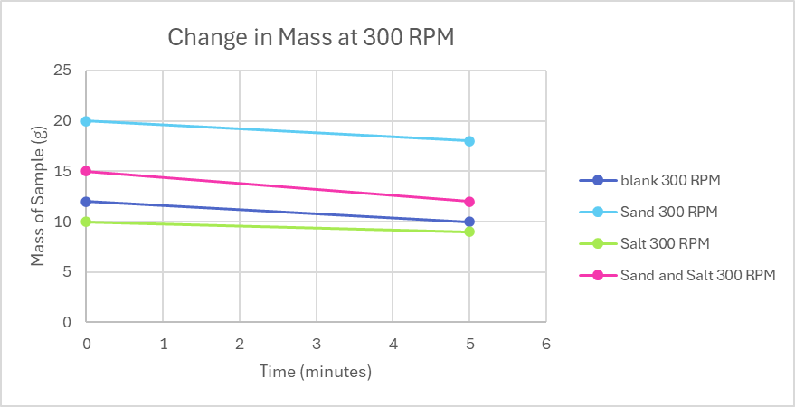
ACCELERATED ROCK EROSION TEST SYSTEM
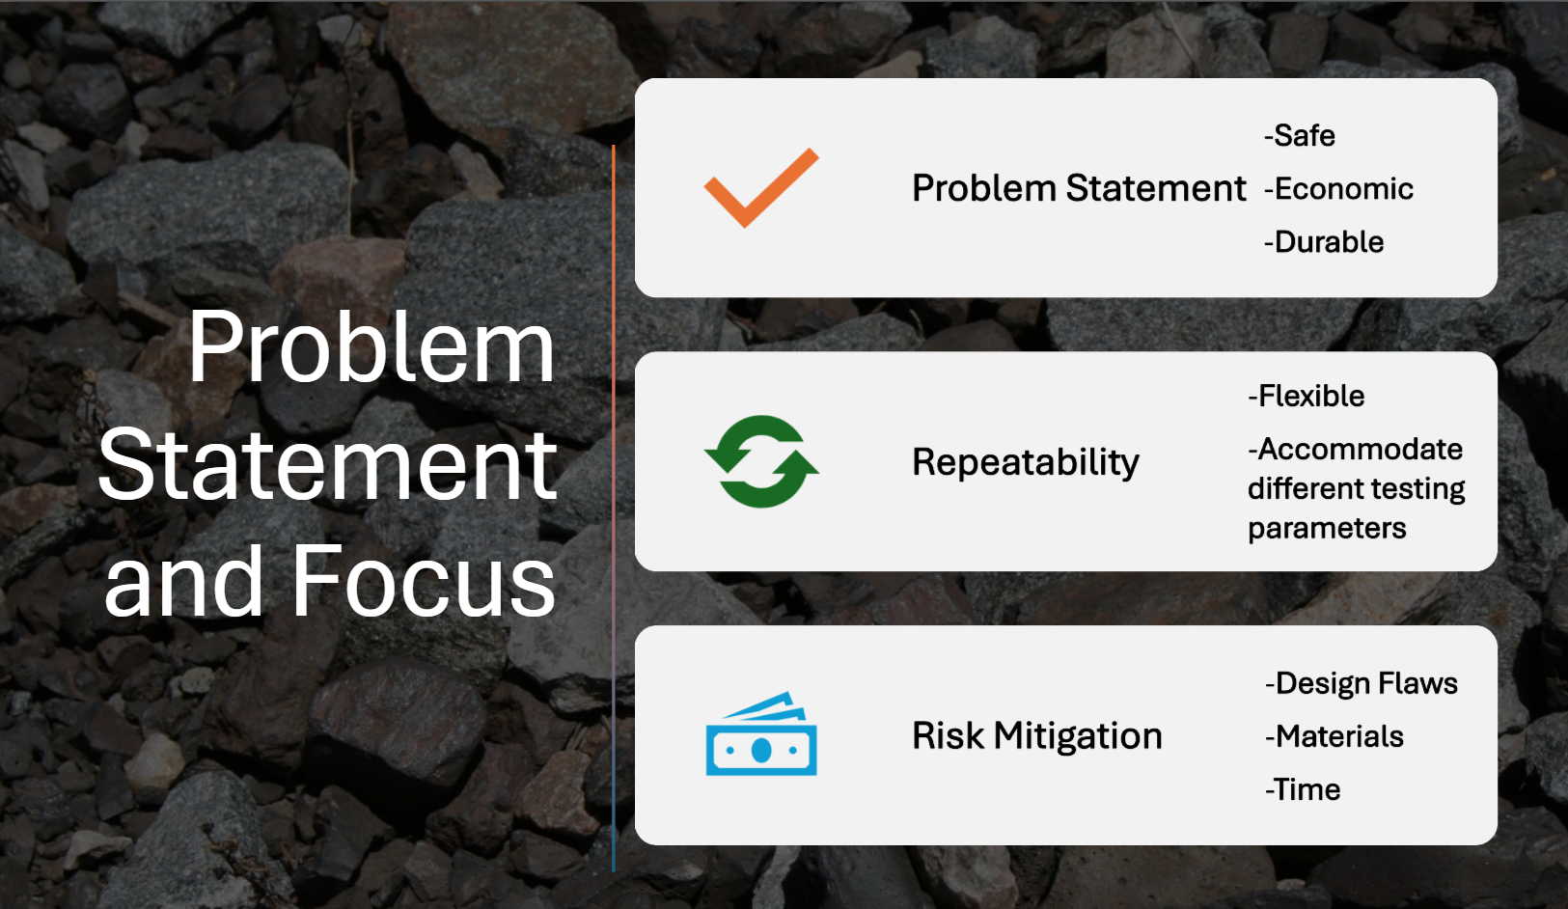

SALT
- 300g Kosher Salt
SAND & GRAVEL
- 300g mixture of sand and gravel
ROTATIONAL SPEED
- 300 and 550 RPM

speed = 300 RPM
 | Minitial (g) | Mfinal (g)
blank | 12 | 10
sand | 20 | 18
salt | 10 | 9
sand and salt | 15 | 12
speed = 550 RPM
 | Minitial (g) | Mfinal (g)
blank | 8 | 4
sand | 16 | 12
salt | 15 | 14
sand and salt | 12 | 9

