GNG5140: Engineering Design

Deliverable C: Design Requirements and Project Plan

Submitted by
Team Opioid Overdose
Ayham AlAkhras 300207406
Min Ju Kim 7296534
Varsha Srinivasan 300157999

February 14, 2021
University of Ottawa

Abstract

The GNG5140 project utilizes a brownfield design approach, meaning that previous work is built upon and elaborated on to recreate and improve the product. This report first introduces opioids and opioid overdose. It then outlines the working of various prototypes of previous work, by considering their key concepts, benefits, and drawbacks. The report then outlines the user testing results performed by the team. The data from testing were examined and a new problem statement was devised, and a new project plan was developed. Design improvements and new design requirements were established.

Table of Contents
Abstract i
Table of Contents ii
List of Figures iv
List of Tables v
List of Acronyms vi
Introduction 7
The Story So Far [1] 7
1 Prototype Testing 8
1.1 Prototype Metrics 8
1.2 Design Features and Flaws 8
1.2.1 Save your Sole [2] 8
1.2.2 O2-POD [3] 9
1.2.3 OP-Watch [4] 10
1.2 Testing Results of Prototypes 11
1.2.1 Save your Sole 11
1.2.2 O2-POD 13
1.2.3 OP-Watch 15
1.2.4 Summary of Results 17
2 Revision of Prototype Requirements 18
2.1 Design Fixes and Improvements 18
2.1.1 Design Fixes 18
2.1.2 Design Improvements 19
2.2 Revised Design Requirements 20
2.2.1 Performance Requirement 20
2.2.2 Non-Performance Requirement 20
2.3 Problem Statement 21
2.4 New Prototypes 21
3 Project Plan 21
Updated Project Plan 22
Conclusions and Recommendations for Future Work 22
Bibliography 24
APPENDICES 25
APPENDIX I: Save your Sole Arduino Code 25
APPENDIX II: O2-POD Arduino Code 26
APPENDIX III: OP-Watch Arduino Code 28

List of Figures
Figure 1. Prototype of Save your Sole 11
Figure 2. Serial Monitor Output of Save your Sole 12
Figure 3. Prototype of O2-POD 14
Figure 4. Serial Monitor Output of O2-POD 14
Figure 5. O2-POD App with Established Bluetooth Connection 15
Figure 6. Prototype of OP-Watch 15
Figure 7. Serial Monitor Output of OP-Watch 16
Figure 8. OP-Watch App with Connection Failure 16
Figure 9. MAX30100 Pulse Oximeter with Built-in Resistors a) in Place, b) Removed 18

List of Tables
Table 1. Save your Sole SpO2 Measurements 12
Table 2. Testing Results 17

List of Acronyms
Acronym | Definition
OD | Opioid overdose
HR | Heart rate
SpO2 | Blood oxygen saturation
GPS | Global Positioning System
USB | Universal Serial Bus
PC | Personal Computer
RR | Respiratory rate
BrPM | Breaths per minute
ML | Machine learning

Introduction

The Story So Far [1]
One of the first steps in designing a prototype for a project is to empathize with the ones who are affected by the problem that the project is trying to solve. The previous deliverable talks about the definition and symptoms of an OD, and its impact on a provincial (Ontario), national (Canada), and global scale.
Deliverable B also reviews three different prototypes of an OD monitor available on MakerRepo. It also talks about the potential issues or risks, as well as areas for improvement of each prototype based on the information available in the user manual of the prototypes.
The deliverable also reports the different metrics, requirements, and specifications for this project. The project metrics and requirements were generated based on the list of requirements that the client and the team discussed during the first client meeting. The target specifications were generated by benchmarking the other prototypes of this project and existing devices on the market that perform similar tasks.
Finally, the deliverable generates a plan to test out the prototypes to determine the quality of their performance. The results from the testing will be discussed later in this report.

1 Prototype Testing

1.1 Prototype Metrics
In order to determine the quality of the tested prototypes, the following metrics from Deliverable B will be used:
- Cost
- Size
- Weight
- Battery life
- Measurement accuracy
- Response time

1.2 Design Features and Flaws
The design features and flaws of the selected prototypes are briefly discussed below, based on the information given in the user manual of each prototype.

1.2.1 Save your Sole [2]
Save your Sole monitors for an OD by measuring SpO2 by placing the MAX30100 pulse oximeter on the user’s foot. The sensor sends the acquired data to an Arduino Nano where the data is processed. The data is then sent to the user’s smartphone via Bluetooth where it is displayed on a companion app. If the user’s SpO2 drops below 90%, it alerts the emergency contacts specified by the user.
The most prominent feature of Save your Sole is the location of the measurement: the foot. Since the prototype is to be place in the user’s shoe – between the footbed/insole and the user’s foot, it will allow for greater discreetness and privacy for the user. Placing the device into the shoe also prevents the sensor from moving around, which can result in inaccurate measurements. Another unique feature of this prototype is the ability to add multiple emergency contacts. This allows for increased safety for the user, by contacting multiple people in case one emergency contact is unable to respond.
One area where Save your Sole comes short is its microcontroller. Rather than using an Arduino Nano, using a microcontroller with integrated Bluetooth modules such as the Arduino Nano 33 BLE or ESP32 will reduce the cost of the device. Also, Arduino Nano 33 BLE and ESP32 have a more powerful processor than the Arduino Nano, so using them will improve the prototype’s performance.

1.2.2 O2-POD [3]
O2-POD monitors for an OD by measuring SpO2 by placing the MAX30100 on the user’s earlobe, placed in contact with the earlobe via a clip. The device also has an ear pod to disguise the device to make it seem like the user is listening to music. The sensor sends the acquired data to an ESP32 where the data is processed. The data is then sent to the user’s smartphone via Bluetooth where it is displayed on a companion app. If the user’s SpO2 drops below 90%, it plays intervening sounds through the ear pod and alerts the emergency contact specified by the user.
O2-POD’s most prominent feature is its intervention system. By attempting to wake up the user, it could reduce the risk of a serious OD before any help arrives.
One area where O2-POD comes short is its alert system. The current prototype only allows for one emergency contact. Adding multiple emergency contacts will greatly reduce the risk of an OD-related death since the system will contact multiple people, especially if the one emergency contact is unavailable.

1.2.3 OP-Watch [4]
OP-Watch monitors for an OD by measuring SpO2 by placing the MAX30100 on the user’s wrist. The sensor sends the acquired data to an ESP32 where the data is processed. The data is then sent to the user’s smartphone via Bluetooth where it is displayed on a companion app. If the user’s SpO2 drops below 90%, it vibrates and plays a sound. The user can press a button if a false positive occurs. If the OD is real, the device contacts the emergency contact and sends the user’s GPS location.
OP-Watch’s most prominent feature is its intervention system. By attempting to wake up the user, it could reduce the risk of a serious OD before any help arrives. Multiple intervention systems could reduce the risk even further.
Similar to O2-POD, one area where OP-Watch comes short is its alert system. The current prototype only allows for one emergency contact. Adding multiple emergency contacts will greatly reduce the risk of an OD-related death since the system will contact multiple people, especially if the one emergency contact is unavailable.

1.2 Testing Results of Prototypes

1.2.1 Save your Sole
The prototype of Save your Sole was not available at Makerspace, but the same hardware components were provided so that it could be reproduced as shown in Figure 1. Therefore, the size and weight of the prototype could not be tested.
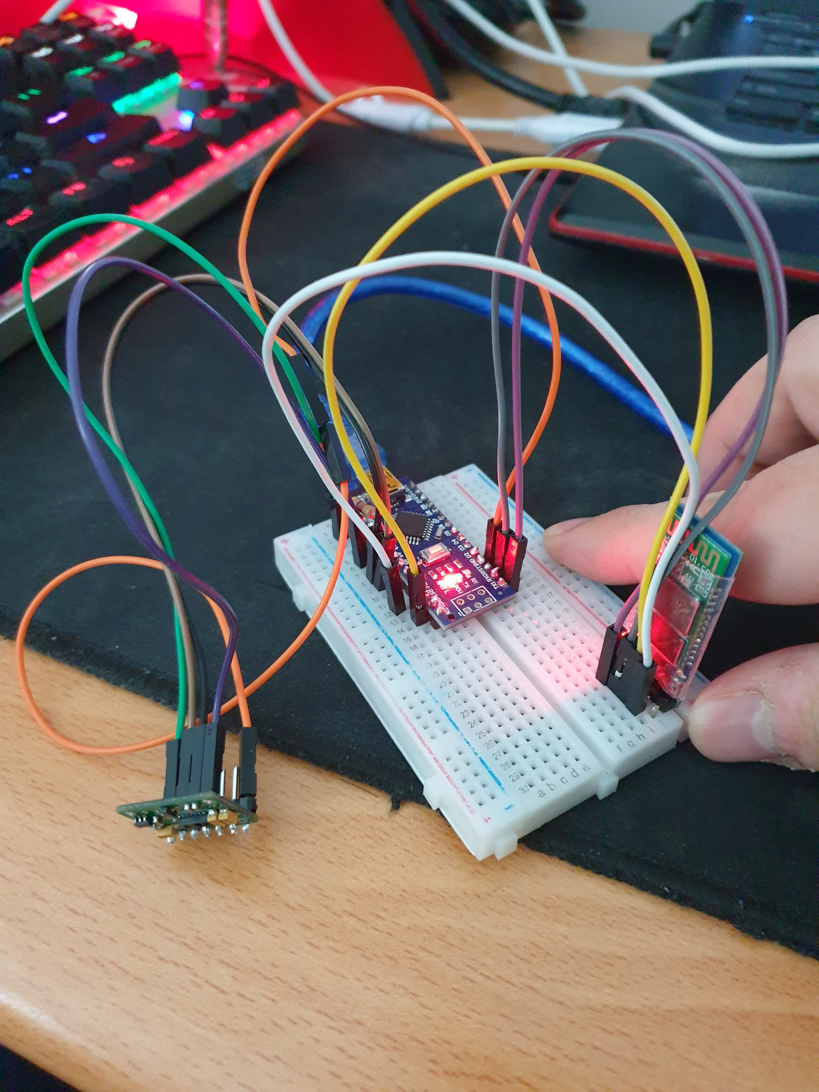
Figure 1. Prototype of Save your Sole
The Arduino code for the prototype was available on MakerRepo and ran successfully, measuring the users’ SpO2. Figure 2 shows the Serial Monitor when running the Save your Sole code, displaying the user’s HR and SpO2.
Figure 2. Serial Monitor Output of Save your Sole
The device was tested on three subjects to measure their SpO2 for 30 seconds to ensure that the device measures accurately. The SpO2 measurements are shown in Table 1.
Table 1. Save your Sole SpO2 Measurements
 | SpO2 (%)
t (seconds) | Participant 1 | Participant 2 | Participant 3
0 | 0 | 0 | 0
1 | 0 | 0 | 0
2 | 0 | 0 | 0
3 | 116 | 0 | 0
4 | 116 | 0 | 109
5 | 116 | 0 | 98
6 | 97 | 97 | 98
7 | 97 | 97 | 98
8 | 97 | 98 | 98
9 | 97 | 98 | 97
10 | 97 | 98 | 97
11 | 98 | 98 | 97
12 | 98 | 98 | 97
13 | 98 | 98 | 97
14 | 98 | 98 | 98
15 | 98 | 98 | 98
16 | 98 | 98 | 97
17 | 98 | 98 | 97
18 | 98 | 98 | 97
19 | 98 | 98 | 97
20 | 98 | 98 | 98
21 | 98 | 98 | 98
22 | 98 | 98 | 98
23 | 98 | 98 | 97
24 | 98 | 98 | 97
25 | 98 | 98 | 97
26 | 98 | 98 | 97
27 | 98 | 98 | 97
28 | 98 | 98 | 97
29 | 98 | 98 | 98
30 | 98 | 98 | 98
It should be noted that the SpO2 measurement of the first 3 seconds were zero. Ideally, there would have been more participants for measurements for more accurate results. Also, these measurements would have been compared to those of a medical grade device, but the current situations would prove difficult to do so.
The mobile application was not available on MakerRepo so its functionality such as the alert system could not be tested.

1.2.2 O2-POD
The hardware component of O2-POD was provided from Makerspace as shown in Figure 3, and the software component were easily found on MakerRepo for testing. However, there was a note stating that the ESP32 microcontroller and the MAX30100 sensor were not functional for the prototype.
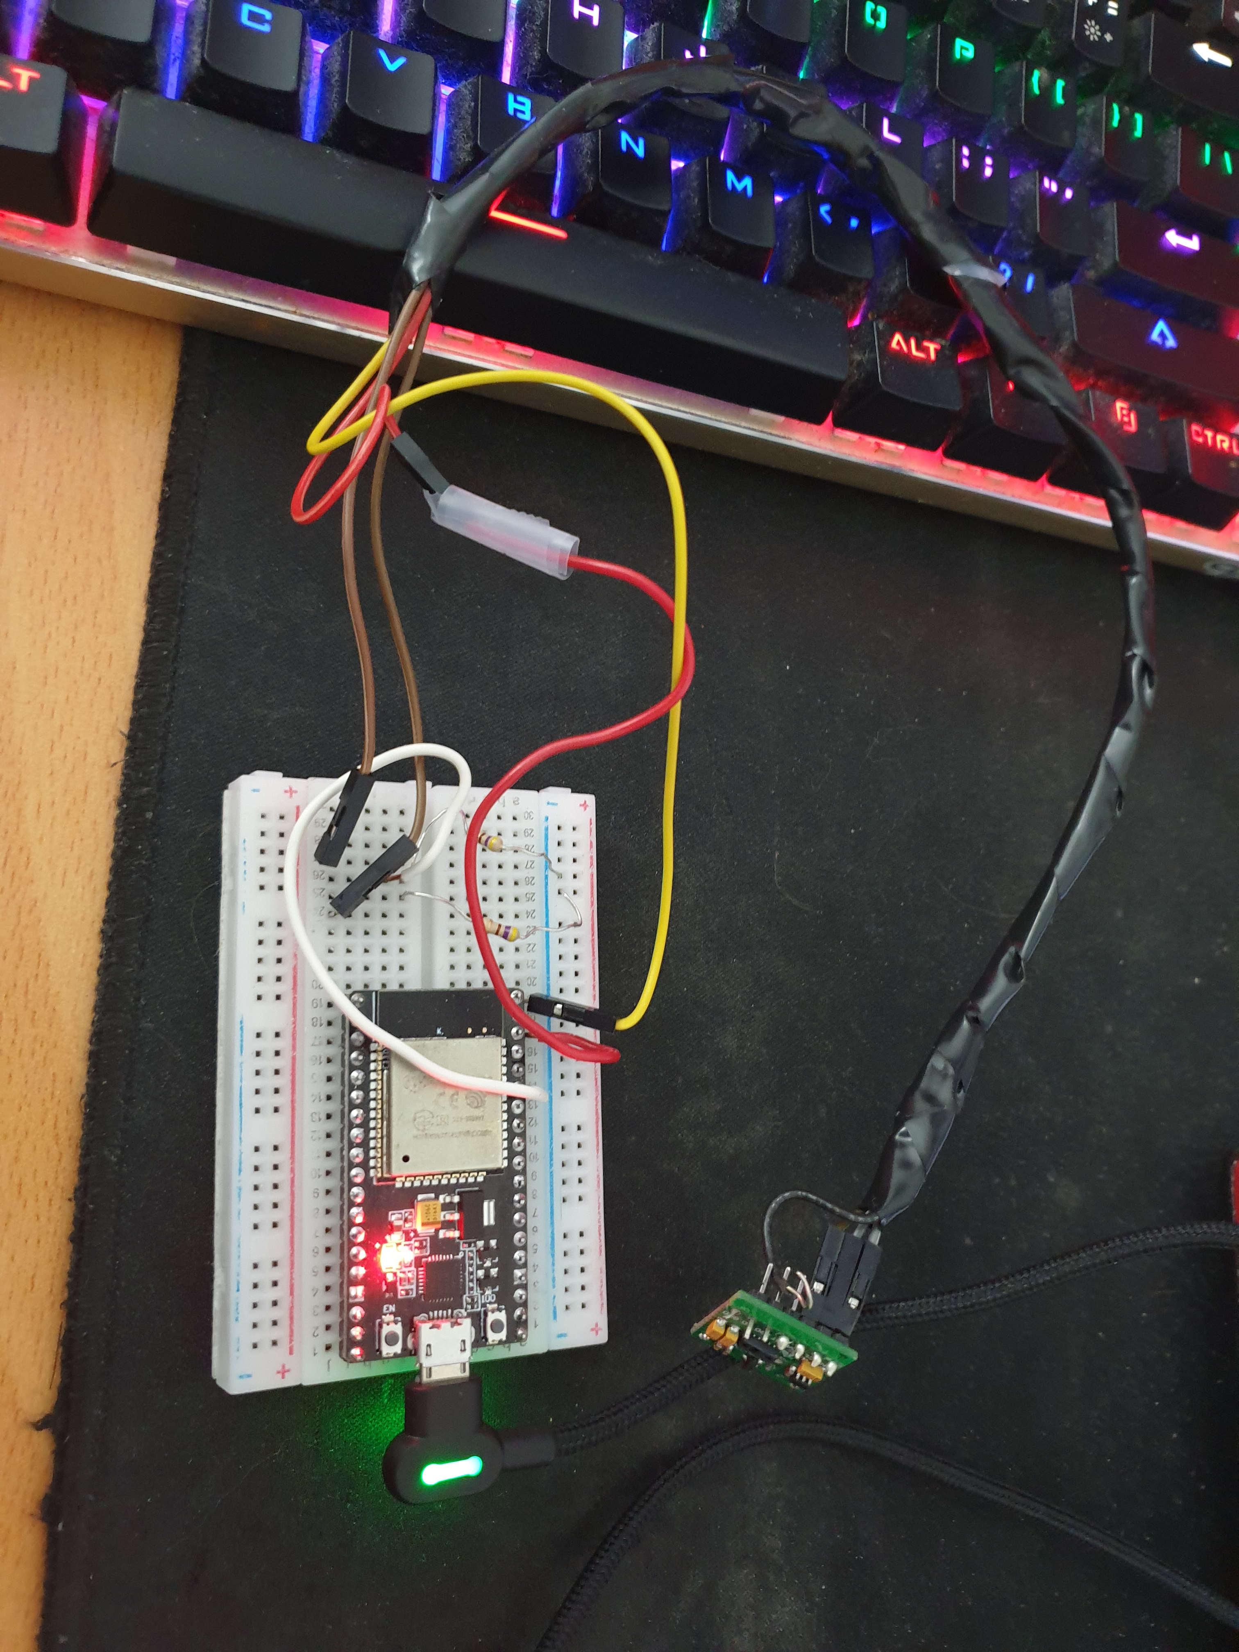
Figure 3. Prototype of O2-POD
Figure 4 shows the Serial Monitor output when running code, showing that microcontroller’s Bluetooth became enabled, but the pulse oximeter failed to operate.
Figure 4. Serial Monitor Output of O2-POD
On the other hand, the mobile app was available on MakerRepo and could be easily installed on a smartphone. The app successfully paired with the device, but because the SpO2 sensor was not working, the alert system of the app could not be tested. Also, the app has a feature where it shows the GPS location coordinates of the user, but the location value did not change if when the devices were connected. Figure 5 shows the app connected with the device.
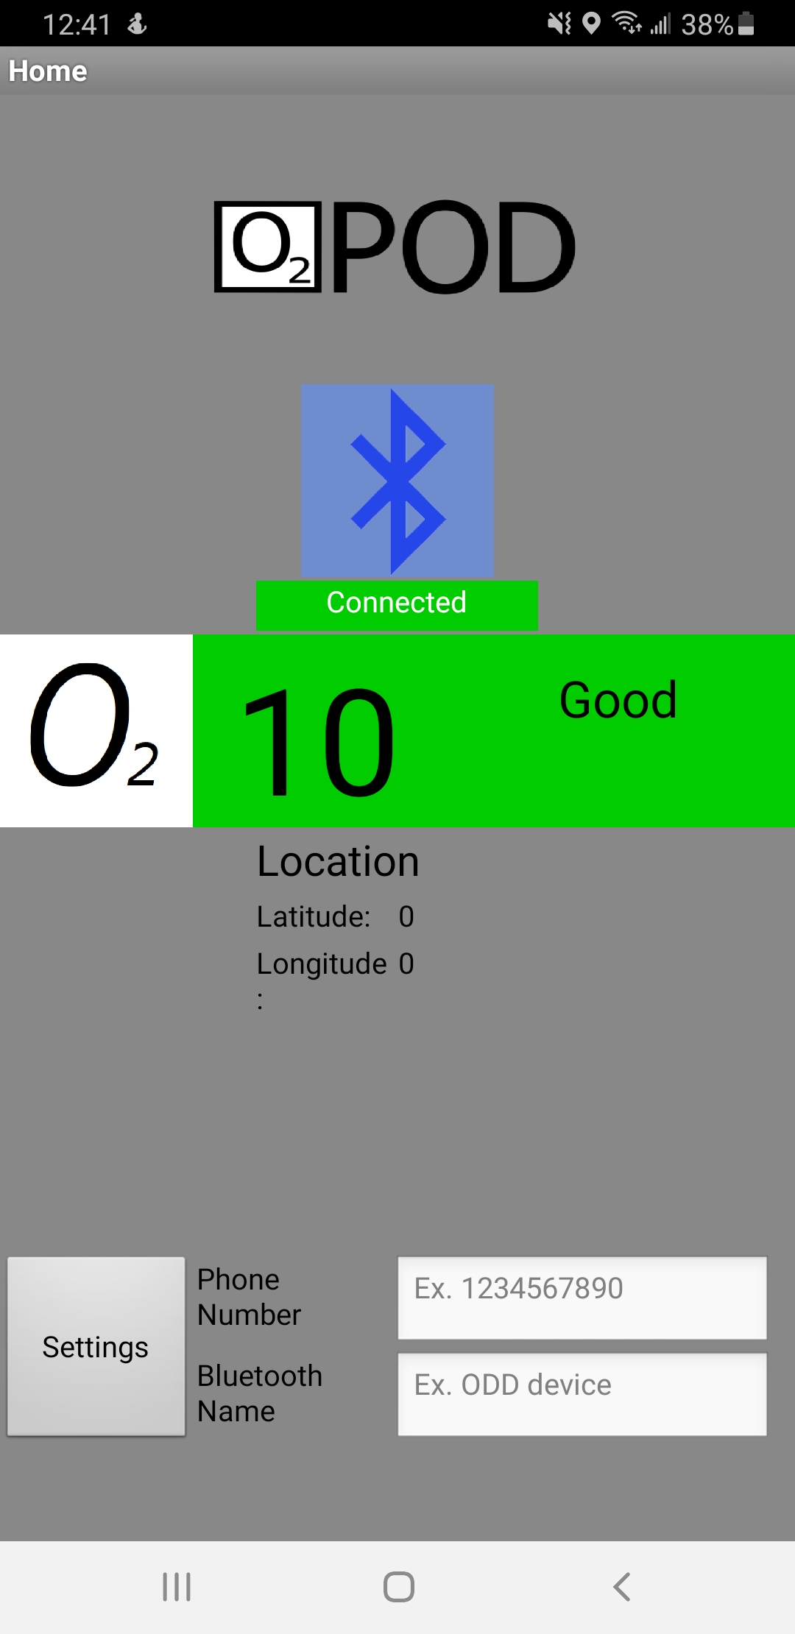
Figure 5. O2-POD App with Established Bluetooth Connection

1.2.3 OP-Watch
Like Save your Sole, the prototype for this project was not available at Makerspace so the hardware components were provided. Therefore, the size and weight of the prototype could not be tested, like Save your Sole. The prototype was replicated as shown in Figure 6 using the parts provided.
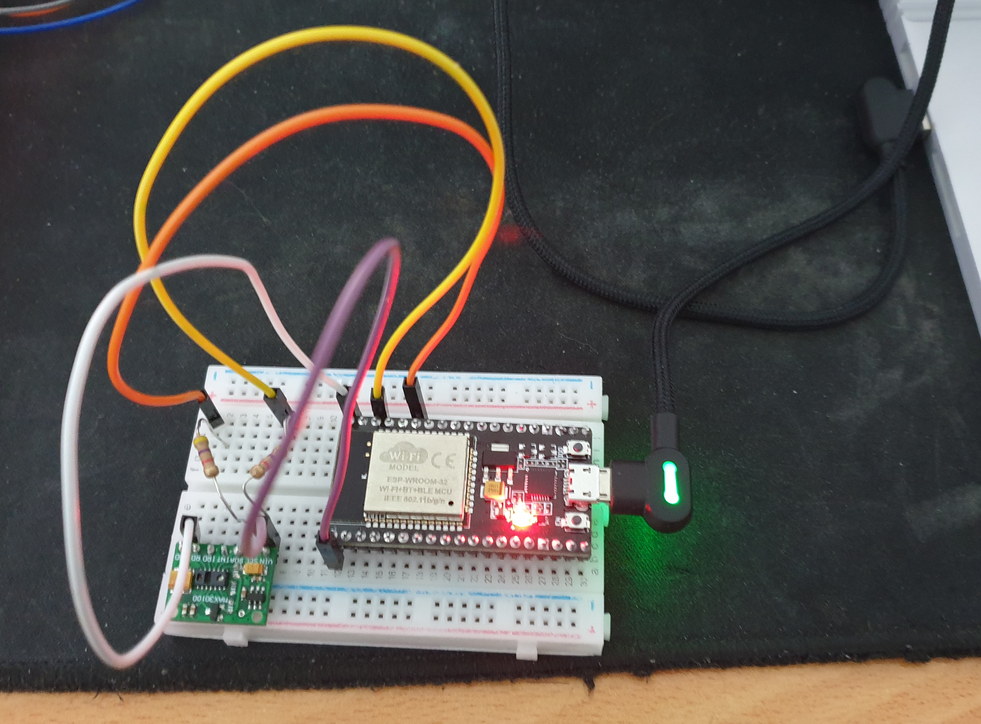
Figure 6. Prototype of OP-Watch
The Arduino code was easily found on MakerRepo and installed onto the ESP32 board, but both Bluetooth and pulse oximeter failed to operate as shown in Figure 7.
Figure 7. Serial Monitor Output of OP-Watch
The app was also easily found on MakerRepo and installed on a smartphone. However, the app was not able to connect to the device because the Bluetooth module of the ESP32 microcontroller was not functional. Figure 8 shows the app after failing to connect to the device.
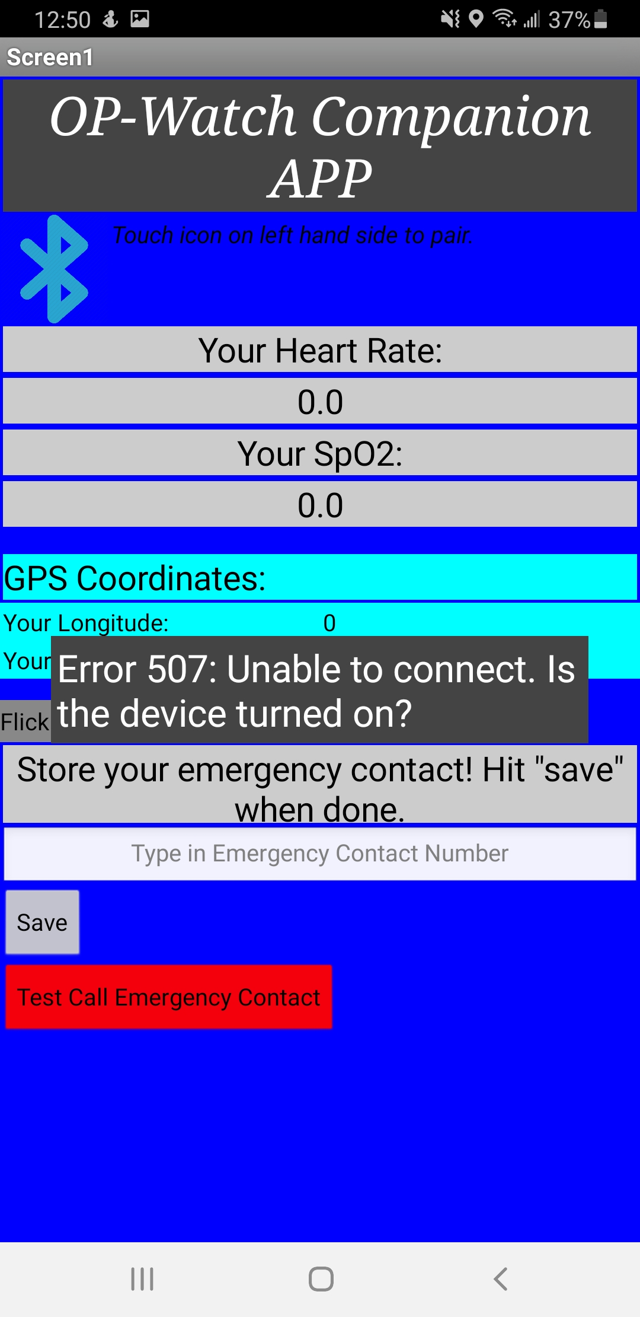
Figure 8. OP-Watch App with Connection Failure

1.2.4 Summary of Results
It should be noted that all three prototypes used the MAX30100 pulse oximeter for measuring SpO2. All three prototypes removed the three built-in resistors on the chip and added external resistors to the circuit.
It should also be noted that all three prototypes planned to be powered by a portable power source such as a battery or a power bank. However, none of the prototypes had such a device and they were powered via USB connection to a PC for testing. Therefore, the battery life of them could not be tested as well.
The summary of testing results obtained from the prototypes is shown in Table 2.
Table 2. Testing Results
Metric | Save your Sole | O2-POD | OP-Watch
Cost (CA$) | 90.50 | 70.17 | 55.86
Size (cm×cm×cm) | N/A | 45×5.3×1.8 | N/A
Weight (g) | N/A | 58 | N/A
Battery Life (hr) | N/A | N/A | N/A
Measurement Accuracy (%) | N/A | N/A | N/A
Response Time (min) | N/A | N/A | N/A

2 Revision of Prototype Requirements

2.1 Design Fixes and Improvements
Since the prototypes produced less-than-stellar testing results, there are plenty of room to fix and improve their designs.

2.1.1 Design Fixes
One method to fix the design is to use another pulse oximeter to the MAX30100. As mentioned before, all three prototypes used the MAX30100 with the built-in resistors removed as shown in Figure 9. This was due to a design problem where the default resistors not being compatible with the voltage supplied by the Arduino Nano or ESP32 [2, 4].
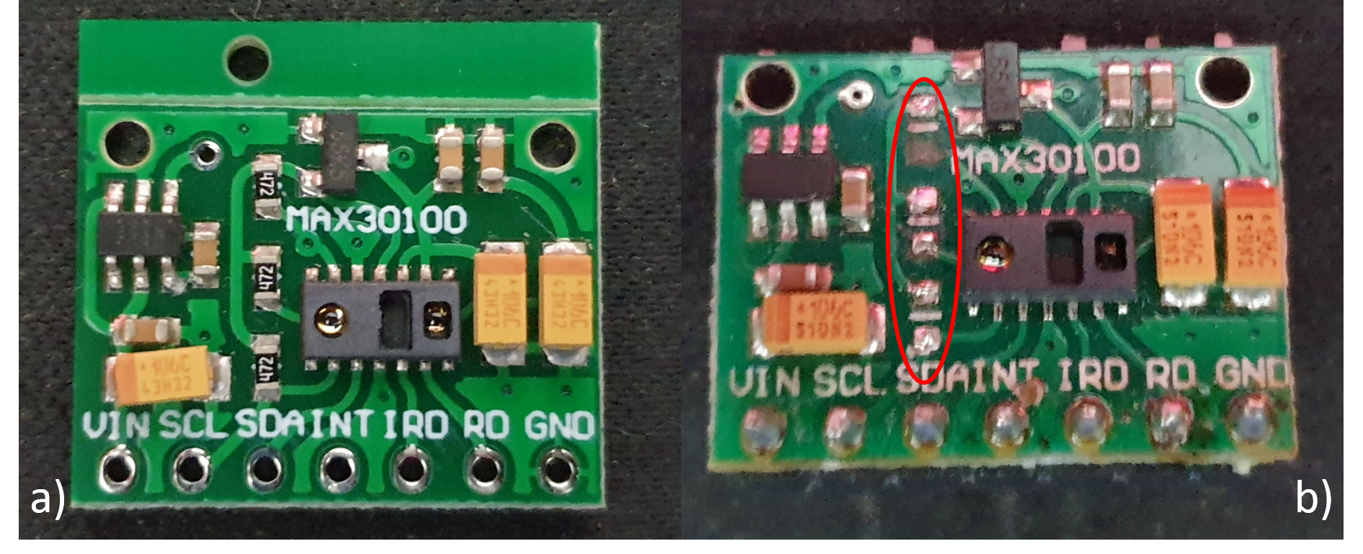
Figure 9. MAX30100 Pulse Oximeter with Built-in Resistors a) in Place, b) Removed
Using a different sensor that is compatible with these microcontrollers such as the MAX30102 or a different version of the MAX30100 such as the GY-MAX30100 may increase the cost, but they will save time and budget for new resistors and eliminate the possibility of potentially damaging the chip while removing the resistors.

2.1.2 Design Improvements
One improvement that could be made to this project is to measure the RR. RR below 10 BrPM is one of the signs that can be easily measured to determine an OD along with SpO2 below 90% [5]. Measuring RR as well as SpO2 will provide a more accurate description of the user’s status compared to only measuring SpO2.
Another improvement is to implement ML into the project. ML can allow for a more accurate signal processing, and to set up a “base” SpO2 and RR for each user. The device can be taught by measuring the SpO2 and RR of the user while they are at rest.

2.2 Revised Design Requirements
The revised design requirements are divided into two sections: performance and non-performance. For the initial list of project requirements, refer to Deliverable B.

2.2.1 Performance Requirement
- The device detects an OD within 3 minutes of occurrence.
- The device allows the user to customize the emergency contact.
- The device is externally activated by the user before the intended usage.
- The device is in contact with the user’s skin while monitoring.
- The device is hand-free while it is monitoring.
- The device connects to the user’s smartphone, displaying the SpO2 and RR measurements.
- The device can operate for a long period of time without recharging.

2.2.2 Non-Performance Requirement
- The device will be small and discreet.
- The cost of the device is below CA$ 100.
- The device is non-invasive.
- The device is comfortably wearable for long periods of time.

2.3 Updated Problem Statement
Design and test an opioid overdose monitoring system that can effectively alert the appropriate parties when a user is experiencing an overdose. It must be discrete, reliable, cost effective, and intuitive.

2.4 New Prototypes
From testing previous projects, the following prototypes are required to effectively evaluate key features of the proposed project:
- Circuit diagram and simulation: a prototype to simply show and test the circuit needed for all sensors and Bluetooth functionality. The simulation will be done on TinkerCAD, an online tool used specifically to test Arduino circuits and components. The prototype will serve as a blueprint for the final circuit and allow the team to predict the output from the circuit and test the Arduino code.
- Physical circuit prototype: utilizing a simple breadboard setup, all circuit components will be implemented and tested in a focused physical prototype. Using the built-in serial monitor in Arduino, the output of the HR monitor can be sent directly to the compiler and the data can be checked for major errors. Furthermore, a Bluetooth connection can be formed to establish data transfer between the Arduino board and a smartphone. This prototype mainly serves as a verification of the circuit simulation and as a method to effectively test the Bluetooth data transfer.
- User interface prototype: this focused analytical prototype consists of a sketch of the user-interface to effectively visualize and evaluate the visual appeal and ease of use of the software.
- Software prototype: this prototype consists of the user interface implemented into a mobile device. While complete measurement functionality is not required, the empty application can be used to further evaluate the intuitiveness and appeal of the user interface.
- Machine learning prototype: the machine learning focused physical prototype tests the RR sonar measurement system to be implemented into the device. This prototype does not require a user interface or any functionality beyond RR measurement and results display. It serves as a crucial tool to help evaluate the validity of the RR measurement.
- Ergonomic prototype: this physical focused prototype will consist of simple crafting materials such as foam and cardboard and will help evaluate the comfort and discretion of different ergonomic designs.
- Comprehensive prototype: this prototype will be presented at design day and will combine all aspects of the opioid overdose monitoring system to create a fully functioning device that effectively tracks a user’s HR and RR. The circuit will be finalized and soldered together to insure a reliable connection. A simple exterior module to hold all components will also be utilized based on the ergonomic prototype. Then, the mobile application including user interface and RR measurement system will be finalized and paired to the exterior device.

3. Project Plan
The Project begins with the first team meeting followed by a thorough literature survey. A client meeting was set up to understand the client and user expectations to identify metrics and establish benchmarks. A document on design research [1] was developed which included the test plan and performance comparison.
Weekly team meetings monitor the progress of the project and helps in resolving any potential threats to milestones. A new problem statement was created based on the results of the existing modules and user testing results. With access to the existing prototypes, the project plan had minor changes leading to the development of an updated plan which was portrayed as a Gantt Chart.

3.1 Updated Project Plan
The figure below is the Gantt Chart with major milestones included in it. 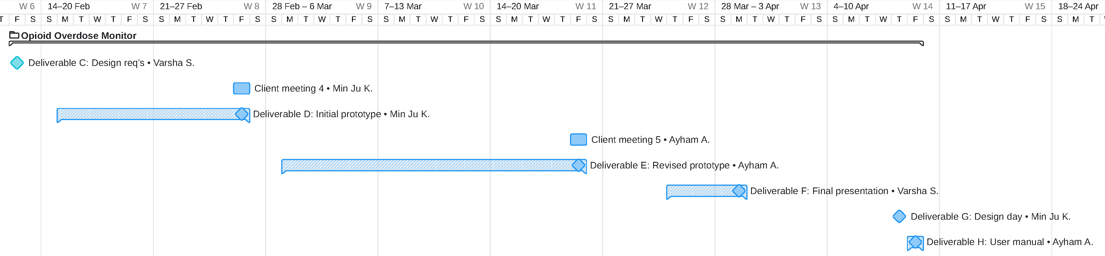

4. Conclusions and Recommendations for Future Work
The previous prototypes provided an insight to the working of various design modules and helped us better understand the difficulties based on user test results. Based on the client’s requirements, we understood that the device has to be discrete, reliable, cost effective, and intuitive.
A list of updated design metrics, project specifications and constraints were generated using the data acquired during this research. A project plan for these prototypes were also generated based on the information acquired from previous physical modules, and a physical test was done to evaluate the result of user testing.
Future works would involve creating various prototypes and performing Black box and White box testing according to the test plan developed by the team. User testing and further feedback for the prototypes will be received from the client after these prototypes are presented.

Bibliography

[1] AlAkhras, A., Kim, M. J., Srinivasan, V., (2021). GNG5140: Engineering Design Deliverable B: Design Research.

[2] Pennington, B., Piro, T., Karner, T., Zahiri, H. C. (2020). Save your Sole: User Manual. Retrieved from https://makerepo.com/Brendan9Penn/save-your-sole-c01-team-c3

[3] Nasr, A., Trela, D., Sheykholeslami, P., Romana, R., Stojanovic, V. (2020). Opioid Overdose Monitoring Device User Manual. Retrieved from https://makerepo.com/rikkiromana/o2pod-anopioid-overdose-monitoring-device-c6

[4] Baig, A., Ahmad, B., Al-Zaidi, A., Onoruvwe, D., Elmasry, Y. (2020). OP-Watch – Opioid Overdose Detection Device. Retrieved from https://makerepo.com/AbdelSB/c7-opwatch

[5] Cahill, T. (2020). Canada’s Overdose Crisis [PowerPoint slides]. Ottawa, ON.

APPENDICES

APPENDIX I: Save your Sole Arduino Code

#include <CircularBuffer.h>
#include <MAX30100.h>
#include <MAX30100_BeatDetector.h>
#include <MAX30100_FIlters.h>
#include <MAX30100_PulseOximeter.h>
#include <MAX30100_Registers.h>
#include <SoftwareSerial.h>

#define REPORTING_PERIOD_MS 1000

SoftwareSerial EEBlue(10, 11);
PulseOximeter pox;
uint32_t tsLastReport = 0;

void onBeatDetected() {
Serial.println("Beat!");
}

void setup() {
// put your setup code here, to run once:
Serial.begin(115200);
Serial.print("Initializing pulse oximeter...");

if(!pox.begin()){
Serial.println("FAILED");
} else {
Serial.println("SUCCESS");
}

pox.setIRLedCurrent(MAX30100_LED_CURR_7_6MA);
pox.setOnBeatDetectedCallback(onBeatDetected);

Serial.begin(9600);
EEBlue.begin(9600);
//Serial.println;
}

void loop() {
// put your main code here, to run repeatedly:
pox.update();

if(millis() - tsLastReport > REPORTING_PERIOD_MS){
Serial.print("Heart rate: ");
Serial.print(pox.getHeartRate());
Serial.print("BPM / SPO2: ");
Serial.print(pox.getSpO2());
Serial.println("%");

tsLastReport = millis();
}

if (EEBlue.available()){
Serial.write(EEBlue.read());
}

if (Serial.available()){
EEBlue.write(Serial.read());
}
}

APPENDIX II: O2-POD Arduino Code

#include <Wire.h>
#include "MAX30100_PulseOximeter.h"

#include "BluetoothSerial.h"

#if !defined(CONFIG_BT_ENABLED) || !defined(CONFIG_BLUEDROID_ENABLED)
#error Bluetooth is not enabled! Please run `make menuconfig` to and enable it
#endif

BluetoothSerial SerialBT;
#define REPORTING_PERIOD_MS 1000

// PulseOximeter is the higher level interface to the sensor
// it offers:
// * beat detection reporting
// * heart rate calculation
// * SpO2 (oxidation level) calculation
PulseOximeter pox;

uint32_t tsLastReport = 0;

// Callback (registered below) fired when a pulse is detected
void onBeatDetected()
{
Serial.println("Beat!");
}

void setup()
{
Serial.begin(115200);
SerialBT.begin("ESP32test"); //Bluetooth device name
Serial.println("The device started, now you can pair it with bluetooth!");
Serial.print("Initializing pulse oximeter..");

// Initialize the PulseOximeter instance
// Failures are generally due to an improper I2C wiring, missing power supply
// or wrong target chip
if (!pox.begin()) {
Serial.println("FAILED");
for (;;);
} else {
Serial.println("SUCCESS");
}

// The default current for the IR LED is 50mA and it could be changed
// by uncommenting the following line. Check MAX30100_Registers.h for all the
// available options.
// pox.setIRLedCurrent(MAX30100_LED_CURR_7_6MA);

// Register a callback for the beat detection
pox.setOnBeatDetectedCallback(onBeatDetected);
}

void loop()
{
// Make sure to call update as fast as possible
pox.update();

// Asynchronously dump heart rate and oxidation levels to the serial
// For both, a value of 0 means "invalid"
if (millis() - tsLastReport > REPORTING_PERIOD_MS) {
Serial.print("Heart rate:");
Serial.print(pox.getHeartRate());
Serial.print("bpm / SpO2:");
Serial.print(pox.getSpO2());
Serial.println("%");
SerialBT.write(pox.getSpO2());
tsLastReport = millis();
}
}

APPENDIX III: OP-Watch Arduino Code

#include <CircularBuffer.h>
#include <MAX30100.h>
#include <MAX30100_BeatDetector.h>
#include <MAX30100_Filters.h>
#include <MAX30100_PulseOximeter.h>
#include <MAX30100_Registers.h>
#include <MAX30100_SpO2Calculator.h>

#include <Wire.h>
#include "MAX30100_PulseOximeter.h"

#define REPORTING_PERIOD_MS 1000

PulseOximeter pox;

uint32_t tsLastReport = 0;

void onBeatDetected()
{
Serial.println("Beat!");
}

#include "BluetoothSerial.h"

#if !defined(CONFIG_BT_ENABLED) || !defined(CONFIG_BLUEDROID_ENABLED)
#error Bluetooth is not enabled! Please run `make menuconfig` to and enable it
#endif

BluetoothSerial SerialBT;

void setup()
{
Serial.begin(115200);

Serial.print("Initializing pulse oximeter..");

// Initialize the PulseOximeter instance
// Failures are generally due to an improper I2C wiring, missing power supply
// or wrong target chip
if (!pox.begin()) {
Serial.println("FAILED");
for(;;);
} else {
Serial.println("SUCCESS");
}

pox.setOnBeatDetectedCallback(onBeatDetected);

SerialBT.begin("ESP32test"); //Bluetooth device name
Serial.println("The device started, now you can pair it with bluetooth!");
}

void loop()
{
// Make sure to call update as fast as possible
pox.update();

// Asynchronously dump heart rate and oxidation levels to the serial
// For both, a value of 0 means "invalid"
if (millis() - tsLastReport > REPORTING_PERIOD_MS) {
SerialBT.print("");
SerialBT.print(pox.getHeartRate());
SerialBT.print(" bpm");
SerialBT.print("|");
SerialBT.print("");
SerialBT.print(pox.getSpO2());
SerialBT.println(" %");

Serial.print("Heart rate:");
Serial.print(pox.getHeartRate());
Serial.print("bpm");
Serial.print("|");
Serial.print("SpO2:");
Serial.print(pox.getSpO2());
Serial.println("%");

tsLastReport = millis();
}
}

