Project Deliverable G:
Prototype II and Customer Feedback

University of Ottawa
GNG1103: Engineering Design
Group 10

March 10, 2024

Catherine Satoh (300351169)
Fahad Husain (300361090)
Jennifer Campbell (300359940)
Manning Whitby (300118220)
Reese Jenkins (300393859)

Table of Contents
1.0 Introduction 3
2.0 Client Meeting Results & Feedback 3
3.0 Prototype II 3

1.0 Introduction
Mines Action Canada needs an accessible VR experience and a short video (1 min) demonstrating the dangers and ethical concerns of autonomous weapons and how civilians adapt their environment to survive. Our initial design criteria were created based on our first meeting with the client. The criteria included communicating the ethical and moral consequences of failed autonomous weapons, generating an emotional response in users, and ultimately inspiring the preemptive banning of autonomous killer weapons. After two more meetings with the client, we narrowed down our storyline and created our VR environment. We have generated a plan for our next prototype and established testing objectives.

2.0 Client Meeting Results & Feedback
Our previous client meeting was successful. We shared our entire presentation and received feedback. Our clients advice was to concentrate on a few specific ethical issues to avoid being too vague. Since the meeting we have decided to focus on the bias and lack of accountability issues with AI autonomous weapons. In our project, the AI has been designed to target military soldiers. Our protagonist (user) fits the stereotypical soldier mold being an able-bodied strong male. Therefore, he is unable to go outside of this protected house without being targeted by the killer robots. Throughout the video, the dialog will share how the protagonist has no one to blame for the tragedies caused by the killer robots.

3.0 Prototype I
Table 1: Test objective of Prototype 1
Test Objectives (Why) | Description of Prototype used and of Basic Test Method (What) | Description of Results to be Recorded and how these results will be used (How) | Estimated Test duration and planned start date (When) | Results
Emotional Response | Find general public’s opinion by using people to view our environment | Comments, (High, Medium, Low)  How do you feel? Make a survey | From first prototype until final design (2 weeks) | 3.18/5  See data (Figure 1)
Ethical Concerns | Find general public’s opinion by using people to view our environment | Gather comments from survey  Make a checklist | Week – 2 weeks | 3.27/5  See data (Figure 2)
Length of Video | Check as a team and cut down if needed | Check video length on editor | 1 minute approx. per test | N/A
Effectiveness of Objects (convey a message?) | Find general public’s view on what it conveys | Get them to try the VR and describe what they understood from each object | When prototype has been completed all the way to final prototype | 4.45/5  See data (Figure 1)

3.1 Description of Results Prototype I
Table 2: Raw Data from Sample Users
Sample User Number | How Strong was your Emotional Response? (1-5) | How Clear were the Ethical Concerns? (1-5) | Was the Story Easy to Follow? (1-5)
1 | 3 | 3 | 5
2 | 5 | 4 | 5
3 | 4 | 4 | 5
4 | 3 | 1 | 4
5 | 3 | 3 | 5
6 | 2 | 2 | 5
7 | 1 | 3 | 5
8 | 2 | 5 | 3
9 | 5 | 4 | 5
10 | 4 | 3 | 4
11 | 3 | 4 | 3

Figure 1: Average values of the Sample Users Feedback
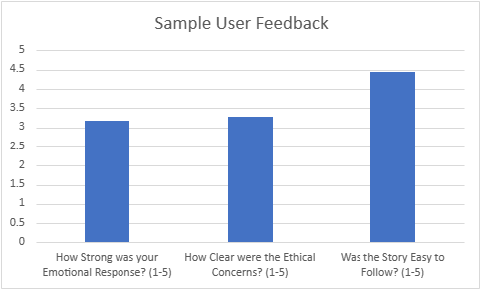

PEER FEEDBACK
- The presentation content was well-structured Good explanation of storyline. No hand gestures or purposeful movement
- They were well prepared!, Good Job!
- Not enough eye contact
- Please speak louder next time and maybe be more interactive next presentation. Content is great.
- the presentation was well constructed
- Asked questions for the clients at the end
- The presentation was well crafted, especially the powerpoint. The presenters articulated well and explained their project in detail. Their storyline was interesting, and I especially liked the drawing of the child showing the fear of the outside world. They left time to ask questions to the client which was a good touch considering the point of this meeting.
- Nice and clear presentation, slides are a bit full
- A bit too much writing on the slides, given the time to present it, but otherwise really clean!
- Their project seems to be overwhelming to get done for a one minute video, and it seems they feel that way based off the end of their presentation
- Good use of time, well-explained, visuals are great. Some slides have too much text for how much time is spent on each slide.
- Good presentation
- good points, and asked lots of questions.
- They asked the clients if they had simplified their project.
- Good - Presented well with confidence and presentation was formal and neat.
Bad- Only two of the the 6 group members talked and they went over time.
- It wasn't really detailed but it was good
- I was a little nervous and fidgety but presentation was fairly understandable minimal feedback got through storyline, goals, and previous feedback a lot of visuals time for questions was good
- Good presentation, and shows visuals of the environment, and elaborates on the story line well.
- clear and concise when discussing the project and the different aspects that went into it
- well developed storyline and visuals. well done research.
- You knew what you wanted to talk about very clearly, however I think when speaking talking slower would allow your points to be stronger.
- Not the best feedback from clients.
- Had good questions.

4.0 Prototype II (screenshots)
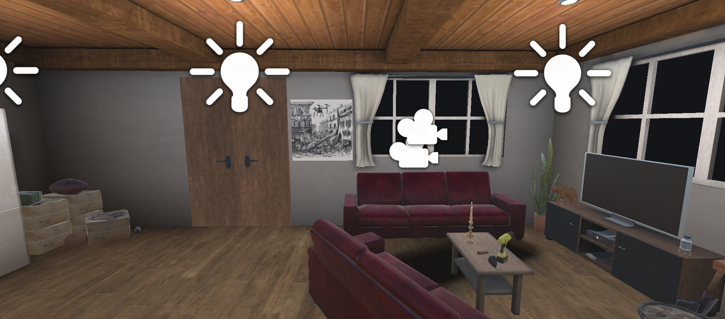
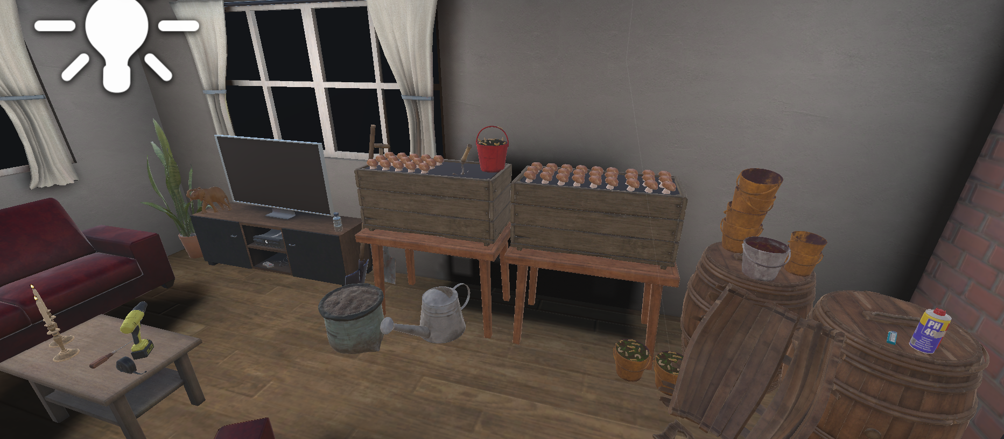
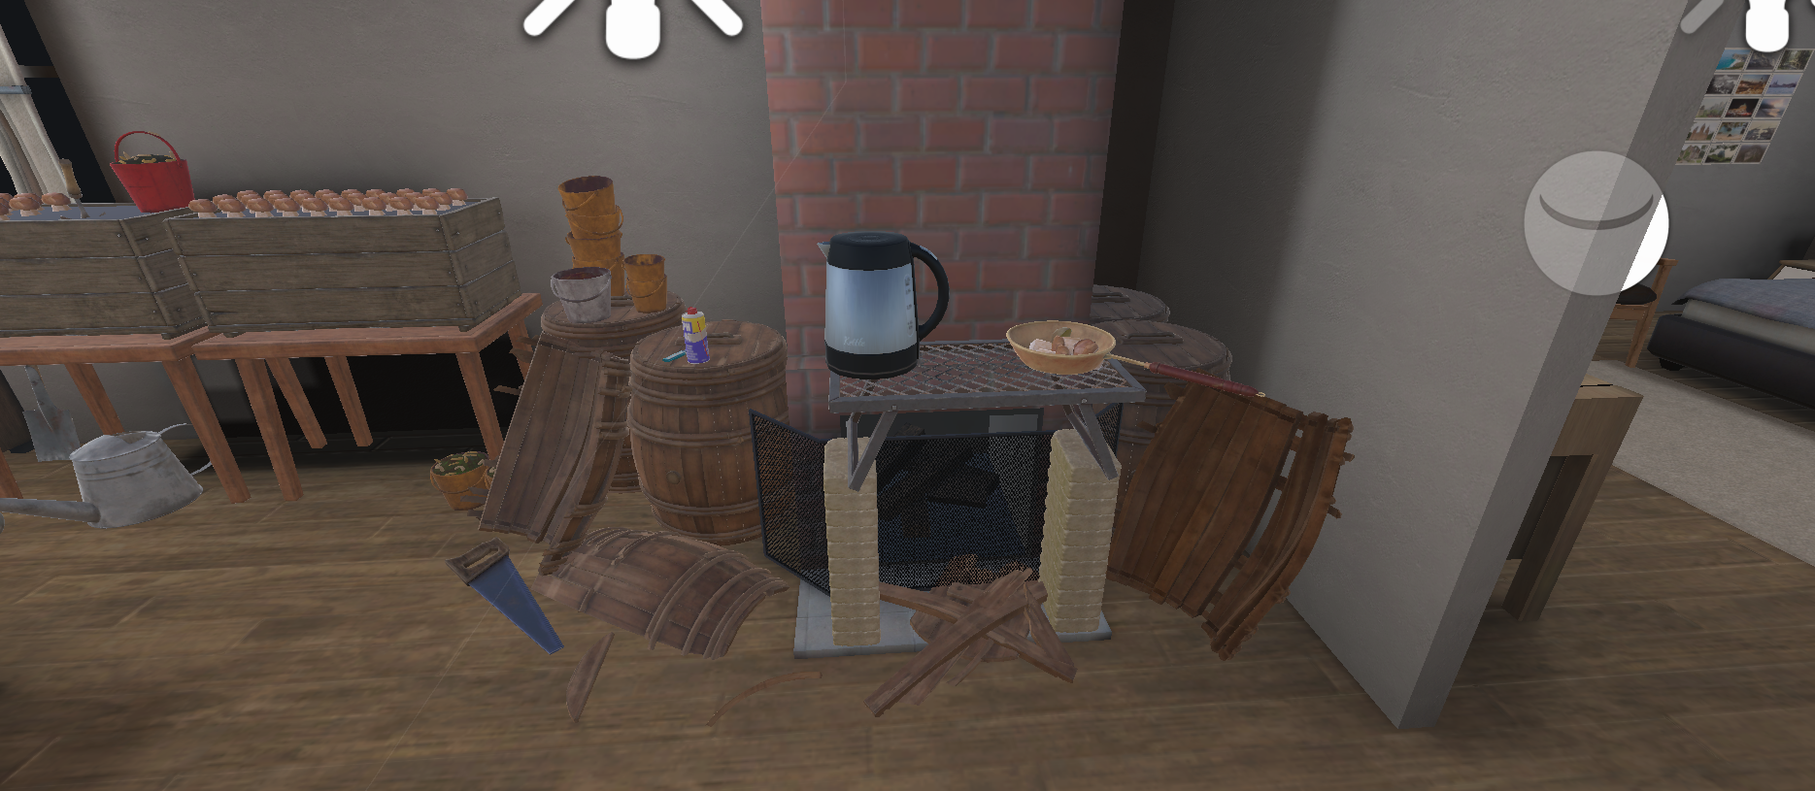
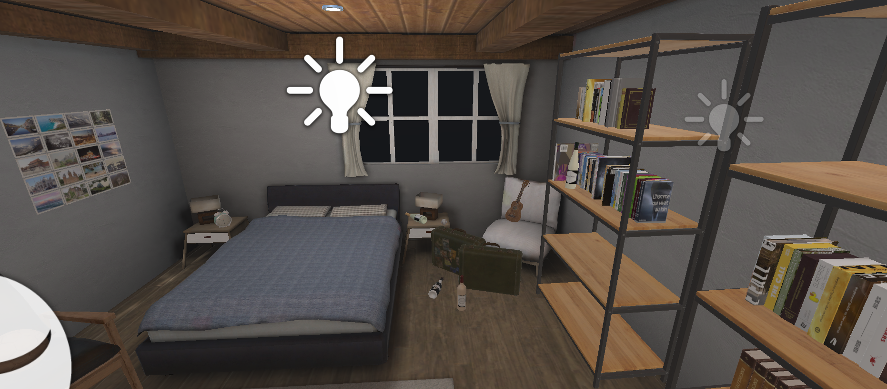
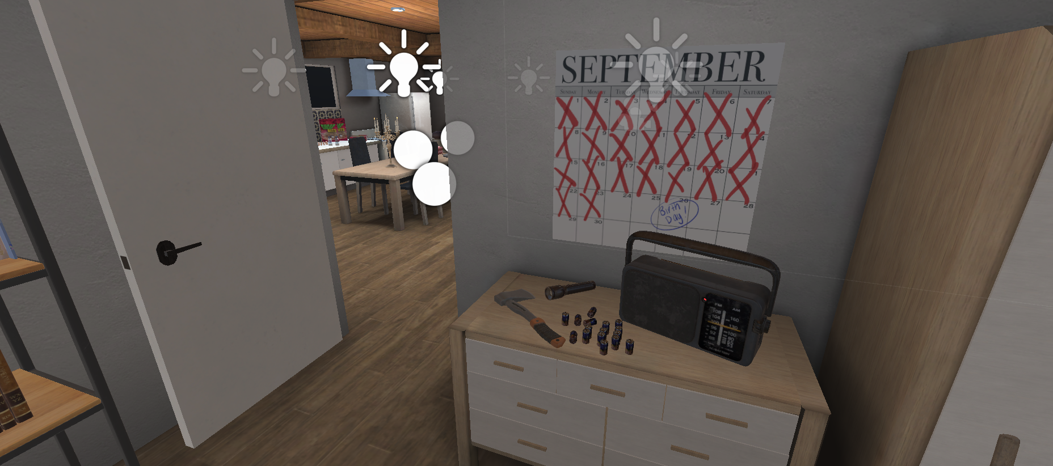

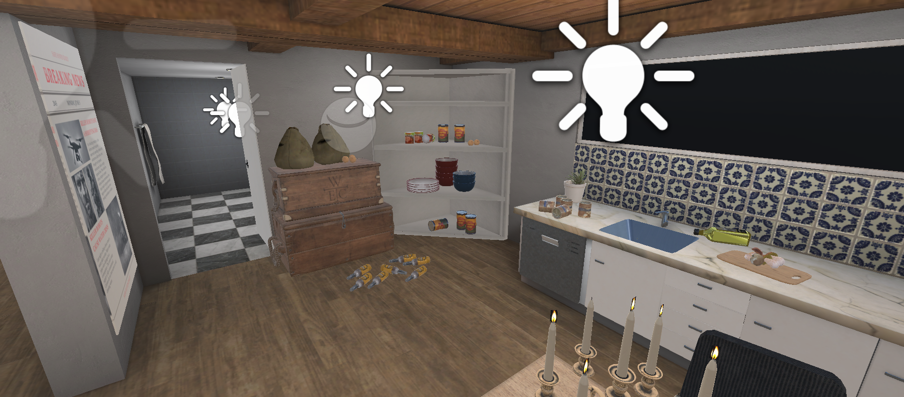
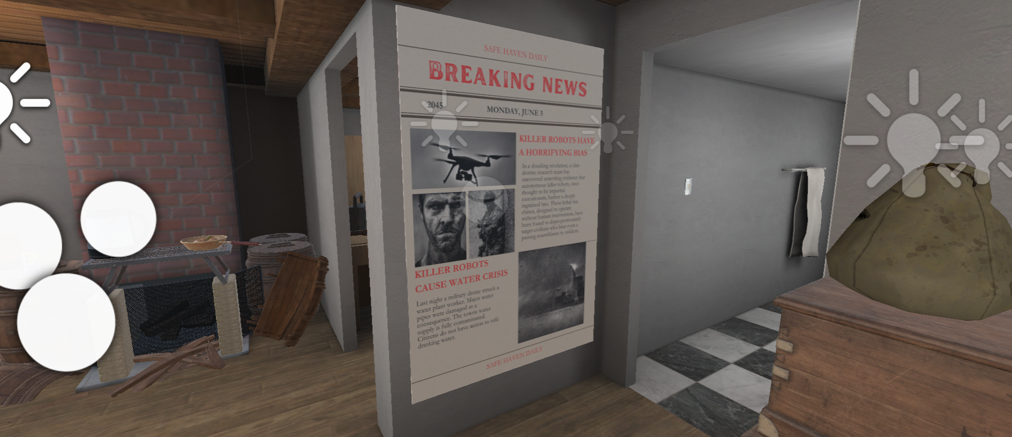
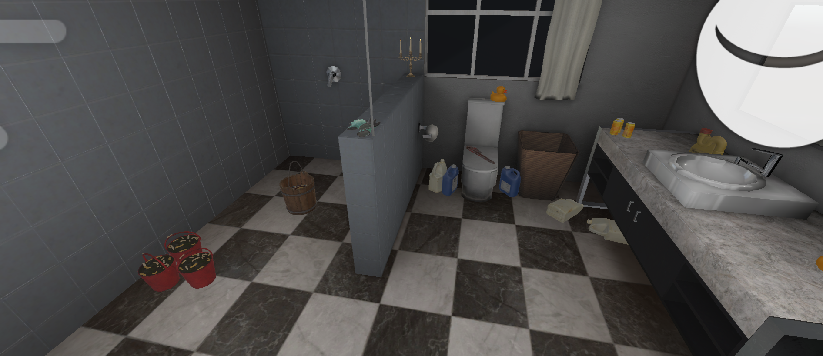
4.1 Ethical Concerns of Prototype II (describe features)
- Bias
In our new prototype we decided to focus on 2 different ethical concerns; one is gender bias. Our story revolves around a kid having lost his dad to robots that target men resembling soldiers. This concern leads to another one, which is: accountability.
- Lack of accountability
For accountability, as mentioned above, it’s closely tied to bias. This is because having lost his dad to the biased robots, he’s forced to confinement in his house as time outside could mean the same fate as his dad for him. Without access to things such as grocery stores, and company, he’s faced with effects of isolation, cleanliness, hunger, thirst and many more.
4.2 Testing plan for Prototype II
Our second prototype will focus on the VR portion of this project. We will use our environment from protype 1 to see how it transfers to a VR experience.
Test Objectives (Why) | Description of Prototype used and of Basic Test Method (What) | Description of Results to be Recorded and how these results will be used (How) | Estimated Test duration and planned start date (When)
Test the Unity environment transfers to the VR | Transfer the Unity environment onto the VR program. | Record how the audio and graphics transfer from one program to another. | 20 minutes
Test the VR is easy to set up | Ensure the setting up the VR is easy, timely, and accessible. | Physically setting up the VR to use and timing the process. This should take less than a minute once practiced. | 10 minutes
Test the Controls on the VR | Ensure the user can move around affectively in the environment. | Have a sample user move through the environment and record their experience. | 5 minutes

4.3 Script outline (1 min worth):
ETHICAL CONCERN: Lack accountability and Gender bias

{silence is interrupted alarm clock, rustles to waking up}
BEDROOM
[grunting noises]
[Radio in the background interrupts]
Radio: “On today’s news, 12 more people were killed by the fleet of killer robots. Based on the recent trend of deaths, researchers have determined that there seems to be a tendency targeting fit males that resemble soldiers due to a programming error.
[kid passes by closet, checks out clothes]
Kid: “Where’d I put that...where’s my watch?”
[franticly searches for it but gives up and passes by bookshelf: “Insert title”, “Insert title”]
Kid: “ugh fine, I’ve gotta check my plants any ways”
[exits]

BATHROOM
[goes to check on plants, nasty state, bathroom adapted to grow plants with fecus]
Kid: “Seems alright, maybe I’ll come back later to check again”

LIVING ROOM

[looks at mushrooms growing from cracks in the house, thinking of eating them]
Kid: “Maybe l should have mushrooms for dinner again tonight, nah, I’ll find something else”

KICTHEN (dim lighting)

[news article laid on the counter right next to him]
Kid: [reads the paper Headline: “Killer robots gone rogue, programming error creates bias”] “Subtext: While testing killer robot prototype for military use, an unexpected programming error was found to target civilians mistaken for soldiers. Most have now been shut down but 5 are still on the loose. Dark clothing and time indoors are recommended to stay safe in the meantime.
[ drops the paper and goes to open the food cupboard, picture of child drawing pasted in front]
Kid: “NO! You’re kidding. I knew I shouldn’t have eaten the last cup noodle. What am I supposed to do now?!”
[goes to test tap but no water comes out?]
Kid: [chuckles] “Just like always, nasty water, dirty clothes and now no food. [sigh]”
[passes by picture of dad, letter attached beneath it]
Dad: [flashback narration] “Hey kid. I didn’t wanna wake you, but I'll be gone by the time you get up, getting food. See you soon.”

Kid: [whispers to himself] “Why’d you have to leave dad?”

Kid: [looks at calendar, 3 months crossed out] [sighs] “Already 3 months since my he’s left.... Huh look at that, it’s almost my birthday soon [monotone] ”
[existential crisis]
“NO, NO! What am I DOING?! I’ll be 17 in a WEEK. I shouldn’t have to starve everyday, reuse all my clothes, boil my water EVERYTIME before drinking it, eat worms that I’ve grown in the BATHROOM? What is this life?..... I’ve gotta get out, do something, anything but this... And the worst part of it all is that there’s no one to blame.”
[exits Kitchen, to leave out the door, scene ends]

THE END

4. 4 (Free) Unity Assets
- Tinned Food: https://assetstore.unity.com/packages/3d/props/food/tinned-food-89246
- Realistic Kettle: https://assetstore.unity.com/packages/3d/props/electronics/realistic-kettle-207636
- Food & Kitchen props pack: https://assetstore.unity.com/packages/3d/props/food-and-kitchen-props-pack-85050
- Food pack mixed: https://assetstore.unity.com/packages/3d/props/food/food-pack-mixed-154349
- Potted plant: https://assetstore.unity.com/packages/3d/vegetation/plants/potted-plant-249570
- Gardening supplies set: https://assetstore.unity.com/packages/3d/props/tools/gardening-supplies-set-257733
- Gardening tools pack: https://assetstore.unity.com/packages/3d/props/tools/gardening-tools-pack-26-pbr-objects-183477
- Toy sprinkling can: https://assetstore.unity.com/packages/3d/props/toy-sprinkling-can-102803
- Petrol chainsaw: https://assetstore.unity.com/packages/3d/props/petrol-chainsaw-74889
- Radio https://assetstore.unity.com/packages/3d/props/radio-230712
- Medication Survival Game Tools | 3D Tools | Unity Asset Store
- 4.99$ Dirty rags Old Dirty Torn Rags | 3D Props | Unity Asset Store
- 4.99$ dirty tiles Indoor Tile Substances Collection | Substances | Unity Asset Store
- Wheelchair Folded wheelchair, Unfolded wheelchair PBR | 3D Props | Unity Asset Store
- Dirty bucket Dirty Bucket(low-poly) | 3D Props | Unity Asset Store

5.0 Conclusion (discussing what steps to take for prototype III)
A lot of changes were made, as you can see, in this new prototype. Now, it requires no purchases from the Unity Asset stores, and its storyline was simplified once again to represents 2 main ethical concerns related to Killer Robots. First, bias which can be seen through the backstory we gave our user, and second, accountability which is demonstrated through his slow descent into madness by the end of the video. Thanks to these modifications, along with the feedback prior to deliverable G, we were able to implement it into our VR environment much more easily.
With this new model, we plan on doing the following for prototype 2 and for the creation of prototype 3:
- gain more feedback from family, friends, and clients
- try to walk through the environment
- figure out how to work on Unity all at the same time (asking TAs)
- recording and editing video (finding people to narrate)
- finding background noise, heartbeats etc.

