GNG5140

Inclusive Bike – Initial Prototype and Test Results

Submitted by
[INCLUSIVE BIKE TEAM]
[JONATHAN HORTON, 7710257]
[SACHIN KASBEKAR, 300341464]
[GAURANG LELE, 300384544]
[KRISTINA PRASAD, 300398734]
[RAGHAV KAUSHIK VAGATA UMESH, 300382565]

7th of March 2024
University of Ottawa

Abstract
This document outlines our first attempt at prototyping and testing our final product. The prototypes in this document are a combination of simulated and concrete products. The global solution that we have come with is described in detail using a block diagram. Moreover, the various prototypes are outlined in detail. Each subsystem’s prototype will be documented in detail using sketches, diagrams, and pictures. When testing is possible, these tests completed for these systems are described and the results of these tests are provided. Moreover, a bill of materials outlining the costs of components that will be purchased is provided.

Table of Contents
Abstract i
Table of Contents ii
List of Figures iv
List of Tables vi
List of Acronyms vii
1 Introduction 8
2 Global Solution 9
3 Prototype, Test, and Bill of Materials 10
3.1 The Display, Brake Lights, and Blinkers 11
3.1.1 Documentation of Brake Lights and Blinkers 11
3.1.2 Testing of the LCD display, Brake Lights, and Blinkers 12
3.2 The GPS Module and Bluetooth Module 13
3.2.1 Documentation for GPS and Bluetooth Module 13
3.2.2 Test Results for Bluetooth and GPS Modules 14
3.3 The Floor and Ramp 16
3.3.1 Documentation of Floor and Ramp 16
3.3.2 Testing the Floor and the Ramp 18
3.4 Mount 24
3.4.1 Documentation of Mount Design 24
3.4.2 Prototype Testing 27
3.5 Straps 30
3.5.1 Documentation of Strapping System 30
3.5.2 Prototype Analysis 32
3.6 Bill of Materials 32
Husky 1-inch x 12 ft. Ratchet Tie-Down (4-Pack) [Straps] 33
4 Updating the Prototype Test Plan 35
5 Conclusions and Recommendations for Future Work 36

List of Figures
Figure 1 – Inclusive Bike Flowchart 9
Figure 2 –Visualization of the final product. Electronics are not depicted. 10
Figure 3 – Electronics of the display 12
Figure 4 – Initial Circuit Prototype of the Electronic System for the Bike 12
Figure 5 – Wiring of the GPS module (left) and the Bluetooth module (right) 14
Figure 6 -- Connection to Arduino for GPS Module (Left) and Bluetooth Module (Right) 14
Figure 7 – The Bluetooth Module and GPS Module Connected 15
Figure 8 – Isometric View of Hinge 16
Figure 9 –Top and side view of Hinge 16
Figure 10 –Isometric View of Ramp 17
Figure 11 –Top and side view of Ramp 17
Figure 12 – Isometric View of Floor 18
Figure 13 –Top and side view of Floor 18
Figure 14 – Total Deformation 19
Figure 15 – Equivalent Stress 20
Figure 16 – Factor of Safety 20
Figure 17 – Total Deformation of Ramp 21
Figure 18 – Equivalent Stress of Ramp 21
Figure 19 – Factor of Safety of Ramp 22
Figure 20 - Total Deformation 23
Figure 21 – Equivalent Stress 23
Figure 22 – Factor of Safety 24
Figure 23 – Welded Component Isometric View 25
Figure 24 – Welded Component of Mounting Top View and Mounting Side View 26
Figure 25 – Welded Mounting Isometric 26
Figure 26 – Welded Mounting Top (left) and side (right) 27
Figure 27 – Total Deformation 27
Figure 28 – Equivalent Stress 28
Figure 29 – Factor of Safety 28
Figure 30 – Total Deformation 29
Figure 31 – Equivalent Stress 29
Figure 32 – Factor of Safety 30
Figure 33 – Rear Strapping 31
Figure 34 – Front Strapping 31

List of Tables
Table 1 – Tests Results for LCD, Break Lights, and Blinkers 13
Table 2 – Tests completed on GPS and Bluetooth Modules 15
Table 3 – Dimensions of Components 18

List of Acronyms
Acronym | Definition
BOM | Bill of Materials
GPS | Global Positioning System
FOS | Factor of Safety

Introduction
This document outlines the initial prototyping of the final product. It serves as a record of why decisions were made early in the design process and outlines the design in its early stages. It exists so that future engineers working on the project may understand why one decision was made over another, and what issues became apparent in the early stages of designing the project. The main purpose of this project is to create an inclusive bike that is significantly cheaper than current existing solutions, while also being easy to use and about as durable as competing products. Note that subsystems are often discussed and tested as separate entities in this deliverable; in a future deliverable the system will be shown as a whole.

Global Solution

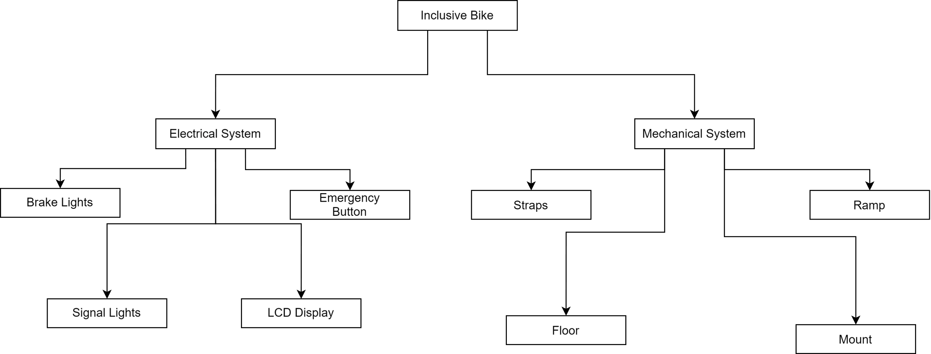
Figure 1 – Inclusive Bike Flowchart
As shown in Figure 1, there are two main subsystems in our solution: the electrical system and the mechanical system. The mechanical features include a system to hold the wheelchair securely to the floor and a ramp designed to bear the weight of the user, up to 150kg, without flexing disconcertingly. This ramp is designed to allow the user to get on and off the trailer without it being overly cumbersome to use. Additionally, a mounting system is included to link the trailer and the bike. On the electrical side, the design includes a brake light that illuminates when the driver activates the bike’s braking mechanism. Blinking signal lights are also incorporated for when the driver intends to turn. Moreover, an LCD display allows the rider to communicate with the driver of the bike. The rider may do so by using 4 buttons. Lastly, an emergency button is conveniently located for the passenger to easily call local emergency services when needed.
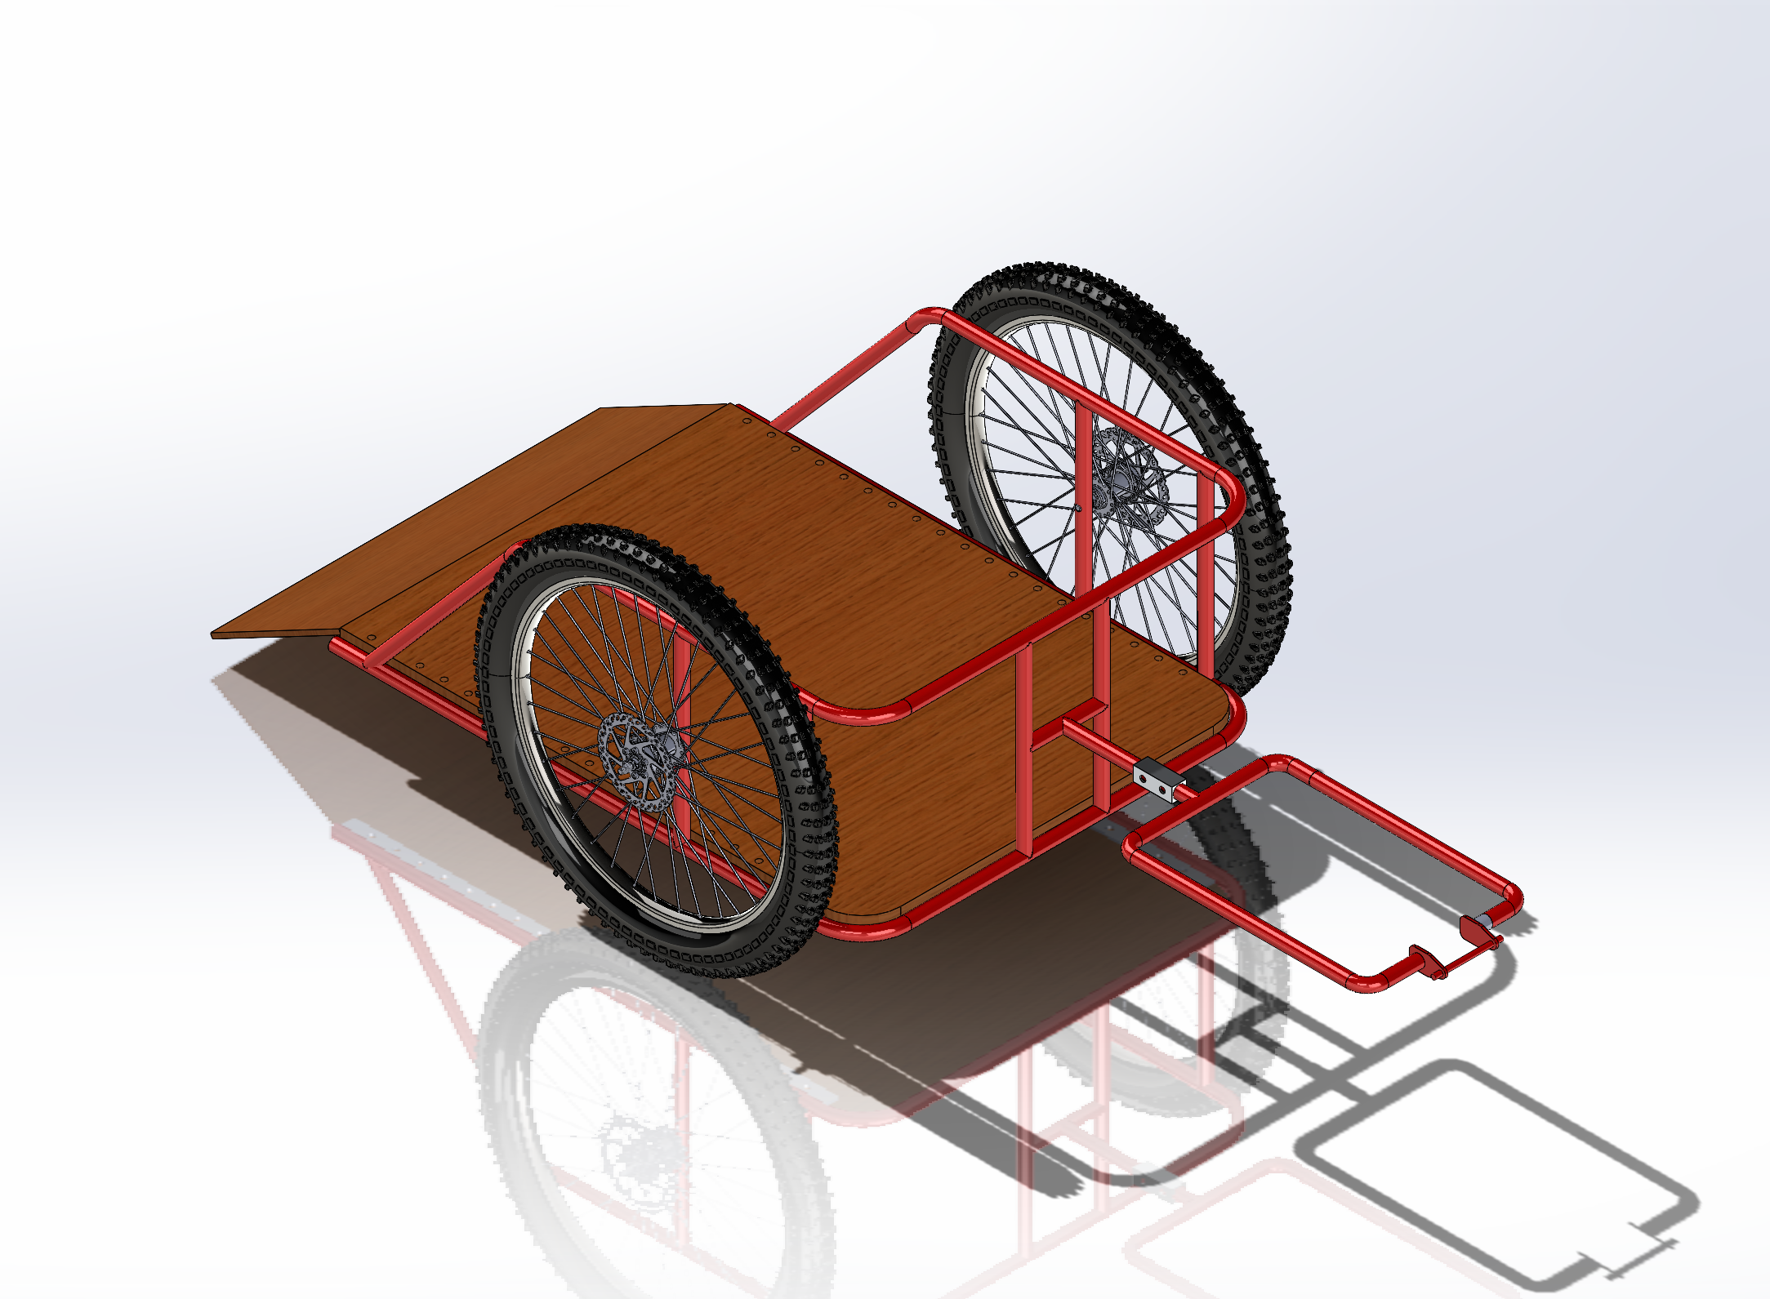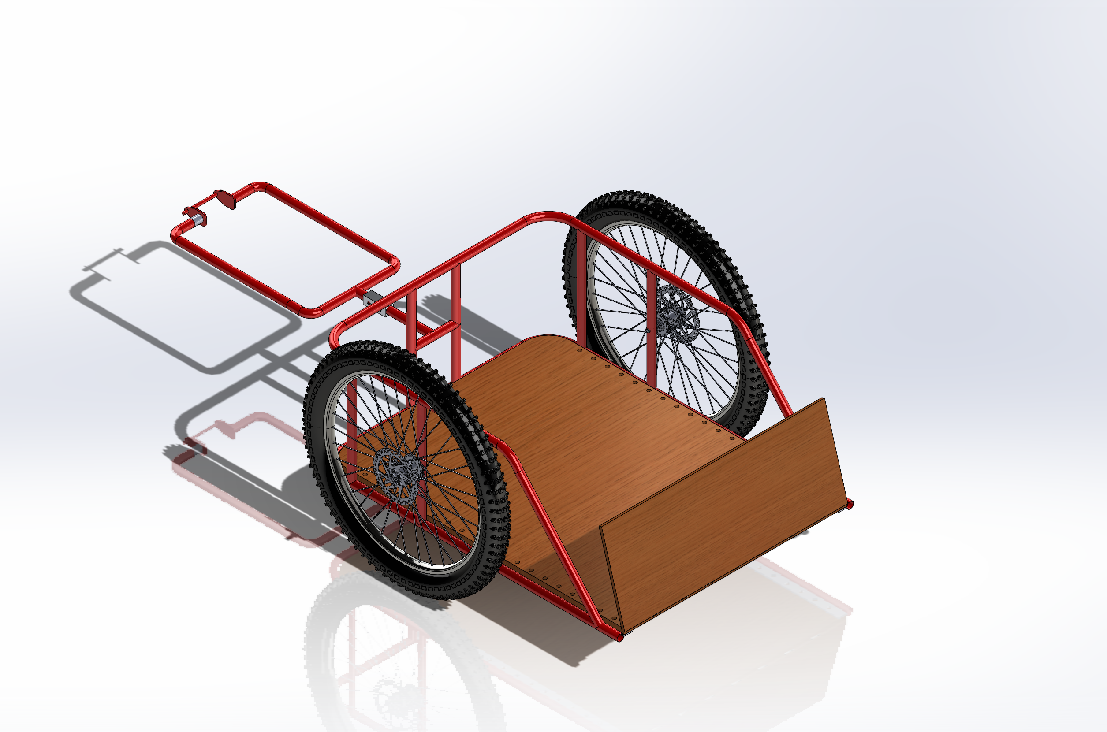
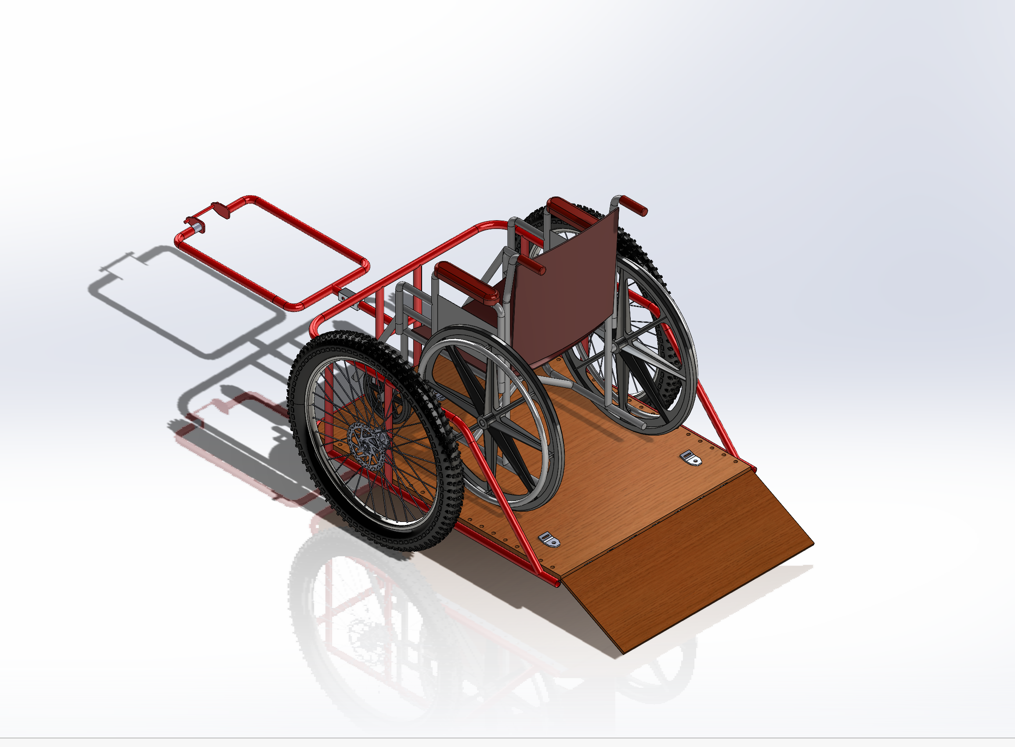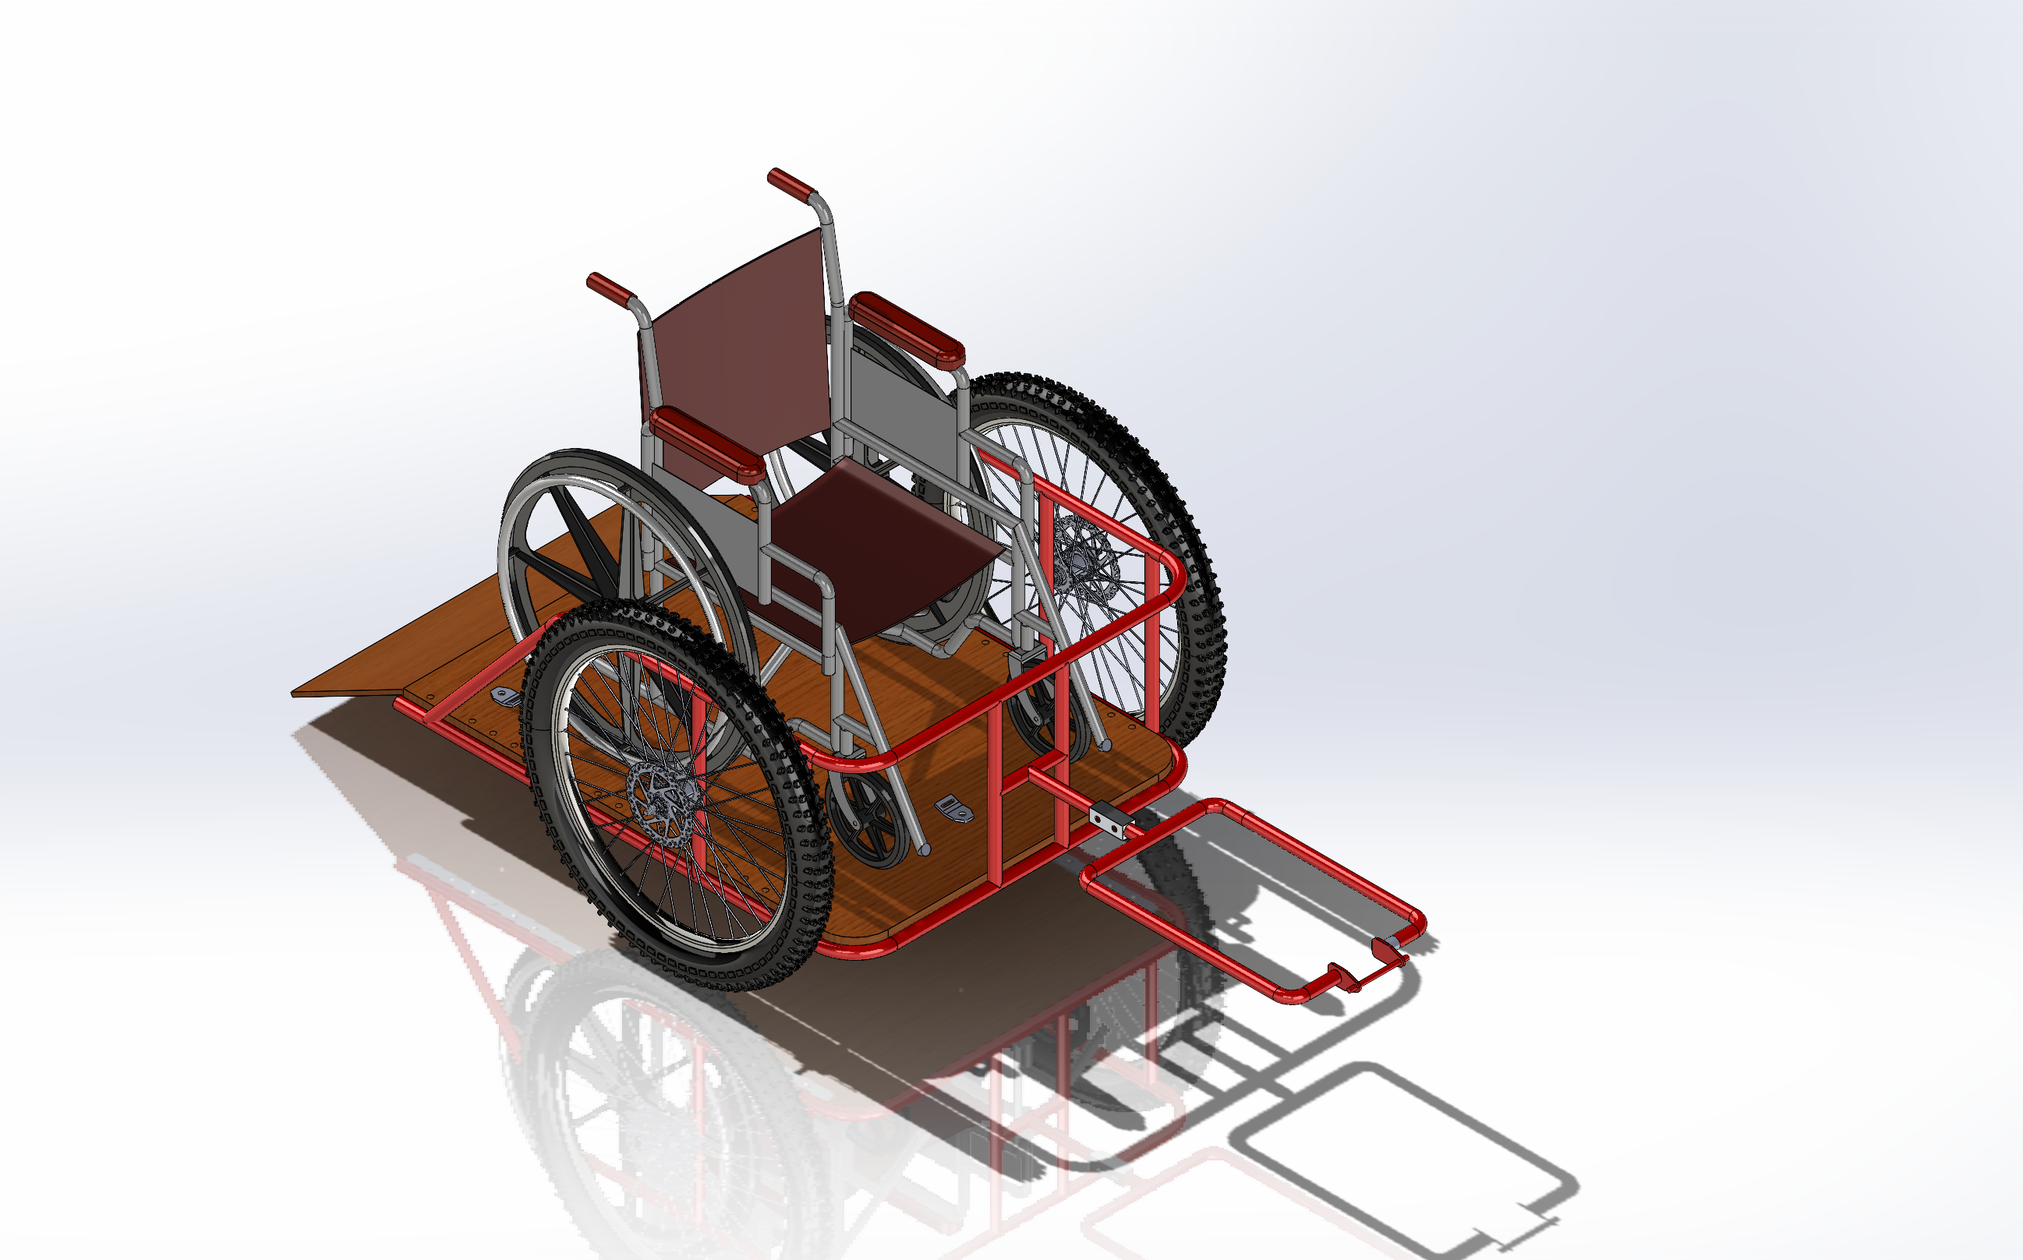
Figure 2 –Visualization of the final product. Electronics are not depicted.
Shown in the figure above is a visualization of the final product. Note that the straps and electronics are not depicted; the combination of each subsystem into a usable product will be shown in a future deliverable and is not the subject of this deliverable.

Prototype, Test, and Bill of Materials

This section documents the initial prototype for subsystem of the protype. The prototyping is broken down into 5 sections: (1) the brake lights and blinkers, (2) the GPS module and Bluetooth Module, (3) the mount system, (4) the floor and ramp, and (5) the straps. Lastly the bill of materials for all components is provided.

The Display, Brake Lights, and Blinkers

Documentation of Brake Lights and Blinkers
Listed below are the purposes of each component tested in this section.
- In regards to the previous prototype where we demonstrated blinkers using a small led strip, a lot of modifications and changes have been introduced in the current prototype.
- For instance, a better LED strip (WS2812B) for the blinkers which is controlled using a slider switch instead of a push button which was used earlier and functions as per the requirements.
- Introduction of LCD for communication with the driver meeting some of the communication requirements.
- Integration of LED strip(blinkers), red LED (brake light), and LCD (communication) and carried out successful testing on breadboard.
- In the previous prototypes for basic testing we had used individual LEDs for the blinkers, and push buttons for control.
The diagram of these components is shown in the figure below.
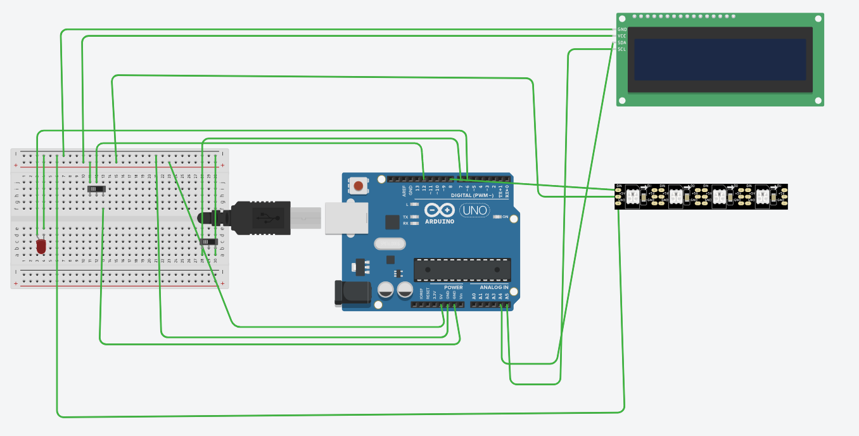
Figure 3 – Electronics of the display

Testing of the LCD display, Brake Lights, and Blinkers
The figure below shows
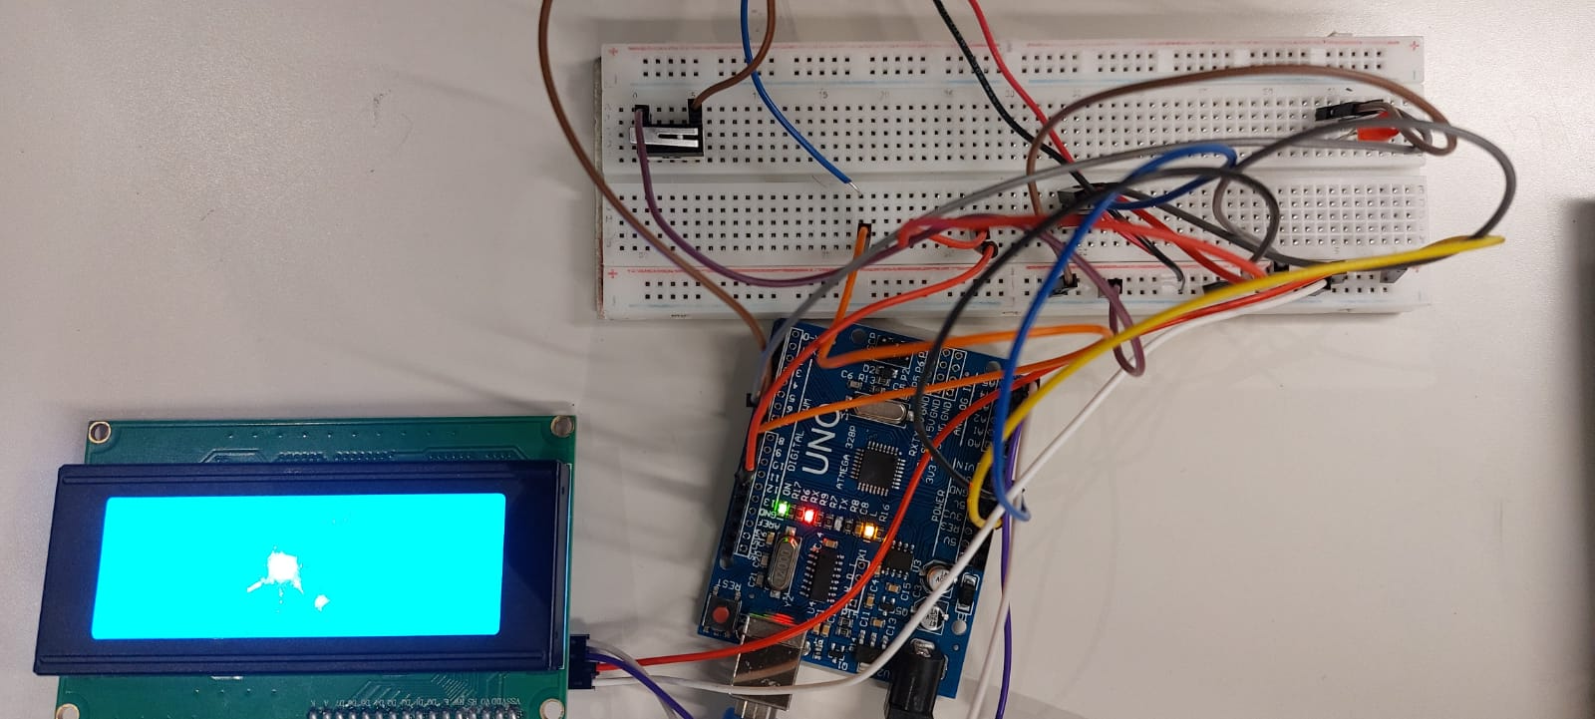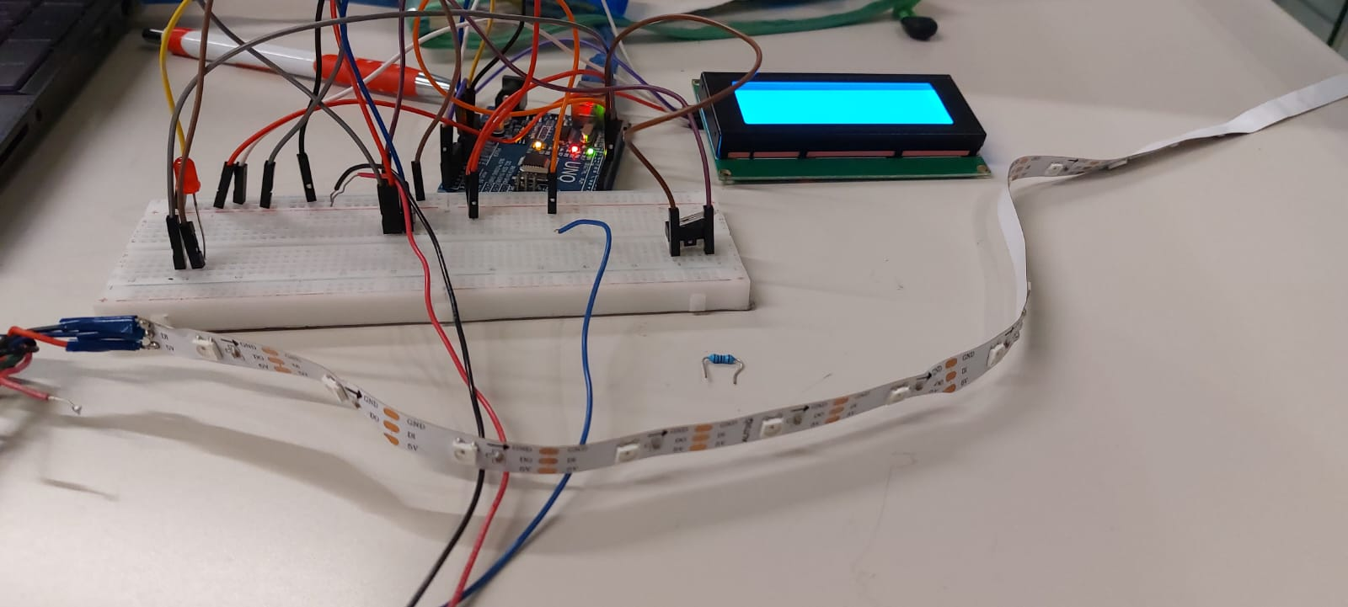
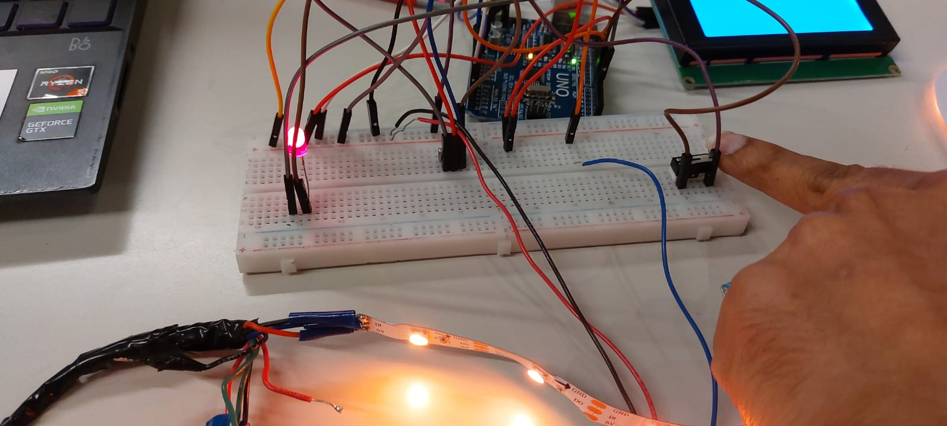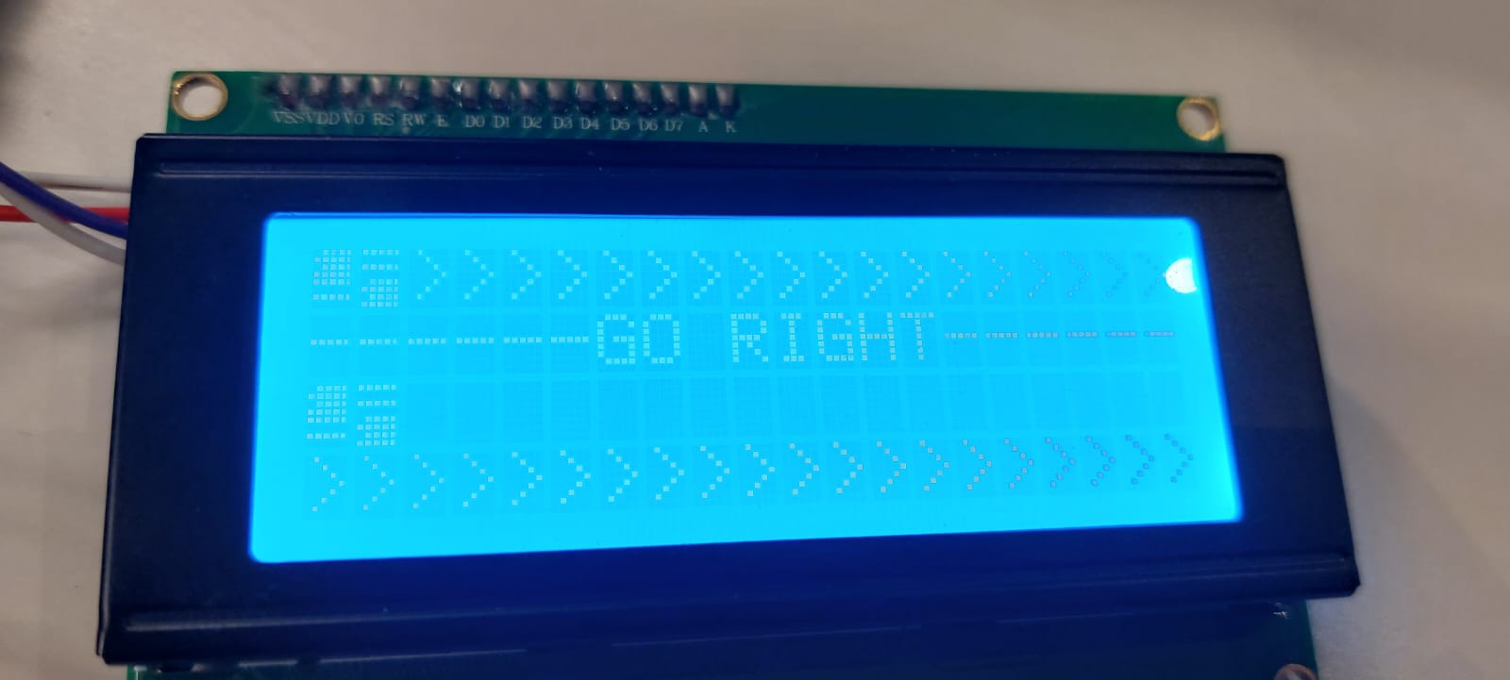
Figure 4 – Initial Circuit Prototype of the Electronic System for the Bike
Table 1 – Tests Results for LCD, Break Lights, and Blinkers
Components-Category(Purpose) | Expected | Actual results
Blinkers (LEDs)- Safety | Blink when turning with high brightness so that it is visible to others | Matches the expectations 100%.
Slider switches(control)-Safety | When pressed turn on blinkers while taking turns and turn off when not needed. | Meeting the mentioned expectations
Red LED(Brake light)- Safety | When brakes are pressed backlight should glow | Currently tested with a small LED that glows when the contact switch is pressed on the breadboard.
LCD- Communication | Show basic messages which the rider wants to convey to the driver and clear messages when the control is changed. | Tested out for one message(right signal) which is working when the blinkers are glowing the slider switch is turned on and the message clears out when the switch is turned off.

The GPS Module and Bluetooth Module

Documentation for GPS and Bluetooth Module
Shown in the figure below are the pin outputs of the GPS and Bluetooth module. Note that the stable and enable pins are not necessary for the operation of the Bluetooth module, as they are only helpful for troubleshooting and power saving, which will not be helpful in our implementation of an emergency button. In the case of the GPS module, all pins are connected to the Arduino. These connections are shown in the subsequent figure.
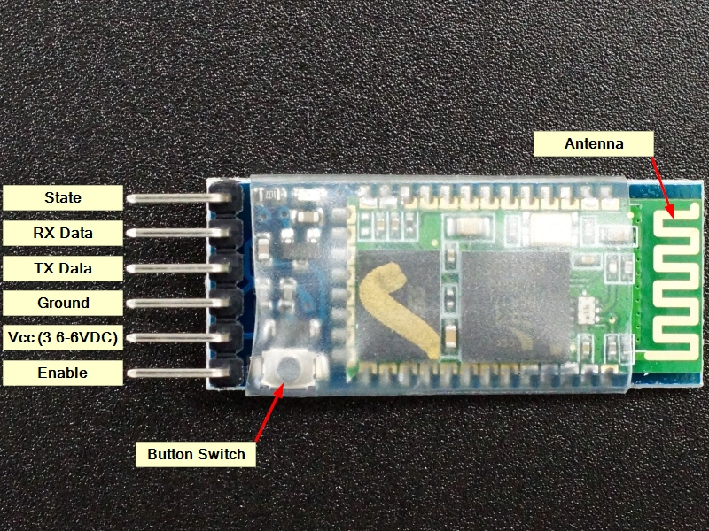
Figure 5 – Wiring of the GPS module (left) and the Bluetooth module (right)

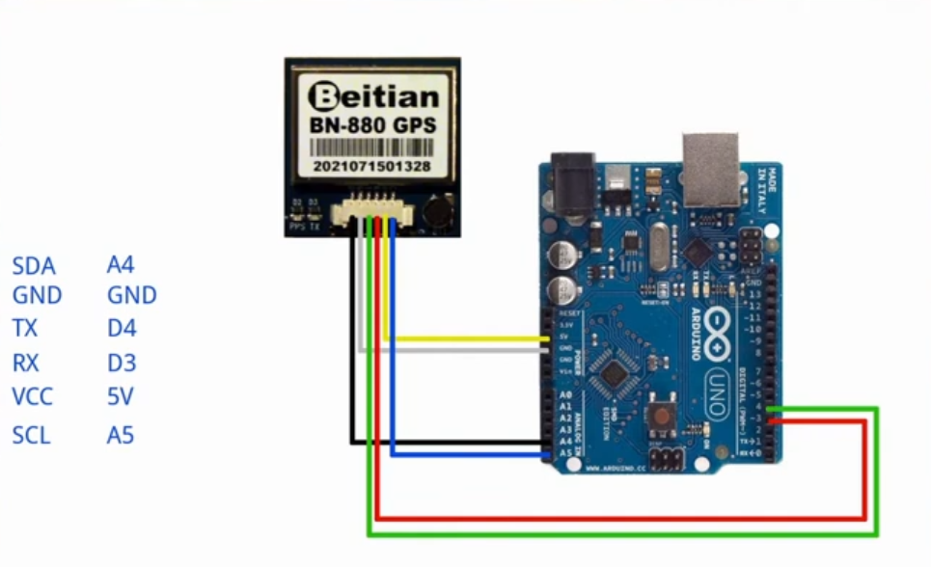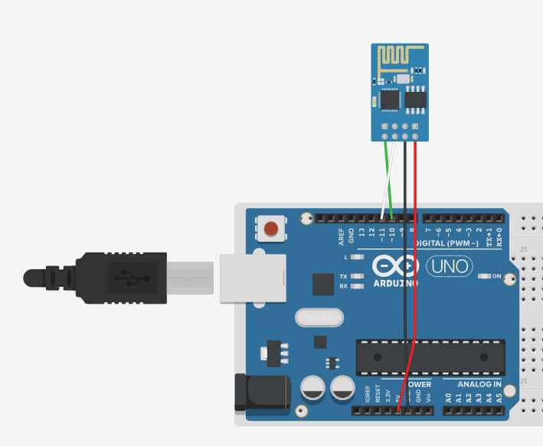
Figure 6 -- Connection to Arduino for GPS Module (Left) and Bluetooth Module (Right)

Test Results for Bluetooth and GPS Modules
Currently only initial testing of the GPS module and Bluetooth module has been completed. While both components appear to be functional based on these tests, further troubleshooting needs to be completed with regards to the connectivity speed of the GPS module. An image of the circuit is shown below along with a table listing the tests currently completed.
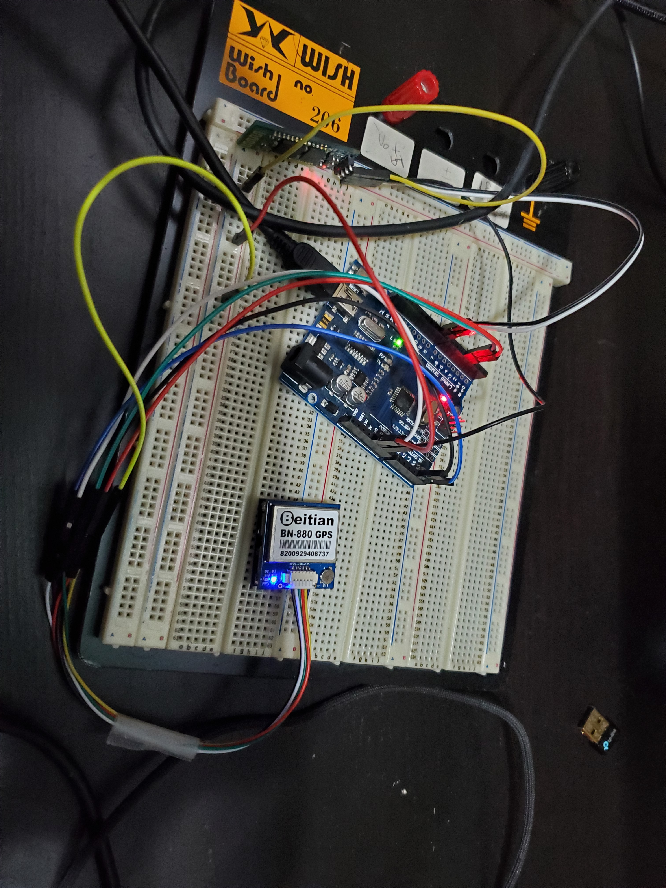
Figure 7 – The Bluetooth Module and GPS Module Connected
Table 2 – Tests completed on GPS and Bluetooth Modules
Components – Category (Purpose) | Expected | Actual Results
GPS Module – Operation Test | The module should accurately output the physical location in terms of latitude and longitude | The module outputs the latitude and longitude, but takes too much time to form a connection (about 15 minutes ~ 1 hour) with satellites.
Bluetooth Module – Operation Test | The module should be able to pair with a phone or a computer. | The module successfully paired with a device.

The Floor and Ramp

Documentation of Floor and Ramp
We have developed new components and subsystems for our inclusive bike. The new components are hinge, ramp, base and a mount for connecting the bike with the carriage. These components are shown in the figures below.
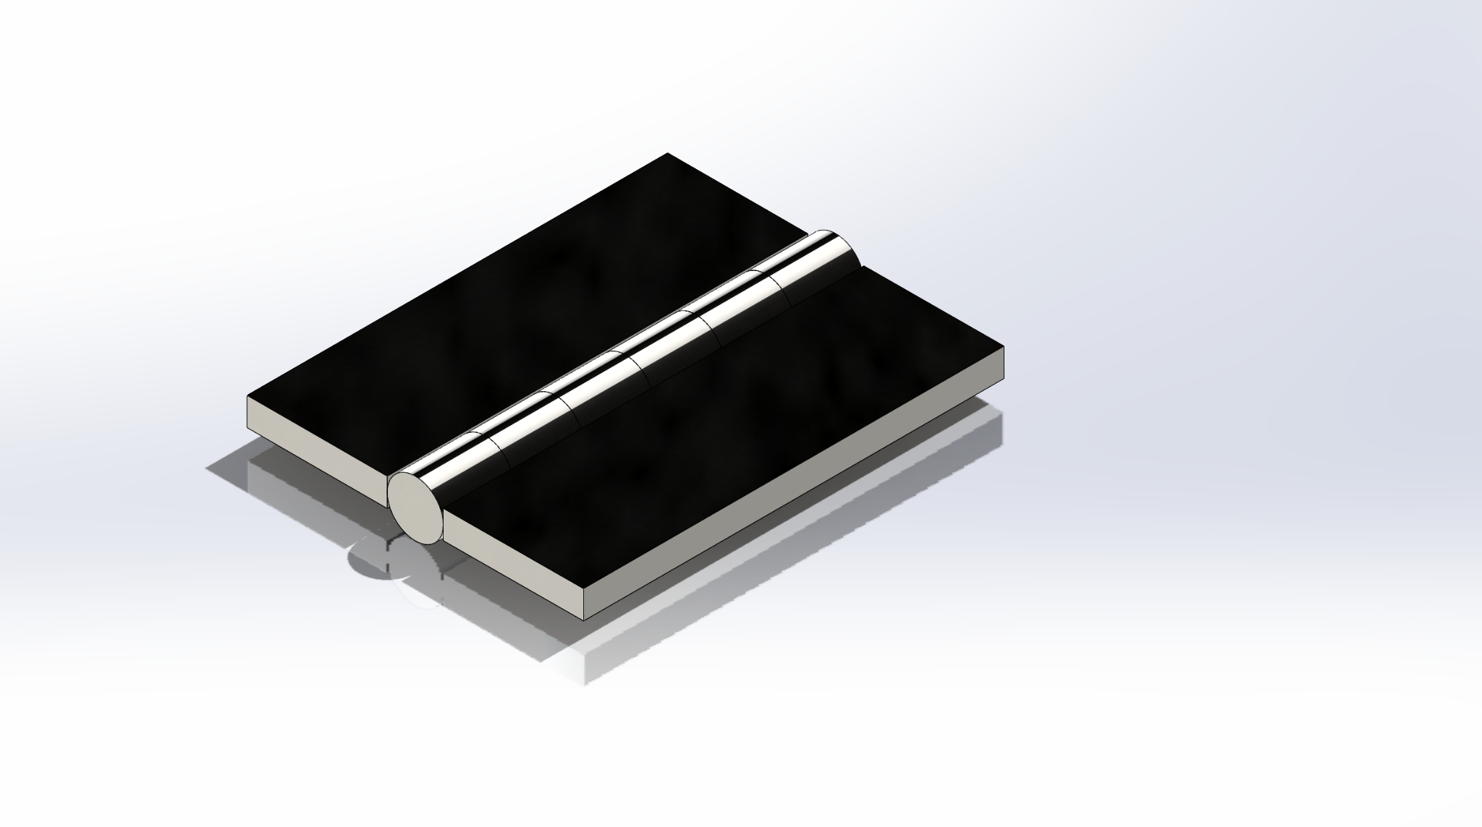
Figure 8 – Isometric View of Hinge
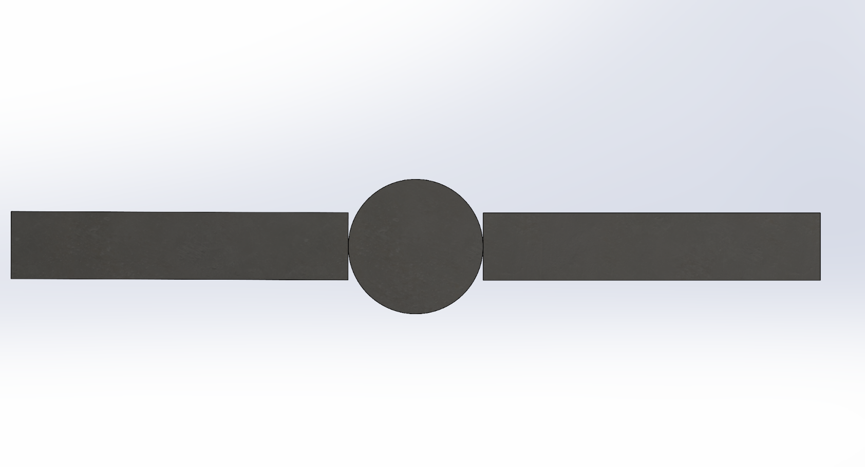
Figure 9 –Top and side view of Hinge
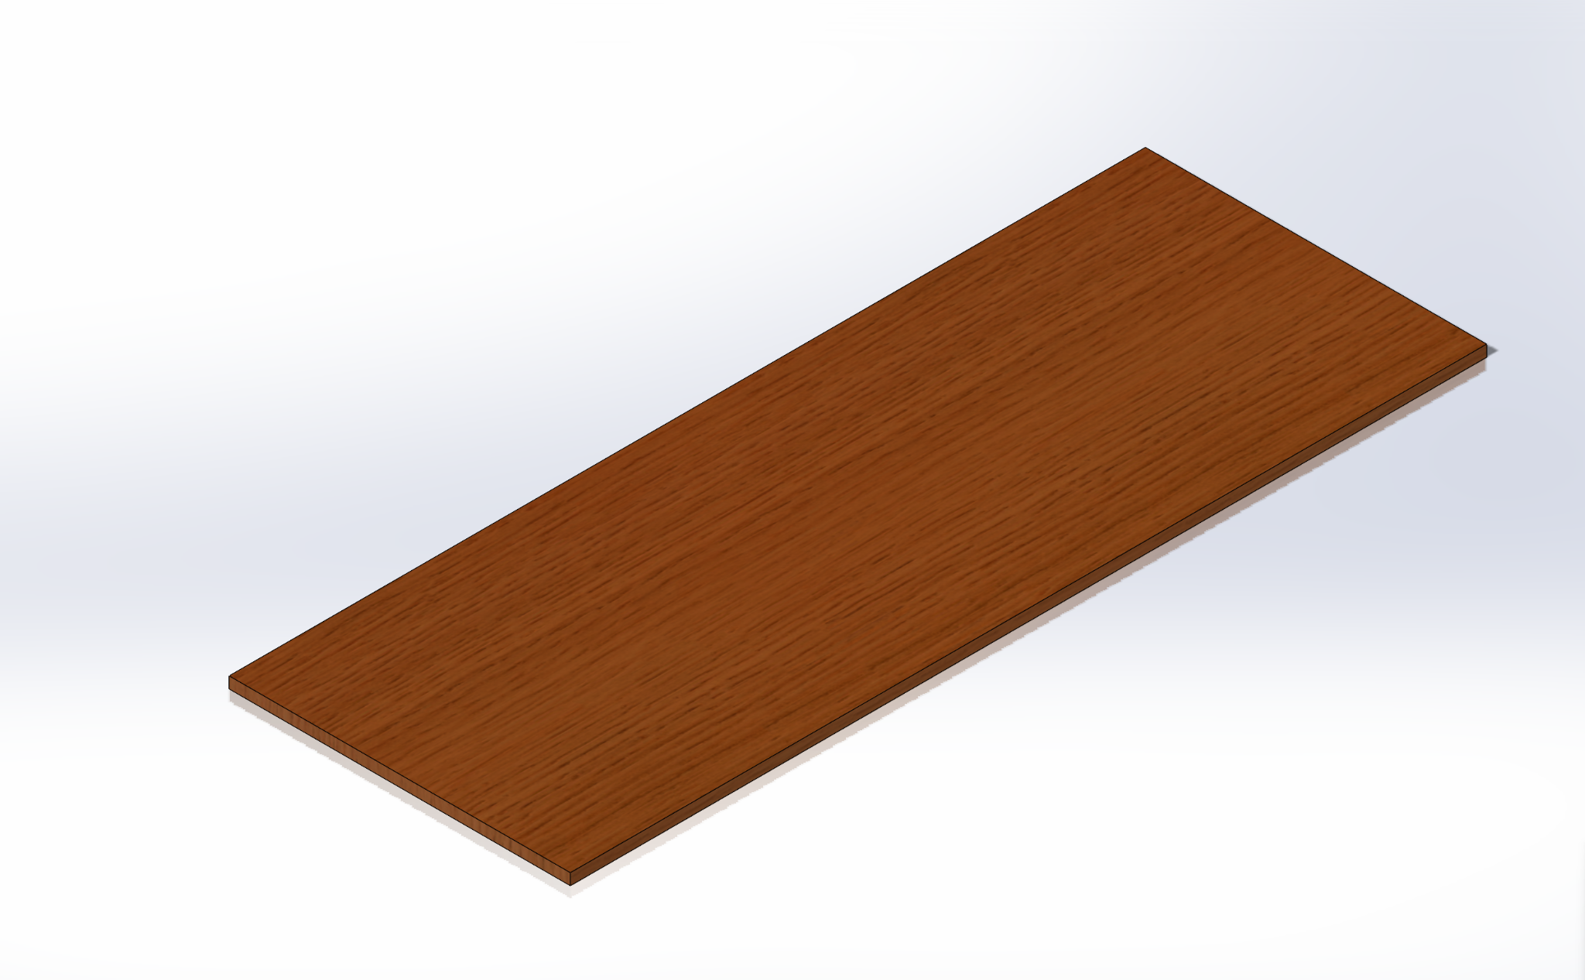
Figure 10 –Isometric View of Ramp
Figure 11 –Top and side view of Ramp
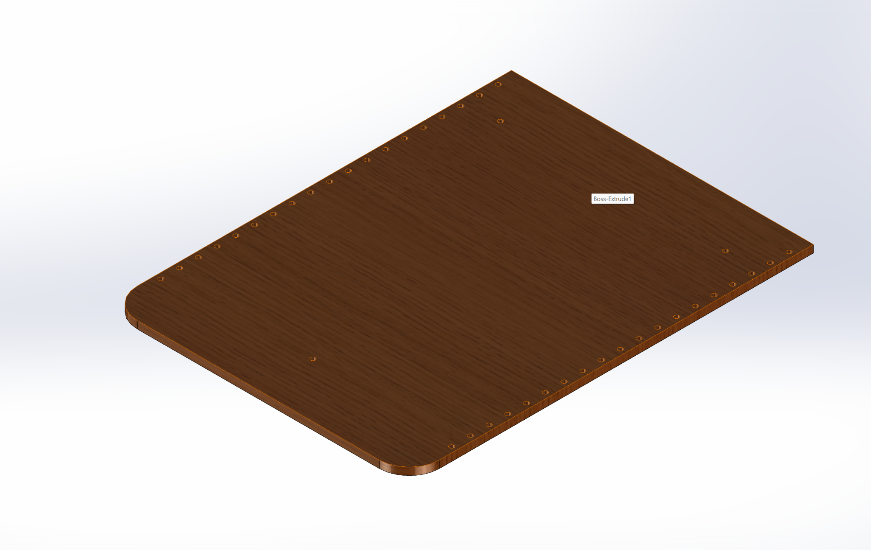
Figure 12 – Isometric View of Floor
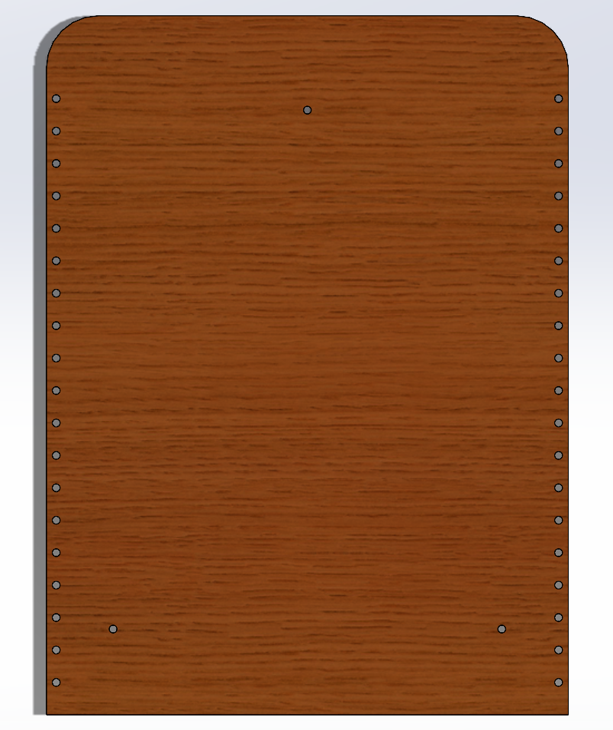
Figure 13 –Top and side view of Floor
The dimensions of the components shown above are given in the table below.
Table 3 – Dimensions of Components
Hinge | LxBxH: 30x24x2 mm
Ramp | LxBxH: 805.5x300x10 mm
Floor | LxBxH: 1077.7x805.52x15 mm

Testing the Floor and the Ramp
In this section the deformation, equivalent stress, and factor of safety are simulated and the results are shown. The results were used to determine the exact size, shape and dimensions of the components. First, the hinge was tested. Static Structural Testing was conducted on the hinge with a maximum load of 1200 N at the point of connection between the base and ramp . The total deformation, equivalent stress and FOS have been pictured below. The load was spread over a 10s time.
The results of the completed tests are shown below.
- Maximum Deformation: 0.0014mm
- Maximum Equivalent Stress: 45.39MPa
- Minimum FOS: 1.9
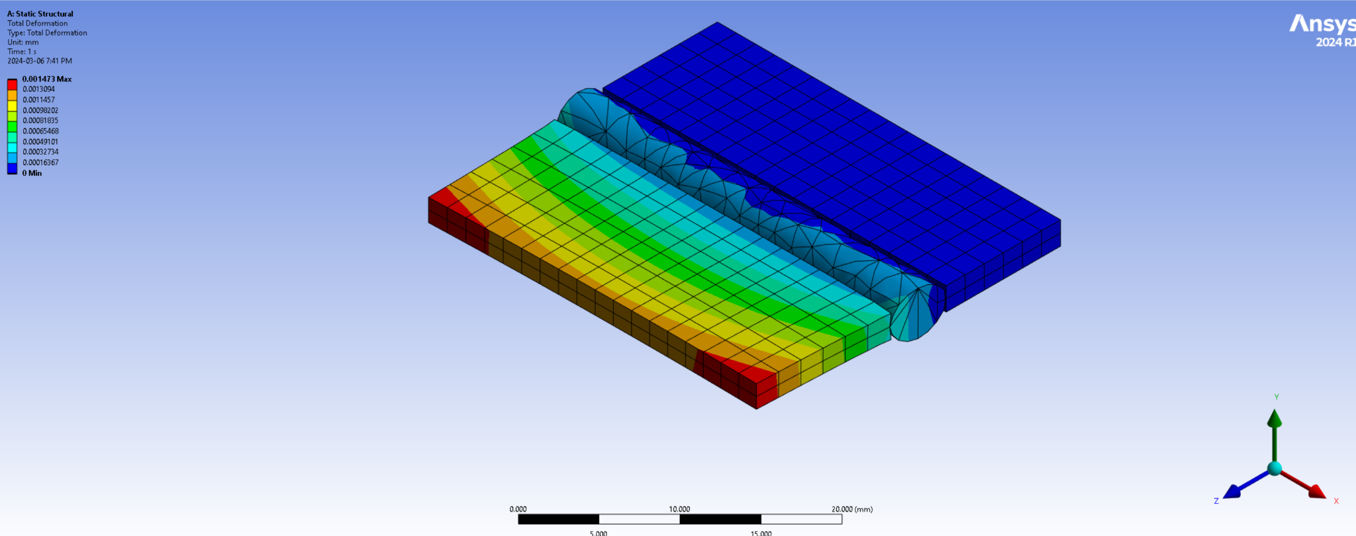
Figure 14 – Total Deformation

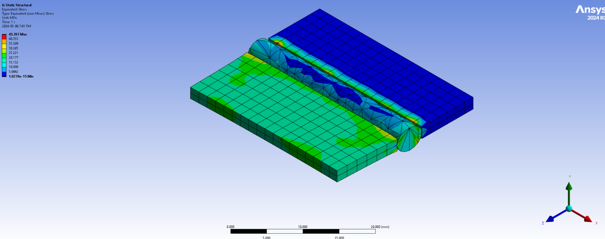
Figure 15 – Equivalent Stress
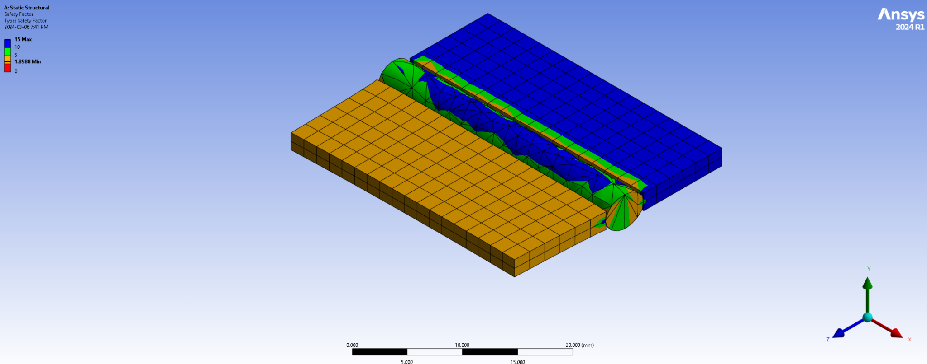
Figure 16 – Factor of Safety
Static Structural Testing was conducted on the ramp with a maximum load of 1200 N on the face of the ramp . The total deformation, equivalent stress and FOS have been pictured below. The load was spread over a 10s time.
The following are the results of the tests in the figures below:
- Maximum Deformation: 0.44mm
- Maximum Equivalent Stress: 60.57MPa
- Minimum FOS: 1.42
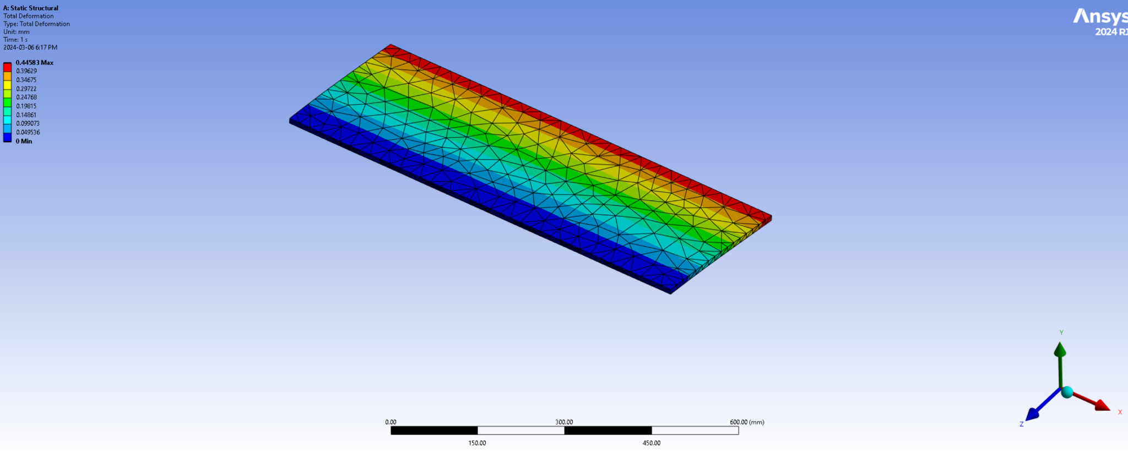
Figure 17 – Total Deformation of Ramp
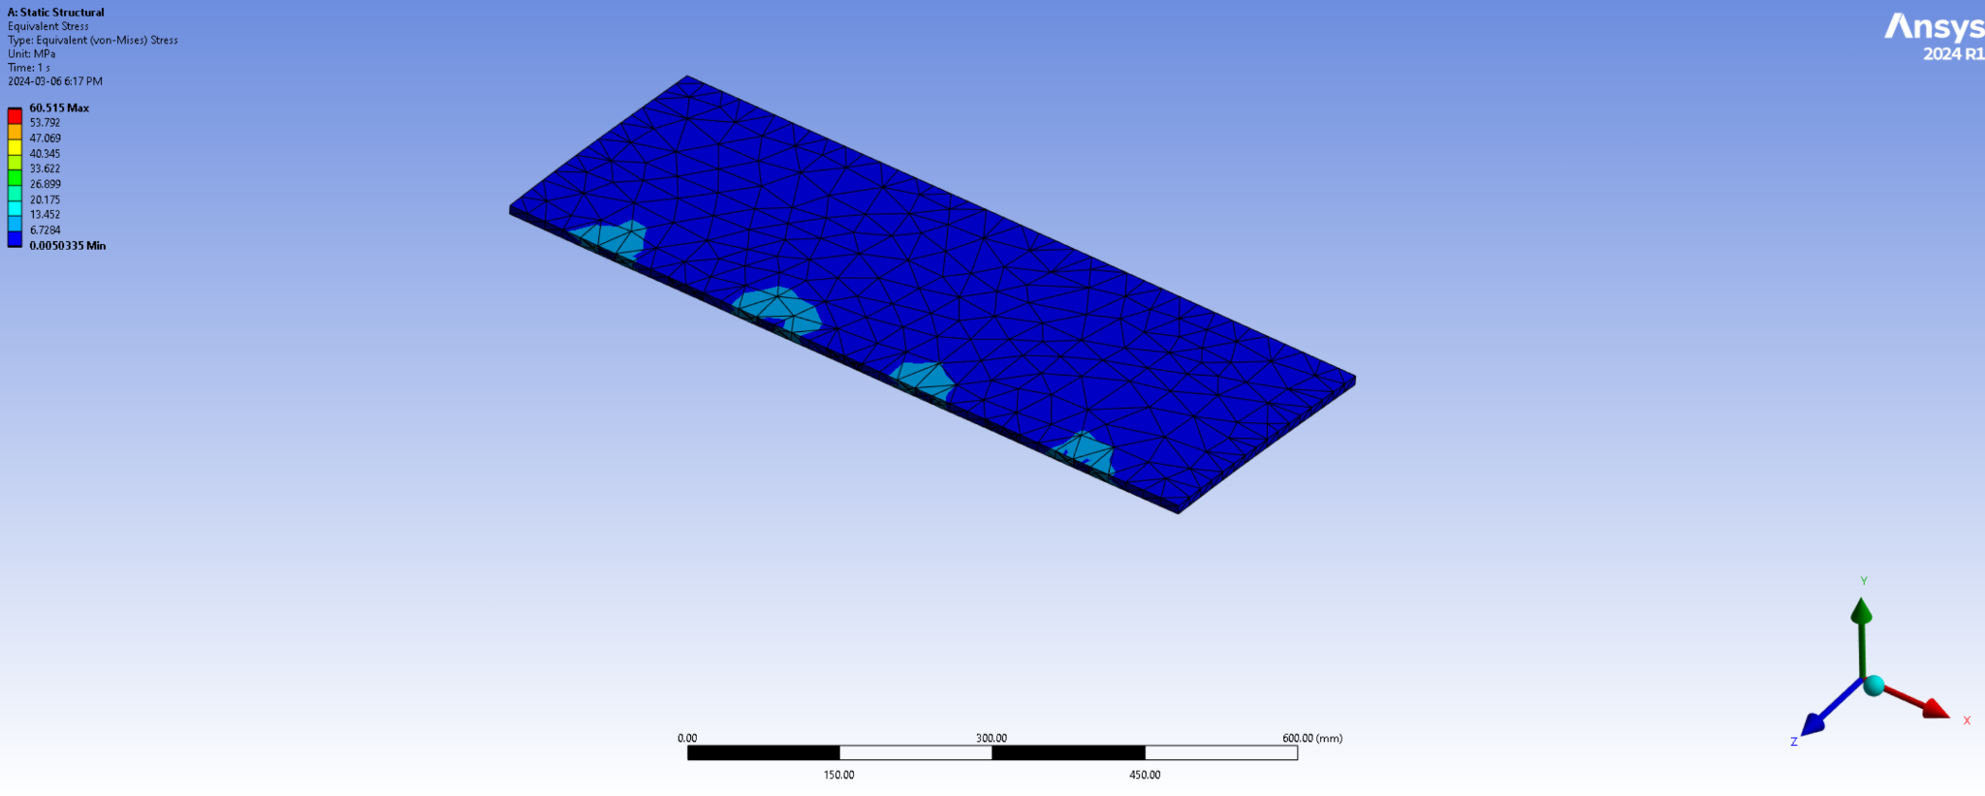
Figure 18 – Equivalent Stress of Ramp
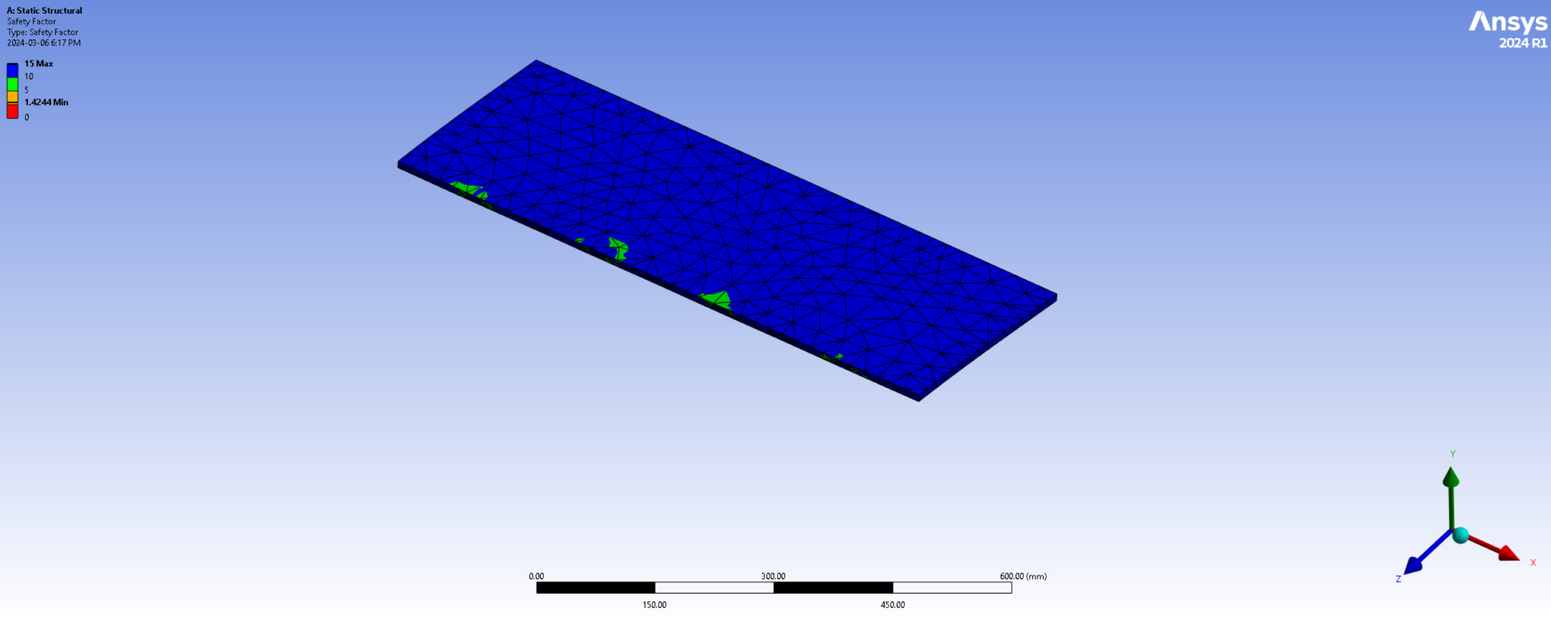
Figure 19 – Factor of Safety of Ramp
Static Structural Testing was conducted on the floor with a maximum load of 2205 N on the face of the floor . The total deformation, equivalent stress and FOS have been pictured below. The load was spread over a 10s time.
The results from the images shown below are as follows.
- Maximum Deformation: 0.09mm
- Maximum Equivalent Stress: 24.21MPa
- Minimum FOS: 3.5

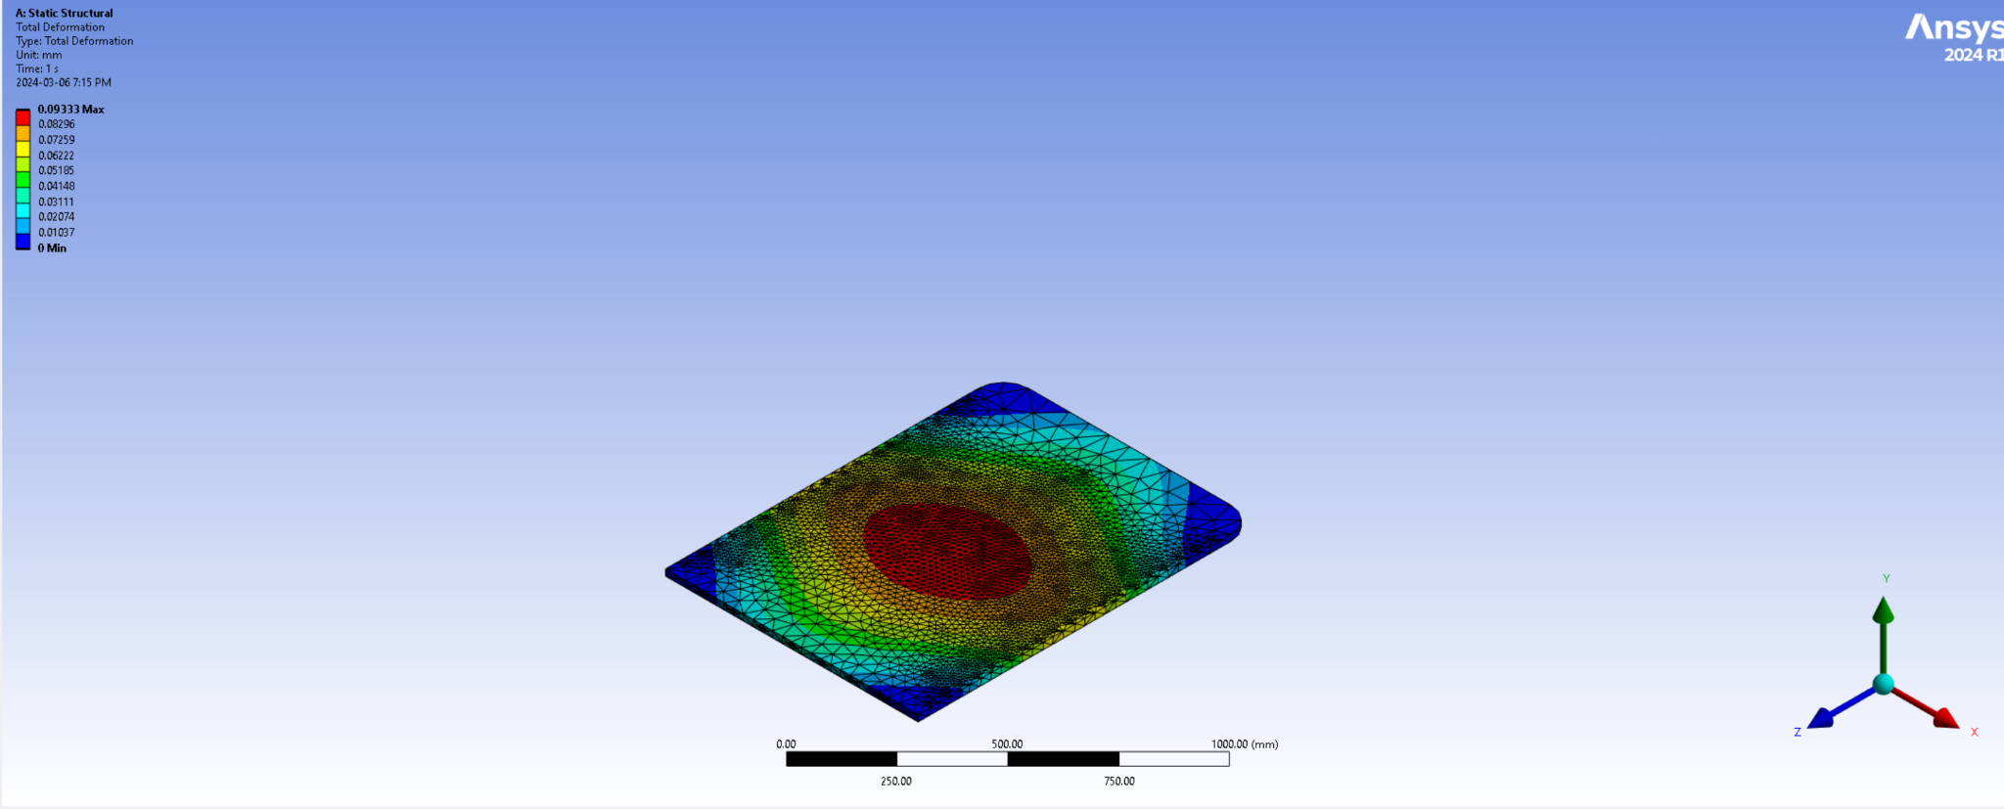
Figure 20 - Total Deformation
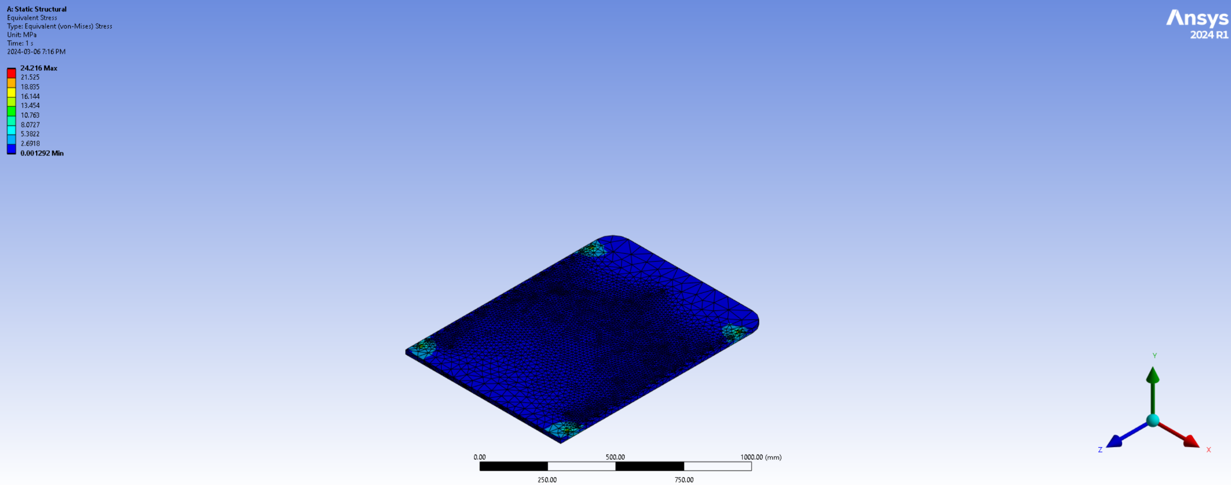
Figure 21 – Equivalent Stress
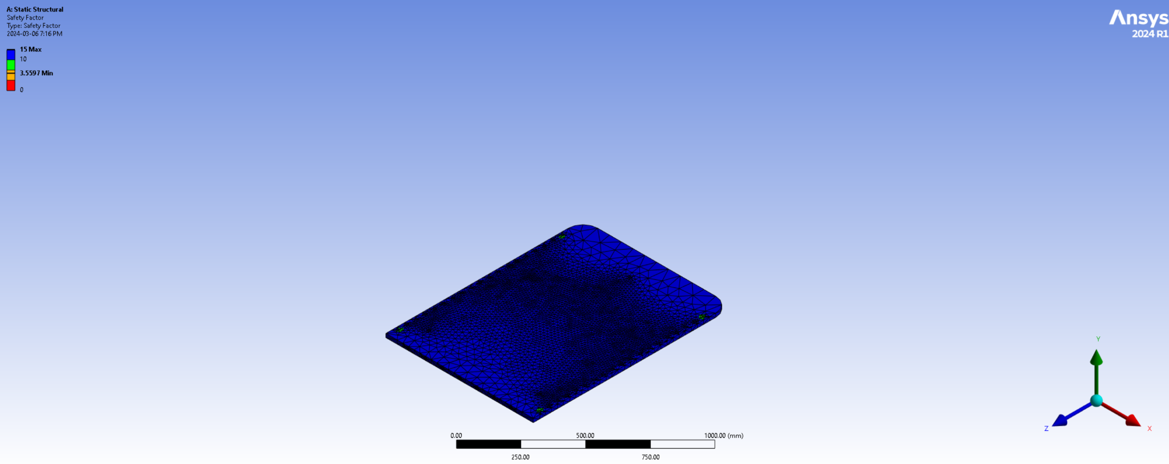
Figure 22 – Factor of Safety

Mount
The rear mount subsystem consists of 2 flanges which will be installed onto the rear axle of the bike. The flanges have a hole in them through which the rear axle will be passed. These flanges are then welded to pipes which wrap around the rear wheel of the bike. Another pipe is welded perpendicular to the wrap around pipe with holes made for bolts to be inserted through.

The maximum deformation is under limits at 0.227mm. The Maximum Equivalent Stress and the Factor of Safety (FOS) figures are dangerously close to failure and hence will be reviewed in the future. The end pipe where the force has been tested on will be covered by a square steel element protruding from the carriage. Two bolts of 12mm will be inserted into the holes to secure the linkage. Hence, the safety concerns are lowered when considering the above use case.

Documentation of Mount Design
The dimensions of the prototype are as follows:
- Rear Axle: Dia. 10mm
- Flange: Hole Dia. 10mm, Length: 75mm, Height: 40mm, Thickness: 5mm
- Straight and Bent Pipes: Dia. 25mm, Thickness: 1mm
- End Pipe: Dia. 25mm, Thickness: 1mm, Hole Dia. 12mm
- Total length of all pipes: 1620mm

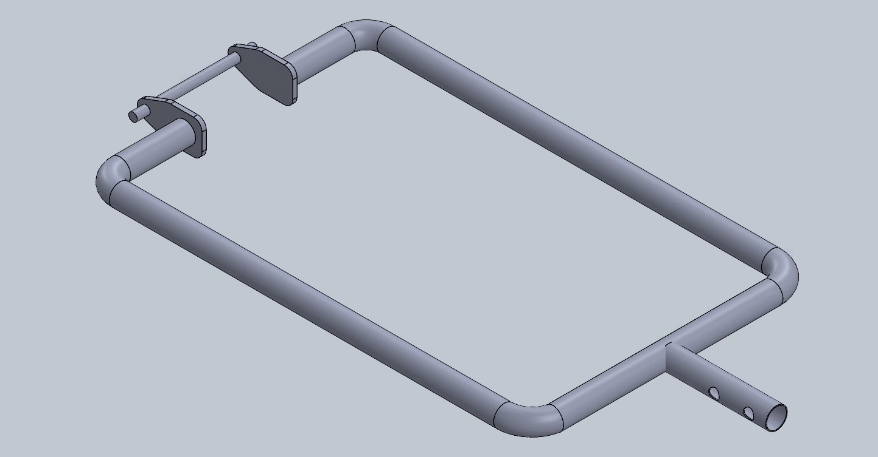
Figure 23 – Welded Component Isometric View

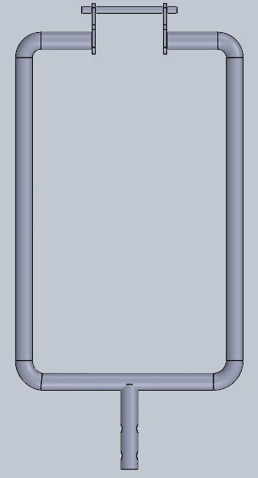
Figure 24 – Welded Component of Mounting Top View and Mounting Side View
The dimensions of the welded component of the mount are as follows:
- Mount LxBxH:80x30x30mm
- End Pipe: Dia. 25mm, Thickness: 1mm, Hole Dia. 12mm
- Total length of pipe: 200
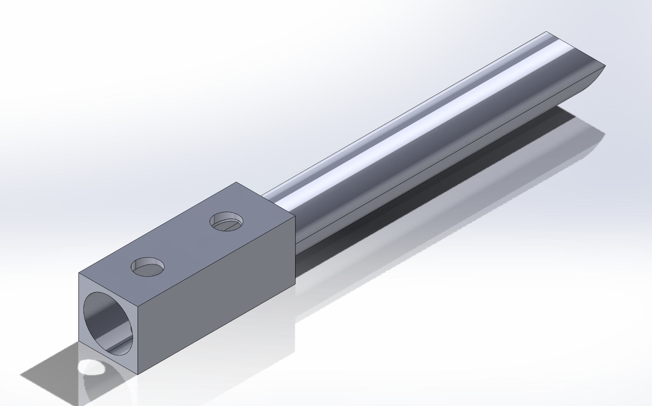
Figure 25 – Welded Mounting Isometric
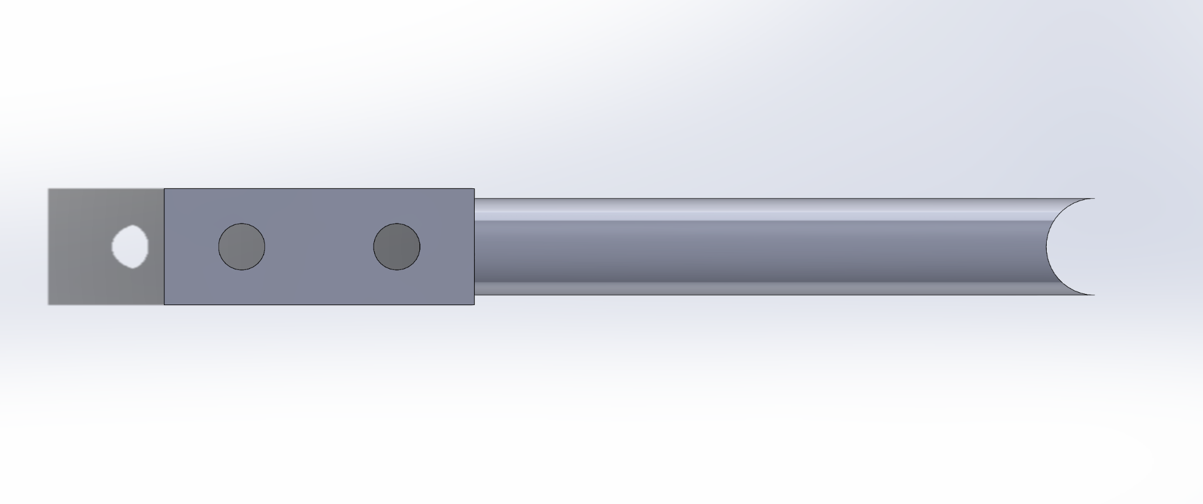
Figure 26 – Welded Mounting Top (left) and side (right)

Prototype Testing
Static Structural Testing was conducted on the Mount with a maximum load of 1200 N at the point of connection with the rest of the carriage. The total deformation, equivalent stress and FOS have been pictured below. The load was spread over a 10s time.
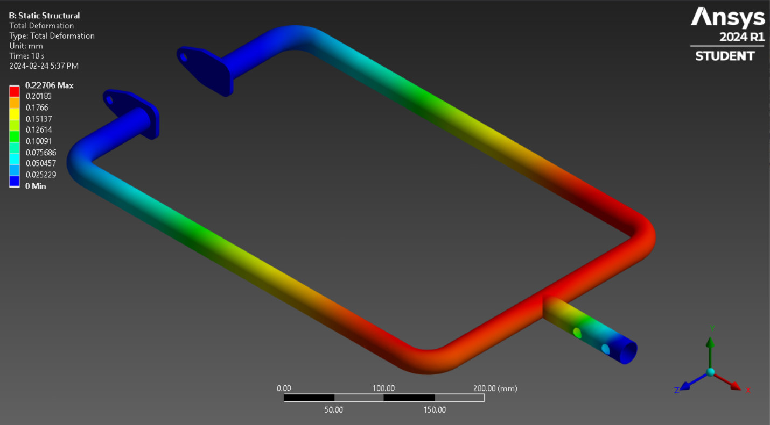
Figure 27 – Total Deformation
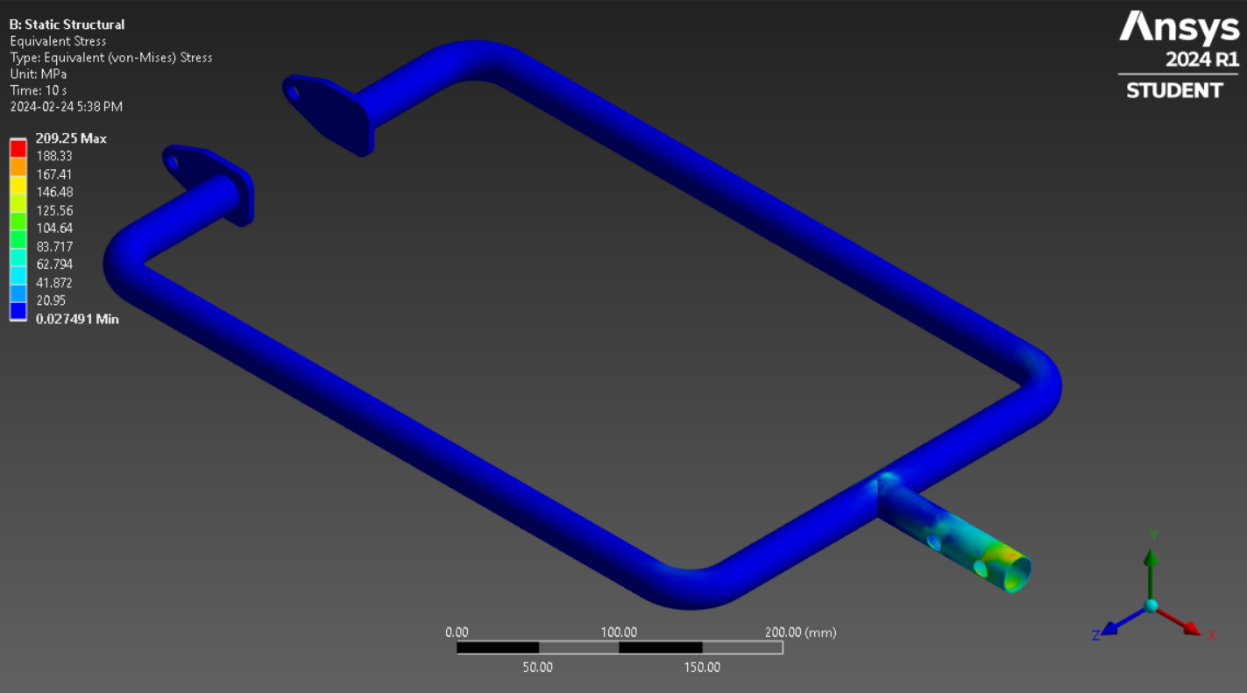
Figure 28 – Equivalent Stress

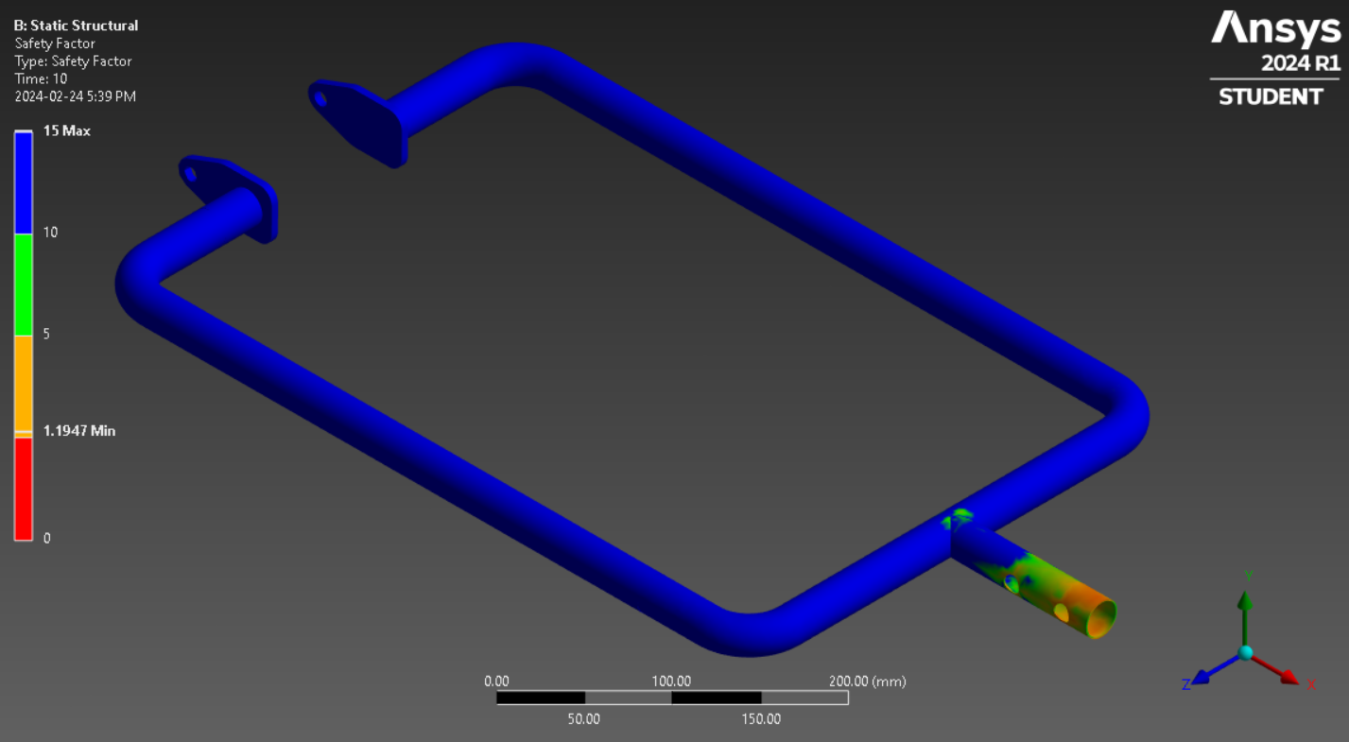
Figure 29 – Factor of Safety
The results are of the tests shown above are as follows:
- Maximum Deformation: 0.227mm
- Maximum Equivalent Stress: 209.25 MPa
- Minimum FOS: 1.19
Shown below are the tests of the welded component of the mounting system. Static Structural Testing was conducted on the mount with a maximum load of 2205 N on the face of the aluminum mount . The total deformation, equivalent stress and FOS have been pictured below. The load was spread over a 10s time.
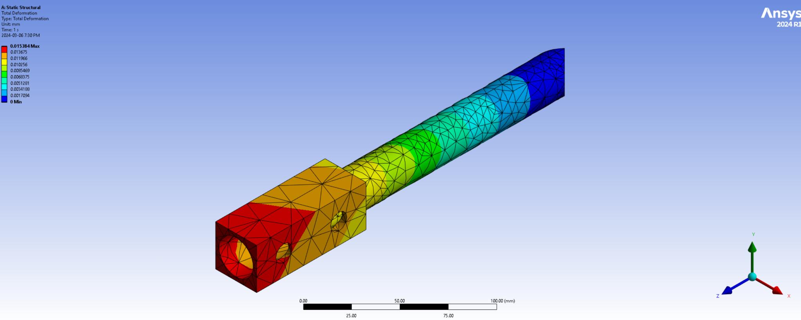
Figure 30 – Total Deformation
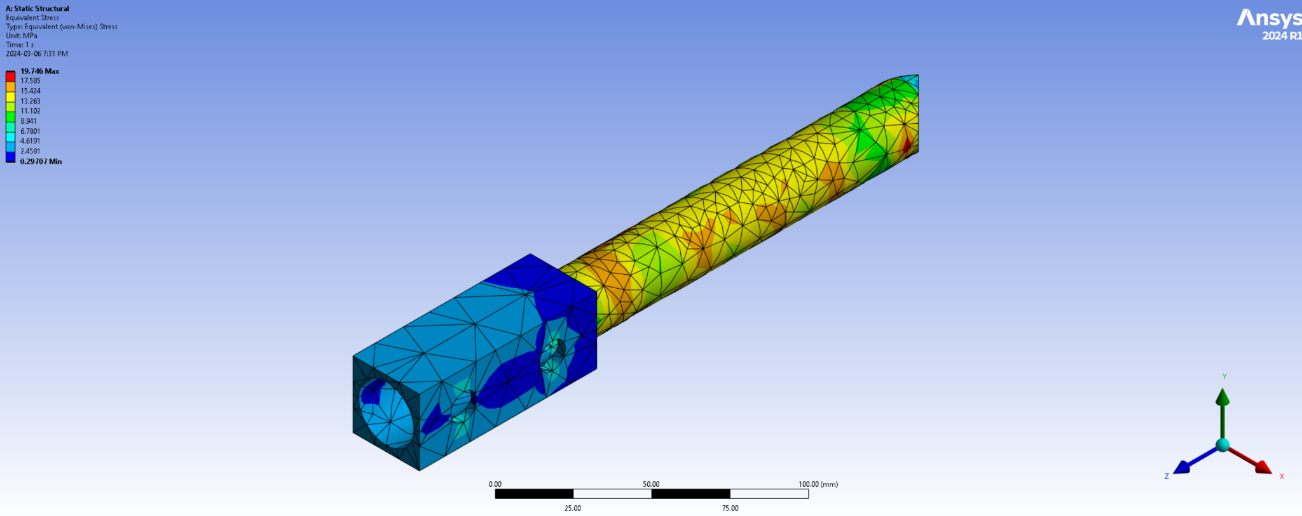
Figure 31 – Equivalent Stress
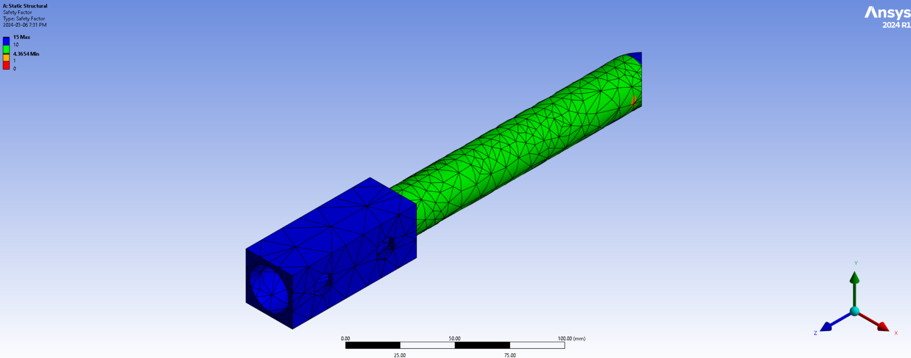
Figure 32 – Factor of Safety
The results for the welded component of the mount are listed below.
- Maximum Deformation: 0.015mm
- Maximum Equivalent Stress: 19.74MPa
- Minimum FOS: 4.6
The maximum deformation varies for all the components but it is under the range of failure. The Maximum Equivalent Stress and the Factor of Safety (FOS) figures are in the range of safety failure.

Straps

Documentation of Strapping System
The strapping system is supposed to improve the safety of a trailer user by securing the wheelchair to the floor of the attachment.
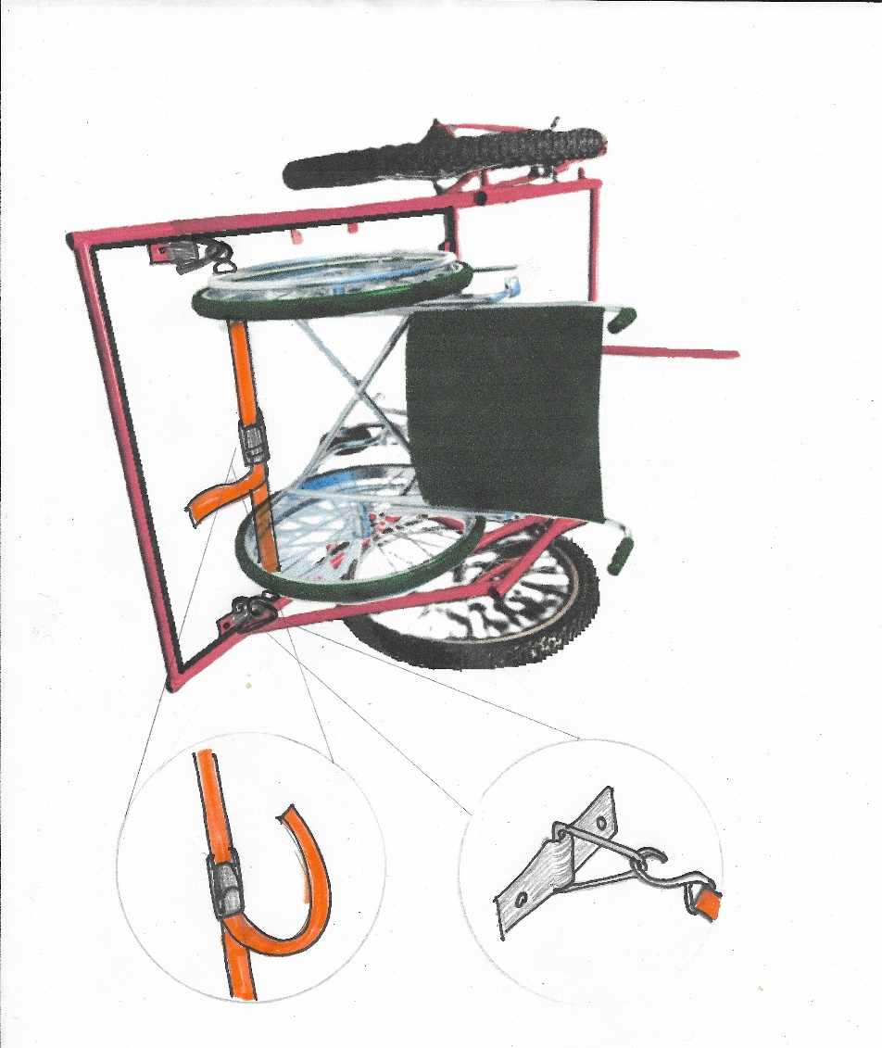
Figure 33 – Rear Strapping
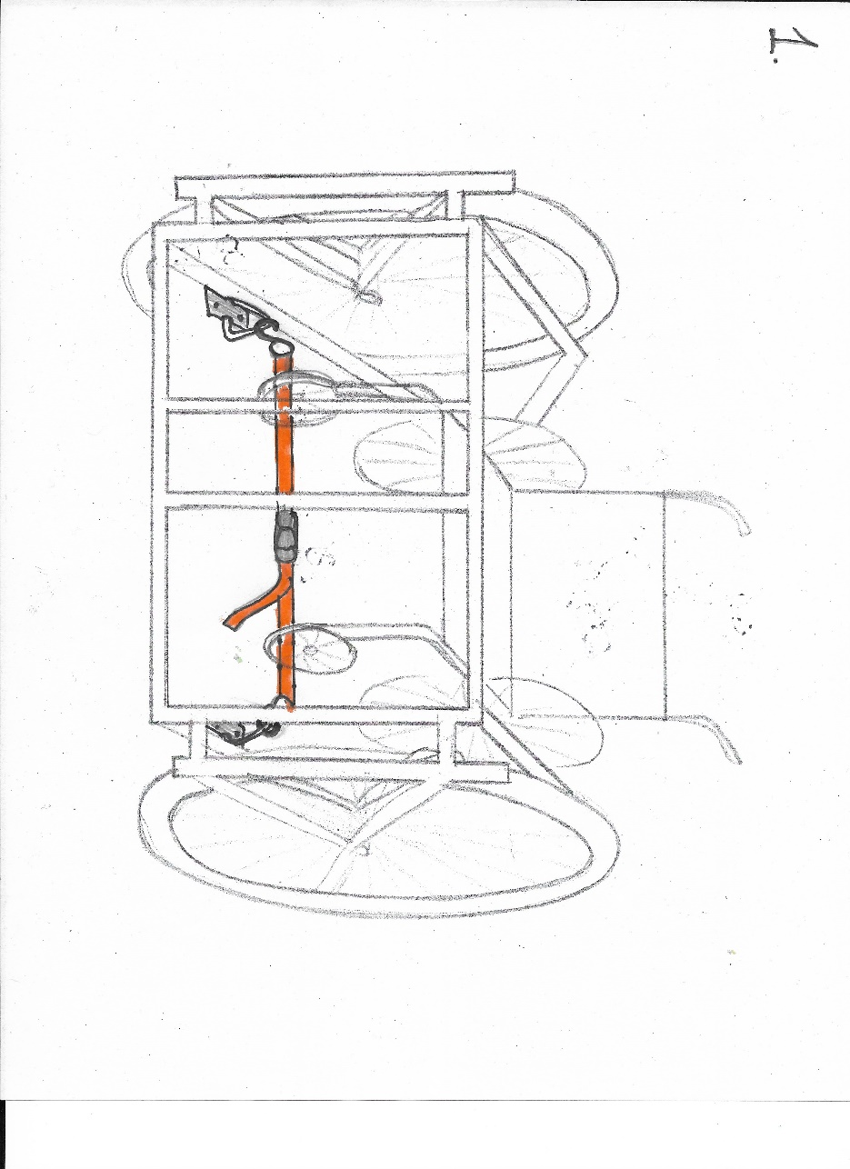
Figure 34 – Front Strapping

Prototype Analysis
Out of three ways of the strapping suggested earlier, we came to a conclusion that the first way would be the best for securing the wheelchair in a stable position as well as the most comfortable for the user. This is because other techniques did not provide leg space for the user, and the given strapping system should anchor the wheelchair at 4 different points when tensioned, which should minimize jostle. Completing the testing of this system is virtually impossible until we complete a concrete prototype.

Bill of Materials
The bill of materials is shown in the table below.
Item | Quantity | Need | Cost | Link
5mm thick steel plate [For Mount[ | 2 | To attach the pipes to the rear axle. | 2 x 20 = 40$* | https://a.co/d/8FDWnrg
1 inch OD steel pipe [For Mount] | 2 x 400 mm | To attach the rear axle to the carriage. | 45$* | https://www.amazon.ca/OD-Brushed-Stainless-Tubing-Custom/dp/B07KRMZPB1?th=1
 | 260mm | To join the two parallel pipes behind the rear wheel. | 13$* | https://www.amazon.ca/OD-Brushed-Stainless-Tubing-Custom/dp/B07KRMZPB1?th=1
 | 125 mm | To create a connection between the mount and the carriage. | 7$* | https://www.amazon.ca/OD-Brushed-Stainless-Tubing-Custom/dp/B07KRBWZC4?th=1
Husky 1-inch x 12 ft. Ratchet Tie-Down (4-Pack) [Straps] | 1 pack | Straps are required to secure wheelchair on the trailer | $19.98 / each | https://www.homedepot.ca/product/husky-1-inch-x-12-ft-ratchet-tie-down-4-pack-/1001031415
Husky Light-Duty Black Anchor Points (4-Pack)  [Straps] | 1 pack | Anchors are required to attach the straps to the platform of the trailer | $9.44 / each | https://www.homedepot.ca/product/husky-light-duty-black-anchor-points-4-pack-/1001580425
Hinge | 6 | To attach the ramp with the floor | 6 x 5 = 30$ | https://www.homedepot.ca/en/home/categories/building-materials/hardware/door-hardware/door-hinges.html
Ramp | 1 | To easily put the wheelchair on the carriage | 1 x 50= 50$ | https://www.homedepot.ca/en/home/categories/building-materials/lumber-and-composites/plywood/mdf.html
Floor | 1 | The floor of the Carriage | Same as above | https://www.homedepot.ca/en/home/categories/building-materials/lumber-and-composites/plywood/mdf.html
Rod | 1 | The rod of the Carriage | 1 x 20= 20$*
Aluminium mount | 1 | The mount the bicycle with carriage | 1x30=30$
TOTAL | N/A | N/A | 139.42 | N/A
TOTAL (with tax) |  |  | 157.54
* It may be possible to obtain this item for free through the University’s Bike COOP or Brunsfield Center or some other source.
Listed in the following table are the electronics. Note that prices are omitted for this project because the electronics were obtained from uOttawa’s Makerspace for free.
Component | Quantity
Arduino UNO | 1
M2M jumpers | 20-30
M2F jumpers | 10
RED LED | 1
LED STRIP | 2
Slider Switches | 2
Contact Switch | 1
LCD | 1
Voltage Source | 5 V
PCBs | 3-4
Speaker | 1
Resistors | 10k ohm(5-6)
Long single-strand wires | 10-30
RGB LED strip | 1
Buttons | 5-10
Bluetooth Module (ZS-040) | 1
GPS Module (Beitian BN-880) | 1

Updating the Prototype Test Plan

Due to licensing problems with Wrike, this section could not be completed for this deliverable. The team is in the process of changing project management software, and this section will either be provided in a future deliverable or in a separate document following a discussion with the professor.

Conclusions and Recommendations for Future Work

In conclusion, most of the electrical and mechanical features of the inclusive bike have been prototyped, and test results have been promising. On the mechanical side of things, the manufacturing process needs to begin to complete a physical prototype. On the electrical side, the components need to be wired together into a single system. Moreover, the electrical system needs to be mounted and wired onto the physical prototype. A box for housing the electronics needs to be created.

